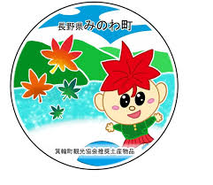
箕輪町英語ニュースレター 令和7年11月
Newsletter November 2025
Minowa Town Hall 箕輪町役場
The newsletter is published monthly by Minowa Town Hall.
〒399-4695 Nagano Prefecture. Kamiina District. Minowa Town. Oaza Naka Minowa,10298.
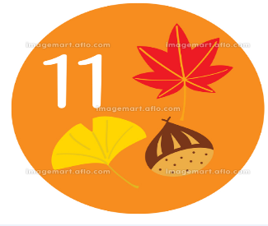
399-4695 長野県上伊那郡箕輪町大字中箕輪,10298 TEL: 0265-79-3111
The cold season has arrived!

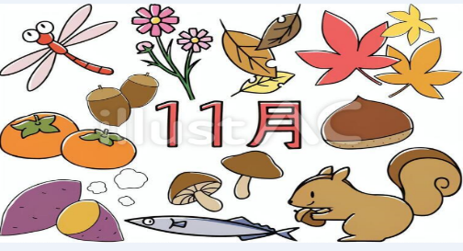

~Let’s take appropriate measures
against infections～

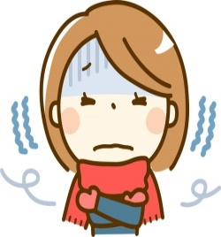
The hot summer is over and the dry winter has arrived.
It is important to take measures against infectious diseases,
such as influenza, coronavirus, as well as mycoplasma.
Check the basic guidelines below and protect yourself:
Clean your hands!
Wash your hands with soap or sanitize them with hand sanitizer.
Do not touch!

Do not touch your eyes, nose, or mouth. Be careful when touching them.
Don’t forget your manners!
When coughing, cover your nose and mouth with the inside of your elbow or with a tissue.

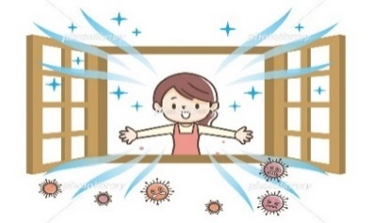
Ventilate the space frequently!

Don’t forget to air out the room. Dry air increases the risk of infection.
Don’t overexert yourself!
If you feel unwell, stay at home. If you have a fever, cough, or difficulty breathing,consult a doctor. Contact the medical institution in advancebefore going to the clinic, to make sure you can be seen.

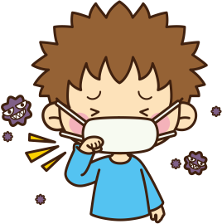
A dry season has arrived.
Remember the basic precautions against infectious diseases such as the flu, influenza, coronavirus, and mycoplasma.
Prevention is very important! !

[Nagano Medical Interpreters Call Center]

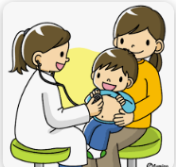
The¨Nagano Medical Interpreters Call Center¨has started operating for foreigners who live in
or are visiting Nagano Prefecture. Now, you can count on telephone translation when consulting
a doctor or purchasing medicine at the pharmacy.

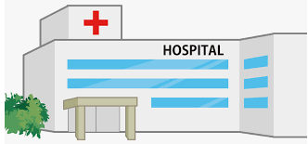

Available languages:
22 languages, including English,
Chinese, Korean, Thai, Filipino,
Portuguese, Vietnamese,etc.
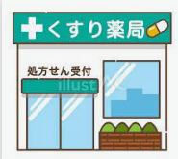
Telephone:

[Price]:
Free service (0 yen)
※To be the fee is charged telephone

Schedule:
24 hours
Reservation:
Not necessary

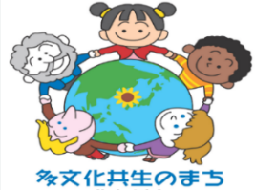
Are you familiar with the situation of foreign residents in Minowa? Vol.4
Curiosities:

In the previous article, we presented the city's initiatives for both foreign and Japanese residents
in the event of disasters, when measures are needed to help foreign residents live in the community.
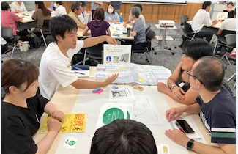
Japanese people are familiar with how to respond in disasters, having participated in evacuation drills since they were young, but as many foreign residents come from countries where earthquakes do not occur, Japanese tend to approach these individuals with the aim of providing information and teaching knowledge to those who are unsure of what an earthquake is, what disaster prevention means, or what an evacuation shelter is.
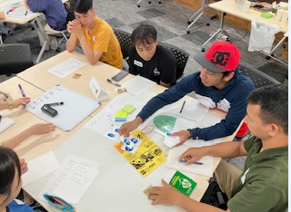
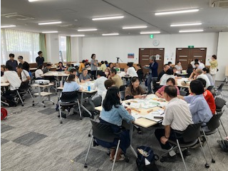
In this article, we will talk about "NICE!" "Multicultural Disaster Prevention Workshop," a new initiative that allowed foreigners and Japanese people to interact and have fun, natural conversations regardless of nationality. Participants shared videos about the disaster and used quizzes and games to discuss topics related to signals that differ between countries and disaster prevention. Foreign residents with difficulties speaking Japanese were also able to actively express themselves thanks to "easy Japanese/yasashii nihongo" and the support of other participants, all learning together on equal terms.
Foreign residents who participated said things like, "It was fun interacting with Japanese people! " and "I learned many things about disaster prevention for the first time! ". The Japanese participants also said things like: "I thought there would be a barrier because I am a foreigner, but when I started talking, I found the conversation very enjoyable!" and "I want to communicate more with foreign residents!" It was a course where we could think, learn, and feel together.

[Japanese classes are also available]

The city's Japanese classes are intended to be a space where people not only learn the essential Japanese language for daily living, but also come into contact with the culture and lifestyle of other countries, including Japan, and form ties with the local community. The classes are attended by long-time residents of Minowa and newcomers to Japan, with different levels of Japanese proficiency, backgrounds, nationalities, etc., but everyone wants to improve their Japanese and converse with the Japanese! They are dedicated people who make an effort on their own, even on their days off, in a place as unknown as Japan.
If you see a foreign resident, why not start by smiling and saying 'Konnichiwa!' or 'Hello!' just like Japanese people do!
A smile is universal! ! :)

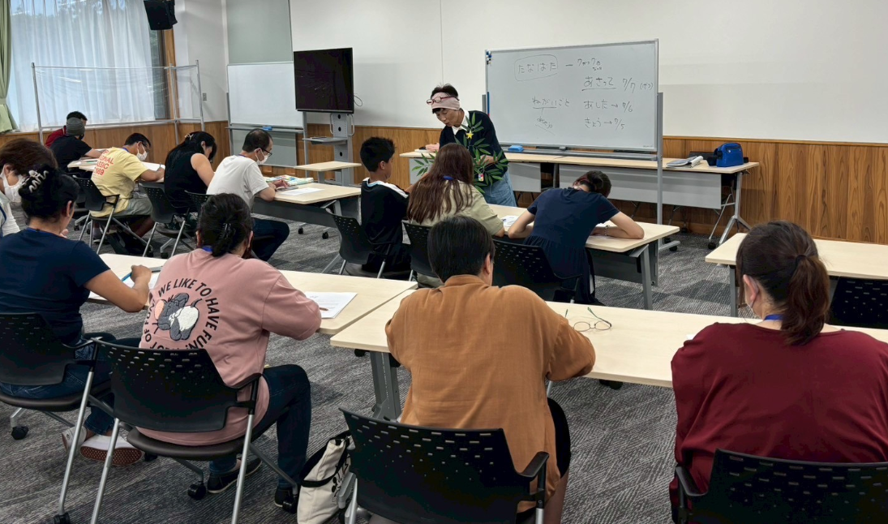
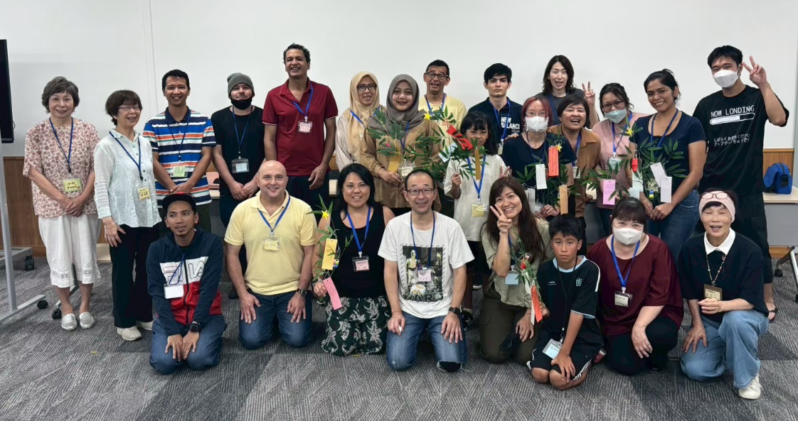
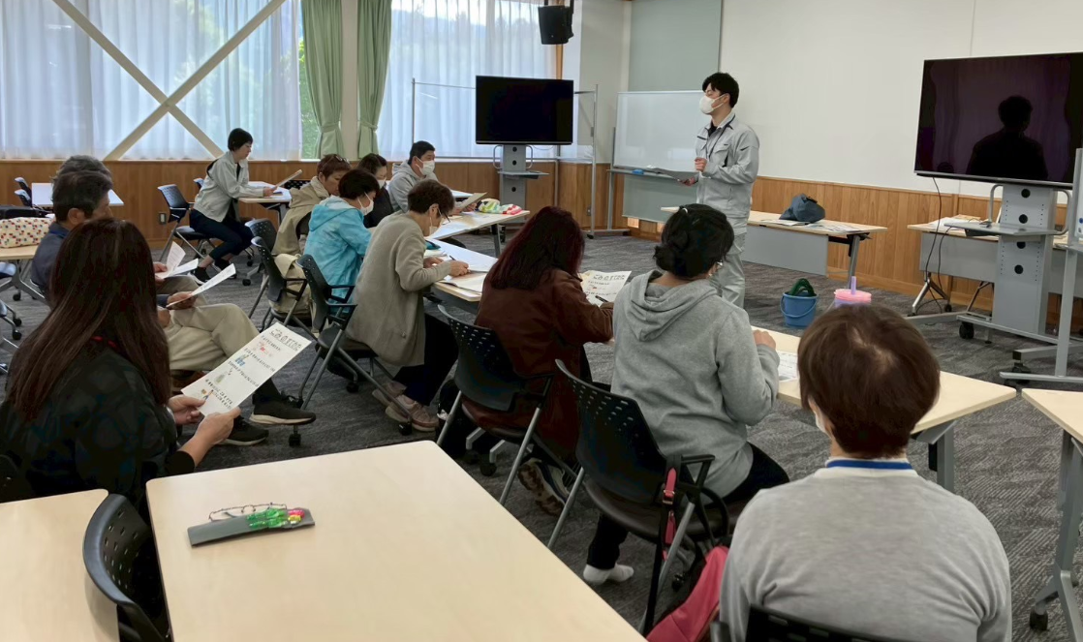

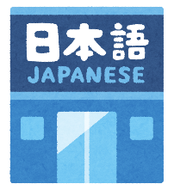
まちで にほんご きょうしつ あります。There are Japanese language classes in town.
◇TeL:070-5077-2420
◇Mail:m.tabunka@gmail. com
◇LINE:https://line. me/ti/p/rhMKeSYmL2
◇WHATSAPP:https://wa. me/qr/5JEBYX7J2XH5H1
◇MESSENGERhttps://m. me/61574885471583?source=qr_link_share
※さいしょに かならず れんらく してください！First of all without fail please be sure to contact us !

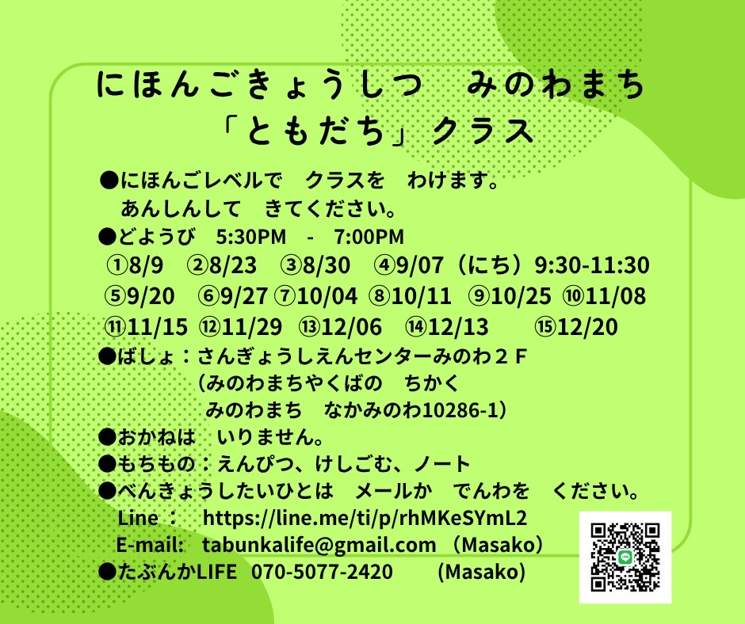
Japanese Class on Saturdays
"Friends" Class
Students will be divided into groups according to their level of Japanese.
Come with peace of mind.
*Saturdays from 5:30 p.m. to 7:00 p.m.
*Location: Sangyo Shien Center-2nd floor
(almost in front of the City Hall)
＊Fee: FREE
＊What to bring: pencil, eraser, notebook.
＊Dates:
November days: 8, 15, 29

⇦ Other dates on the side.⇦

Whoever wants to participate, send an email or call: Tabunka Life: 070-5077-2420 (Massako)

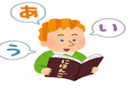

[Japanese lessons] with Japanese volunteers
(On Saturdays – from 1:00 p.m. to 3:00 p.m.)

*November 1st: (Yassumi) Day off
*November 8th: Starting 1:00 pm～(location: Bunka Center Minowa, rooms 5,6)
*November 15th: Starting 11:00 am～(Bounenkai/End-of-year party)
*November 22th: (Yassumi) Day off
*November 29th: Starting 1:00 pm～(location: Bunka Center Minowa rooms 5,6)

*(Fee of \200 yen/per visit)
If possible,
We request
the use
of mask


Important notice to residents:

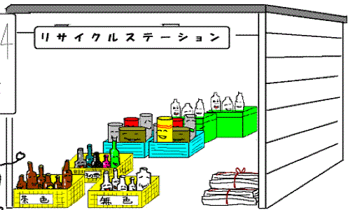
The recyclable waste collection center 'Clean Center Yaotome' informs the residents of Minowa and the surrounding area that, in November, the company will be closed for maintenance/renovation, and, as a result, the 'Midori Recycling Station in Shiguen/Recycle Station' will also be closed.

[Collection Box]for
Small appliances/
Batteries. (Located in the City Hall lobbyof the City Hall)
[Collection box in the City Hall lobby
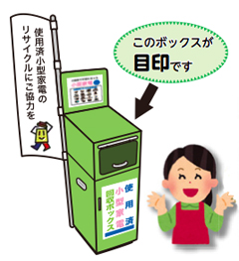
Small Appliances (free of charge)]
This is the
box
- Remove batteries before discarding.
- Small appliances are limited; they must fit in a trash bag.
'non-burnable.'
- Loudspeakers, including wooden products and hazardous flammable materials
(stoves, heaters, etc.) will not be accepted.
- Small appliances are also collected in the 'Collection Box' installed in the City Hall lobby. (The small appliances that can be collected in the Collection Box must be no larger than 30 cm x 10 cm.)

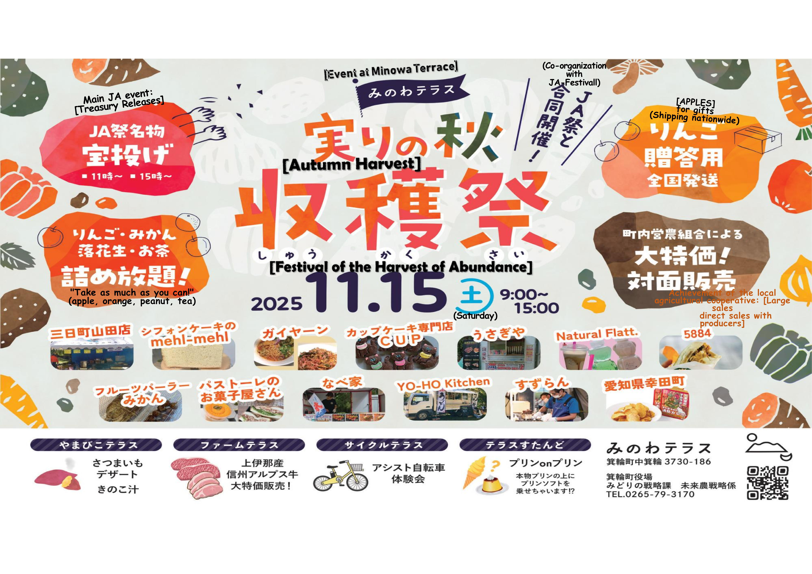

「もみじ (ダム)」
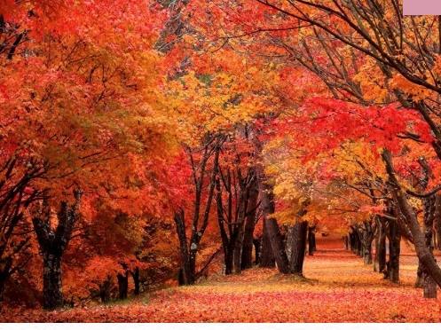
Momiji-ko (Minowa-damu)
In the city of Minowa, on the shores of Lake Momiji/Minowa Dam, about 10,000 maple trees (momiji) are planted, coloring the clear stream along the lake's edge, and at the end of autumn, the blue surface of the water and the fiery autumn leaves create a moving scene. Many people come in large tour buses during the season (late October to early November) to enjoy this view.
In addition, there are parks, squares, and campgrounds around Lake Momiji that you can enjoy depending on the season.
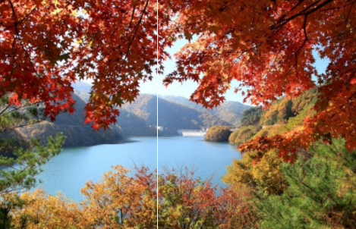
“Minowa Damu /Minowa Dam”
Completed in 1992, the Minowa Dam is a concrete gravity dam, 72 meters high, and is fondly known as “Momiji-ko / Lake Momiji.” After ten years of planting Momiji trees, residents believe that the lake safeguards people’s lives and nature by controlling floods, maintaining the normal flow of water, and providing water to the northern part of the Ina Valley.
The city of Minowa was one of the first in the province to enact a water source protection law and has been making efforts to preserve them. It is a dam with a clear and highly transparent stream. You can enjoy free camping around Momiji Lake, but advance reservation is required.
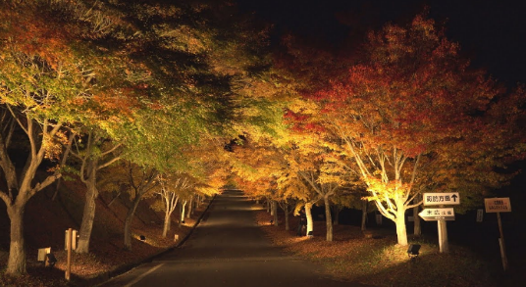
Regarding visiting Momiji-ko with your own car, from November 1st to 9th (to avoid traffic jams from 7:00 to 17:00), private parking is required (reservation needed), but you can use the municipal bus from Matsushima train station (from 10:25 to 15:05 outbound / 12:10 to 16:25 return – a fee of 1000 yen for round trip).
However, this year, since the leaves are changing colors later, you can enjoy the momiji leaves season for a longer time.
The "Momiji Festival/Momiji-ko Matsuri" and the "Light-up Festival" (illumination of the leaves) also take place from October 25th to November 9th.

Come and appreciate the beauty of the colored momiji leaves! !

