**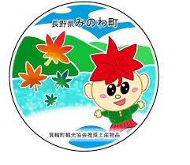箕輪町英語語ニュースレター 令和７年9月**

**Informativo** 　　 September 2025

**Minowa town hall 箕輪町役場**

The newsletter is published monthly by the Minowa town hall.

〒399-4695 Nagano Prefecture, Kamiina District. Minowa Town. Oaza Naka Minowa, 10298.

399-4695 Nagano Prefecture, Kamiina District, Minowa Town, Oaza Naka Minowa 10298

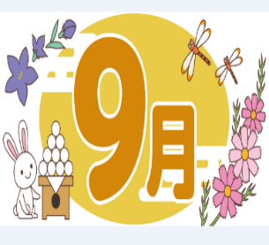TEL: 0265-79-3111 Extensions: 1104/1711

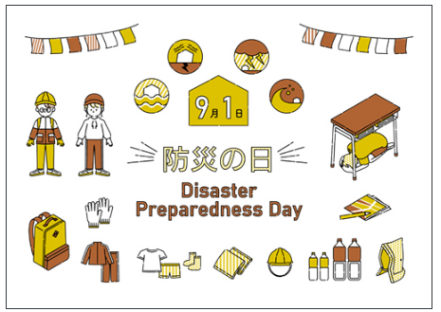

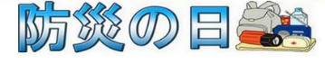

**Disaster Prevention Day**

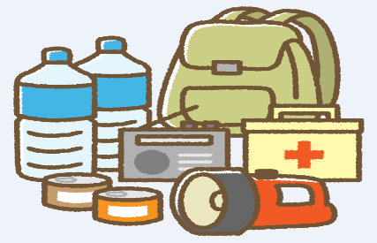. During the first week of September, Japan recalls the importance of "Disaster Prevention," as a major earthquake can occur at any time. **Japan is a country susceptible to earthquakes, tsunamis, and typhoons,** which cause disasters that take lives and destroy buildings and other properties. Therefore, the country has Disaster Prevention Day set on **September 1st**, the date of the Great Kanto Earthquake, which had a magnitude of 7.9 and occurred 100 years ago, in 1923, the 12th year of the Taisho era. More than 100,000 people died or remain missing and over 370,000 buildings were completely destroyed by the quake, burned, or buried. Nowadays, even in homes and buildings with technology to withstand strong earthquakes, it is necessary to be careful indoors to avoid falls that could injure residents or employees in companies. That is why it is important to secure furniture, remove anything that might fall on people while they are sleeping or working, keep the hazard map of the surrounding area close at hand, know where to seek shelter, and have an **emergency backpack** prepared in case　of an evacuation order. **Responsibility for your** life: How about having a family meeting to reflect on disasters and discuss preventive measures? The government and other authorities have the duty to inform and issue alerts as quickly as possible, but the preservation of life is the responsibility of each citizen. It is also important to buy whistles, as they are very useful for attracting attention in emergencies. Another extremely important item that should be available in sufficient quantity for the family is portable toilets. In addition, it is **very important that each family member has a survival kit or an emergency backpack.**

**Example of some important items**

**to put inside the "emergency backpack"**

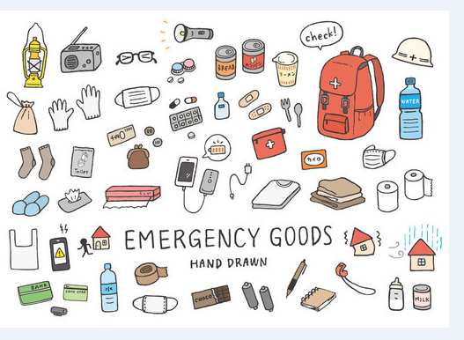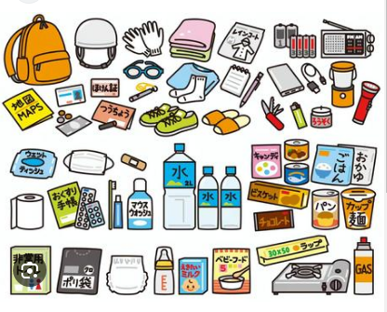

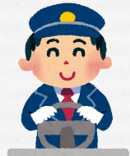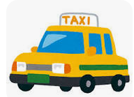

**【TAXI with fixed price within the city】**

With the aim of improving the lives of elderly people and others with mobility difficulties, the city of Minowa operates a fixed fare taxi service called "Machinaka Taxi" in the city, alongside the Minochan bus and the Ina main line, in order to create a public transport network that will connect to the future. We would like to inform you on how to use the fixed price taxi service.



**Who can use it**: If you fit any of the situations below, you can register.

After registration, a registration certificate will be mailed to you.

The service can be used up to

20 one-way trips per month.

**usage fee: ￥500 per use**

・People over 65 years old

**Discounted fare:**

**￥250 per time**

・People who have returned their

driver's license

・Holders of disability certificates:

(physical disability, rehabilitation, health and welfare for mental disability)

・Holders of a specific medical expense certificate (intractable disease)

・People aged 75 or older who never had a driver's license

・Those who receive social assistance (seikatsu hogo) do not have a car.

・Households consisting only of people aged 75 or older who do not own a car.

・Pregnant women and other people with mobility difficulties

(People with mobility problems are those who have difficulty

getting around, such as those who cannot drive due to a

chronic illness)

**Available area:** Limited to the city of Minowa

**Available hours:** Weekdays from **9:00 a.m. to 3:00 p.m.**

**\***Not available on weekends, public holidays, Obon holidays

(August 13th to 16th), and New Year holidays (December 29th to January 3rd)

・Please contact between 9:00 a.m. and 2:30 p.m. on the day of use

・Depending on the timing, use may not be possible

**How to apply: By phone only**

(The phone number for Machinaka Taxi will be provided together with your registration certificate)

**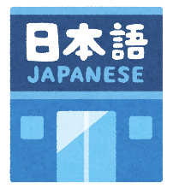**

まちで　にほんごの　きょうしつ　あります。

◇TeL：070-5077-2420

◇Mail :[m.tabunka@gmail.com](mailto:m.tabunka@gmail.com)

◇LINE：[https://line.me/ti/p/rhMKeSYmL2](https://line.me/ti/p/rhMKeSYmL2" \t "_blank)

◇WHATSAPP：[https://wa.me/qr/5JEBYX7J2XH5H1](https://wa.me/qr/5JEBYX7J2XH5H1" \t "_blank)

◇MESSENGER <https://m.me/61574885471583?source=qr_link_share>

**※さいしょに　かならず　れんらく　してください！！**

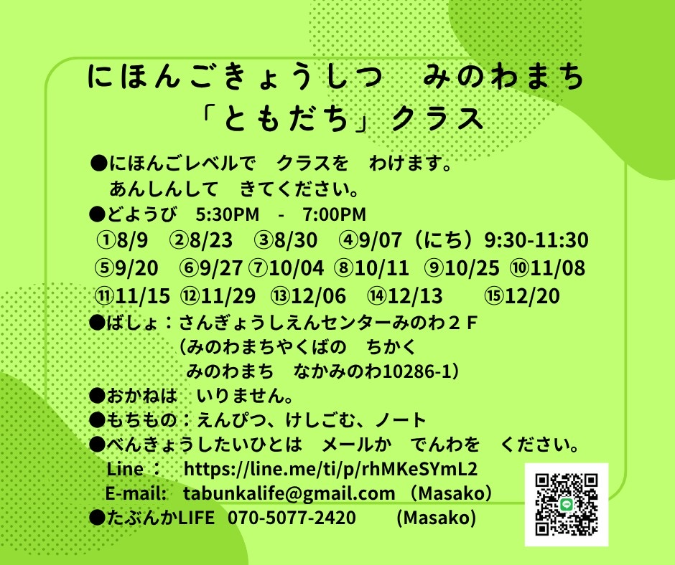

Japanese Class on Saturdays

"Friends" Class

Students will be divided into groups according to their Japanese language level.

Come at ease.

\*Saturdays from 5:30 p.m. to 7:00 p.m.

＊Local: Sangyo Shien Center-2ºandar

(almost in front of City Hall)

\*Fee: FREE

＊What to bring: pencil, eraser, notebook.

＊Dates: August 9, 23, 30

September 7 (Sun.) 9:30–11:30

September 20, 27

⇦ Other dates on the side. ⇦

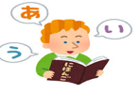

If you would like to participate, send an email or call: Tabunka Life: 070-5077-2420 (Massako)



**[Japanese class] with Japanese volunteers**

(On Saturdays – from 1:00 p.m. to 3:00 p.m.) (＊Fee of ¥200 per session)

\*September 6: from 1:00 p.m. (Location: Bunka Center Minowa / room 3

\*September 13: from 1:00 p.m. (Location: Minowa Base / room 1)

\*September 20: (Yassumi) Holiday

\*September 27: from 1:00 p.m. (Location: Bunka Center Minowa / room 3)

**Typhoon season (taifu) in Japan**

**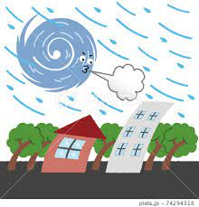**

The typhoon season in Japan varies each year, peaking between **August and September.** Japan is susceptible to natural disasters such as earthquakes, tsunamis, and, of course, typhoons. In the past, landslides and floods resulting from typhoons have caused countless damages and claimed thousands of lives. Local governments prepare instruction manuals and conduct regular safety drills to prepare for emergencies, usually in schools and local neighborhoods. **Make safety your top priority**. Do not attempt to travel to areas affected by floods and do not enter the sea under any circumstances. If it is forecasted that a typhoon will hit the region where you are, ask about the location of shelters (usually schools). It is a good idea to **have a 'typhoon kit**.' Your emergency kit should contain: water, non-perishable food items, a first aid kit, a flashlight, extra batteries, changes of clothes, and warm clothing. These items will help you be prepared in case of an evacuation or a few days at home without electricity.

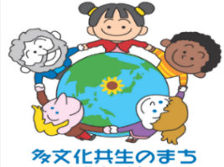

**Do you know about the situation of foreign residents in Minowa? Vol.3**

**Curiosities:**

In this edition, we will introduce the efforts the city is making to support

foreign residents in case of an emergency. In the previous article, we mentioned that most of the people living in the city of Minowa are not visitors, but in fact local residents who live in Minowa.

In the city of Minowa, for the benefit of foreign residents who may lack information, the city hall staff is trained to set up a "Multilingual Disaster Support Center" (a place that provides disaster-related information in various languages to support residents who are feeling mentally shaken) and to conduct interview training at evacuation shelters. In addition, several courses are being held for foreign residents, but also for local residents who are in support roles, and efforts are being made to strengthen the support system.

Since last year, we have also conducted a joint training course with the cities of Tatsuno and MinamiMinowa to train foreign residents to be supporters in the event of a disaster, and we will continue to work together with the cities and towns to support foreign residents in the community.

**For foreign residents :**

**The "Multicultural Disaster Prevention Workshop NICE"**

Why not take the first step and seize this opportunity to learn about local disaster prevention together with foreign and local residents?

**● Date/Time: September 7 (Sun.)**

**from 9:30 to 11:30**

**● Location: Sangyo Shien Center Minowa 2F**

**● Capacity: 60 people**

**● Participation fee: Free**

**・**City homepage with multilingual support

**・**Introduction of the translation system

**・**Creation of a consulation counter for foreign residents

**・**Multilingual Disaster Prevention Risk Map

**For Japanese residents:**

**・**Training for volunteer interpreters and translators

**・**Training for foreign supporters in times of disaster

**・**Training in auditory patrol when operating evacuation shelters

**・**Experience at the Multilingual Support Center for disasters



**How to separate and dispose of trash**

**Selective waste collection saves our valuable resources.**

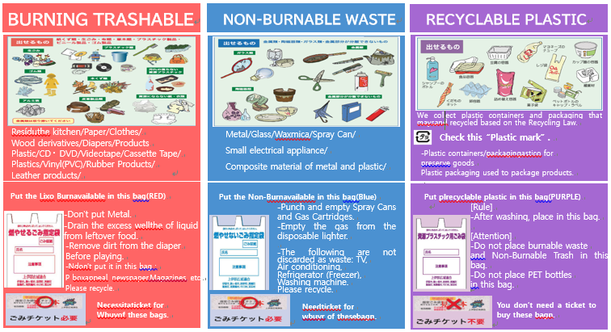

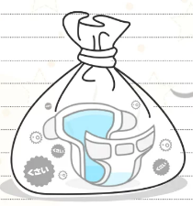

**紙おむつをお使いの方へ、ごみ袋の支給制度がありがます**

**Garbage Bag Supply System for Disposable Diapers**

The Minowa Town Hall has resumed the system that provides "burnable garbage bags" for the disposal of disposable diapers for babies and people certified as needing nursing care. Applications are being accepted and distribution has already begun in July. This system aims to reduce the financial burden on users of disposable diapers, provide support for child care, and improve welfare.

Who is eligible: \*Babies (children under 3 years old) \*those who use disposable diapers \*other special cases

Benefit Details: For each eligible person upon request, up to 60 designated garbage bags (medium size), once a year. ※In some special cases, you may request up to an additional 100 diapers per year.

Application method: Please apply at the Minowa Town Hall, Counter 11.

Attach the following documents: ＊Proof of eligibility (Boshitechô, disability notebook, etc.)

Department of Security and Life Protection, Environment/Transport Sector (Counter 11)

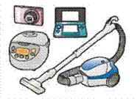

**[Collection of small appliances]**

We will be collecting small appliances free of charge.

* Those who are interested must come directly to the collection site.
* Date and Time: **September 28th (Sunday)** **8:00am ～ 9:00am**
* Collection Location：Parking lot in front of the City Hall.

**[Collection Box]**

For Small appliances/

Batteries. (Located in the City Hall lobby)

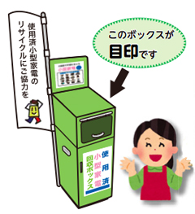 **small appliances (free of charge)**

This is the

box

* Remove batteries or cells.
* Small appliances are limited,

they must fit into a "non-burnable" garbage bag.

* Speakers, including products made of wood and flammable hazardous materials (stove, heater, etc.) will not be accepted.
* Small appliances are also collected in the "Collection Box" installed in the lobby of City Hall.

(The small appliances that can be collected in the Collection Box

must be no larger than 30 cm x 10 cm).

Department of Security and Life Protection, Environment/Transport Sector (Counter 11)