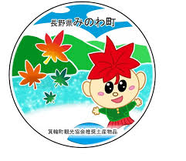
箕輪町えいごニュースレター 令和８年８月
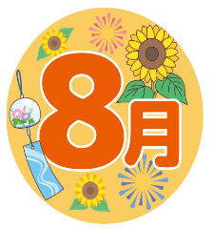
Newsletter - August 2026
Minowa Town Hall 箕輪町役場
The newsletter is published monthly by the Minowa Town Hall.
〒399-4695 Nagano-ken.Kamiina-gun. Minowa-machi. Oaza Naka Minowa ,10298.
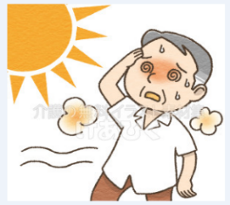
399-4695 長野県上伊那郡箕輪町大字中箕輪10298
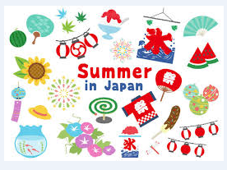
TEL: 0265-79-3111 / 0265-79-3154

ATTENTION! ! [The dangers of excessive heat,

"netyushō" (heatstroke) can be fatal]
Temperatures in Japan are rising, and the country has been facing a dangerous heatwave in recent days, especially between the Kyushu and Kanto regions, with temperatures potentially exceeding 40°C in several locations. Extreme levels of heat are expected, requiring maximum attention and rigorous measures to prevent heatstroke and hyperthermia. There is much talk about ‘netyusho’, or "heatstroke" in English, as excessive exposure to the sun can be fatal if we do not take certain precautions.
‘Netyusho’ in English is heatstroke, a condition caused by excessive exposure to the sun or by spending too much time in a hot, unventilated environment.
Heatstroke symptoms are usually: dizziness, vertigo, or fainting due to excessive heat, muscle aches, body aches, nausea, sweating, and high body temperature. In more severe cases, the person is unable to speak or walk due to the excessive heat.
Which place is most likely to cause heatstroke?
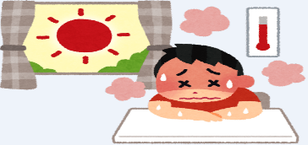
When we talk about 'netsu-chu-sho', we immediately think of an entire day under a scorching sun, or when we exercise for many hours in the summer, but the reality is that heatstroke can happen in places we wouldn't even imagine. For example:
＊High temperature and very humid places;
＊Environments with poor ventilation and very strong sun;
＊When the temperature rises suddenly;
Even on days when the temperature is not high, but the environment is very humid, it can cause heatstroke. Anyone who assumes that being at home means being free from heatstroke is mistaken: 37% of cases in Japan happen at home, and 25% happen while walking on the street on very hot days. Nowadays, there is a lot of talk about 'netsu-chu-sho' at home — which can be fatal for the elderly.
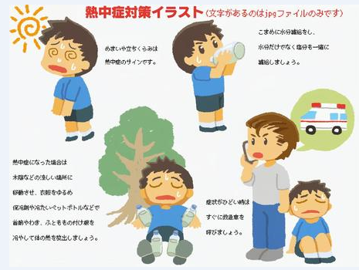
What to do when you have symptoms of heatstroke?
＊Go to the nearest clinic/hospital, or call an ambulance;
＊Move to a cooler place;
＊Remove clothing and cool the body down to lower the body temperature;
＊Drink fluids or eat foods containing mineral salts, but if the person is feeling nauseous, do not force fluid intake.
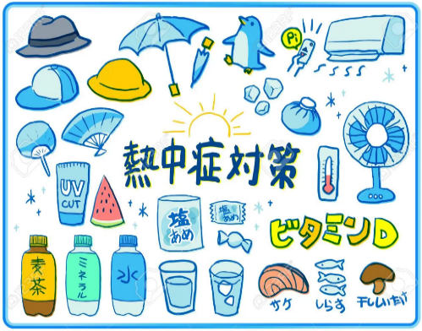
How to take care of yourself to avoid heatstroke? The important thing is to take care not to get heatstroke before the first symptoms appear. Extra care is needed when spending an entire day at the beach, or even when staying at home on a hot day.
＊Drink plenty of fluids; ＊Use air conditioning and fans;
＊Take a shower or use a wet towel around the neck to cool the body;
＊Measure the room temperature;
＊Do not overexert yourself on high-temperature days;
＊Wear cool clothing, use an umbrella and a hat on very hot days.

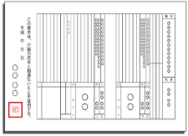
Notice regarding [Issuance of Family Register (Koseki Tohon) in a wide area]
Since 2024, it is possible to request a family register certificate (koseki tohon) or a certificate of removal from the register at the city hall counter, even if it is different from the registered municipality.
Even if your registered address is far away, you can now apply at the city hall where you live or work.
For more information, please contact the Resident Affairs Section/Resident and Environment Division/Minowa Town Hall.
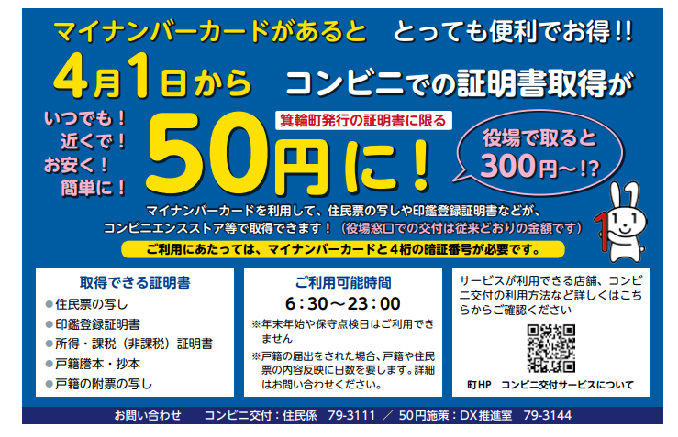
●Not available during the year-end and New Year holidays.
●If you submit a family register notification, it will take several days for the details to be reflected in the family register. (Contact us for more details)

You can use your My Number card to obtain copies of your resident record, seal registration certificate, etc.

Anytime!
Near you!
Cheap!
Simple!

Contact: Minowa Town Hall / Resident Affairs Division 0265-79-3111
Minowa Website / Convenience Stores

Check here for details on locations and convenience stores where the service can be used.

Certificates available:
● Copy of resident record
● Seal registration certificate
●Income/taxation (tax exemption) certificate
●Copy of family register
(kosseki tohon)

To obtain a certificate/document at a convenience store (Kombini), it only costs... . .

It is very convenient and profitable if you have a "My Number Card"! !
Limited to documents issued by the city of Minowa
At City Hall it costs:

To use the service, you will need your card and your 4-digit password.
Opening hours:

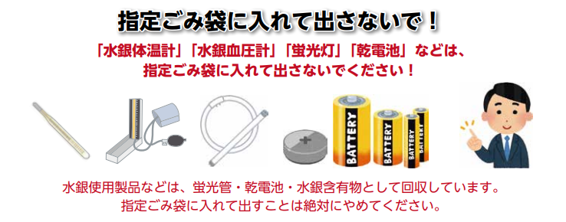
Products containing mercury are collected as "hazardous waste."
Therefore, never place them in a designated trash bag.

[Batteries]
[Fluorescent tube/lamp]
Do not dispose of these items in the designated garbage bag! !
(burnable waste, plastics, etc.)
Anytime!
Near you!
Cheap!
Simple!

Why shouldn't products containing mercury be placed
in a designated trash bag (burnable waste, plastic, etc.)?
At waste collection facilities, such as the "Clean Center Yaotome," there have been fire accidents believed to have been caused by lithium-ion batteries mixed with non-combustible materials. Lithium-ion batteries have the property of igniting when subjected to external impacts. For these main reasons, please do not place them in the designated trash bag (burnable waste, non-incinerable waste, recyclable plastic). Be sure to remove batteries (lithium-ion batteries, dry cells, etc.) from household appliances. When mercury is released into nature, it causes damage such as environmental pollution and harm to health. Furthermore, if mercury is emitted in a concentration higher than the standard value determined by law, it will be necessary to shut down the "waste treatment plant" for a long period, and it will not be possible to treat all the waste generated in households. In Minowa Town, we also collect "lithium-ion batteries," "heated tobacco products with built-in batteries, and e-cigarettes" along with "dry cell batteries and mercury-containing materials." (Minowa Town Hall / Safety and Life Protection Division / Counter 11) Tel.: 0265-79-3154)

[Mercury blood pressure monitor]
[Mercury
thermometer]

Product

