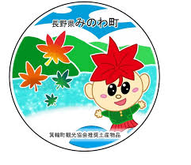
箕輪町英語ニュースレター 令和8年６月
Newsletter June 2026
Minowa Town Hall 箕輪町役場
The Newsletter is published monthly by the Minowa Town Hall.
399-4695 Nagano Prefecture. Kamiina District. Minowa Town. Oaza Naka Minowa, 10298.
399-4695 長野県上伊那郡箕輪町大字中箕輪10298
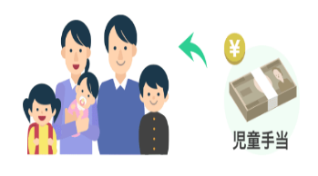
TEL: 0265-79-3111 / 0265-79-3154
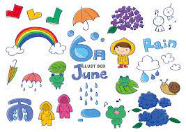

ATTENTION! ! !
Notice regarding [Jidou Teatê (Milk Assistance)]

The Minowa Town Hall informs that a Family Allowance Notification Letter (Current Status Report) will be sent to some households.
At present in Minowa Town, as a general rule, it is no longer necessary to submit the “Family status and income report” for the renewal of Milk Assistance. However, for some families, an update of their family situation will be necessary. Therefore, we ask that you send it or bring it directly to the city hall within the deadline, otherwise you may not receive the subsidy (milk assistance) from August onward. We ask for everyone's understanding and cooperation.

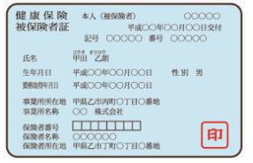
National Health Insurance (Kokumin Kenkō Hoken)

People up to 74 years of age who are subject to resident registration and do not have health insurance through their workplace or other public insurance must enroll in National Health Insurance. Please complete the enrollment procedure at the city hall corresponding to your residence within 14 days.
This applies in any of the following situations.
- People who have resident registration
- When moving to another municipality
- When you leave the health insurance where you work
- When the child is born (the child's portion)
In addition, people who are not subject to resident registration or who have less than three months of the qualification of stay, when their expected period of stay exceeds three months, will be able to enroll in the National Health Insurance. So please be careful. For more information, please consult the city hall.
Insurance premium
If there is a family member enrolled in the National Health Insurance, the head of the household must pay the premium (tax). The insurance premium (tax) is determined based on the number of enrolled family members and the previous year's income. The head of the household pays the annual insurance premium, which is divided into installments with payment deadlines. The fee (tax) can be paid at the city hall, convenience stores, or financial institutions using payment slips sent by the city hall, and bank transfer can also be used.
There are cases in which the insurance premium is reduced for people who have difficulty paying because of disasters, unemployment, bankruptcy, etc. For more information, please consult the city hall.

※This year's fee for the (Kokumin Hoken)/National Health Insurance
will be sent to households in ¨June¨.

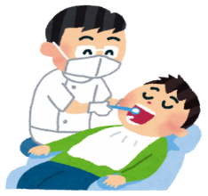
Notice regarding [Free dental examination for adults]

For people who are 21, 31, 41, 51, 61, and 71 years old this year, a
"Free Dental Coupon" that can be used at a designated dentist in the Kamiina district.
＊(If you are pregnant, use the free Dental Examination coupon for pregnant women).
It has been proven that periodontal disease is associated with diabetes, heart disease, and dementia. Preventing oral diseases helps protect overall health !
＊Examination contents: Consultation, oral examination (saliva), X-ray, dental examinations.
Period: 2026/6/1 to 2027/2/27

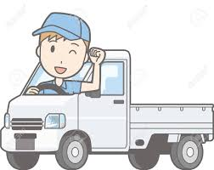
ATTENTION ! ! !
Light Vehicle Tax (Kei Jidousha)
In May, the Minowa Town Hall sent a vehicle tax payment hagaki (postcard/bill) to people who
own light vehicles (kei jidousha) and are registered as of April 1, 2026.
The payment receipt for this tax (due June 1) will be required for the shaken (annual vehicle inspection), so please make the payment and keep the receipt carefully in a safe place.
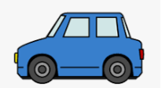
Automobile Property Tax (Jidousha zei)
Automobile property tax (does not include light motor vehicles or motorcycles, etc.) is a prefectural tax levied on all those who own automobiles as of April 1 each year.
Upon receiving the tax collection notice issued by the prefectural tax offices, please make the payment at banks or convenience stores.

⚠[What’s New About the Vehicle Tax “Payment Methods”]⚠

When you receive the tax notice, please make the payment by the specified deadline.
In addition to convenience stores and tax offices, payment can also be made at banks, financial institutions, and post offices nationwide.
New: The tax payment notice includes a QR code that allows easy payment through mobile payment apps such as PayPay, Rakuten Pay（楽天Pay）, and d払い.
In addition, it is possible to make payment using the QR code by accessing the municipal tax payment website on a smartphone or computer, through credit card, internet banking, among other options.
With this payment method, there is no need to go to a physical store or bank, and there is no waiting time. Why not try using them. ＊＊ There are certain conditions and procedures required for payment.
Moreover, depending on the chosen payment method, it may not be possible to issue a receipt or certificate of tax payment. Please be aware of this in advance.

Nagano-ken Nanshin Kenzei Jimusho Kanri-ka
[Nagano Prefecture Car Tax Office in Ina] Tel.: 0265-76-6805
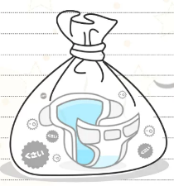
紙おむつをお使いの方へ、ごみ袋の支給制度がありがます
[Waste bag distribution system for disposable diapers]

The Minowa Town Office has restarted the system that provides "burnable trash" bags for disposing of disposable diapers used by babies and people certified as needing nursing care. Applications are being accepted, and distribution will begin on April 1. This system aims to reduce the financial burden on the lives of users of disposable diapers, provide support for child care, and improve well-being.
Who can receive it: ＊Babies (children under 3 years old) ＊those who use disposable diapers ＊other special cases
Benefit details: For each eligible person upon application, up to 60 bags of burnable waste (medium size). ※In some special cases, you may apply for an additional up to 100 diapers per year.
How to apply: Please apply at the Minowa Town Hall, Counter 11.
Please attach the following documents: ①Proof of eligibility (boshi techō, disability handbook, etc.)
②Proof of purchase of disposable diapers (receipt, etc.)

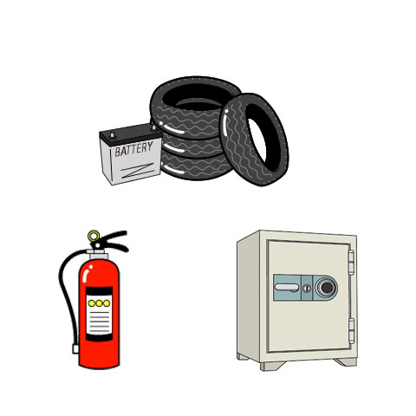
[Collection of tires, batteries]

We will collect tires and batteries that are no longer needed in your home, for a fee.
●Those who are interested must come directly to the collection site.
●Date and Time: June 7 (Sunday) 8:00 AM ～ 9:00 AM
●Collection Location: Parking lot in front of City Hall
Battery (ref. each)
Types | Amount (yen)
Automobiles | 100

Tires (reference per tire)
Types | Value (yen)
Standard car tires or standard motorcycle tires (including wheels) | 400
Width (245 or more / 15 inches / 2 t) | 800
4 t | 1200
  Types | Value (yen)
  Wheel cover | 100
  Wheelbarrow | 100
Large car tires | 1600

Minowa Town Hall
Department of Security and Life Protection,
Environment/Transport Section (Counter 11)
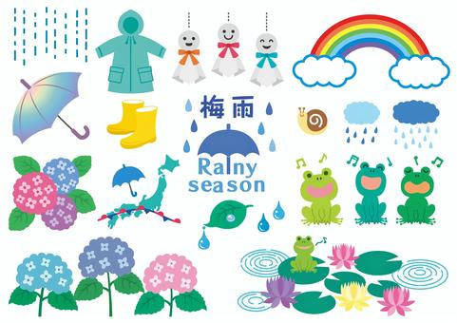
Tsuyu – Rainy Season ☂
梅雨 (Tsuyu)
As June begins, Japan goes through a very rainy and cloudy period called tsuyu. It is a season when it rains a lot. However, the image one has is not of torrential rains, but of a long period with gentle rain and gray days. In other words, there are days and days without the presence of the sun. The beginning of this period is called tsuyu iri, or it is said that one “tsuyu ni hairu” (enters the rainy season). And its end is called tsuyu ake, or it is said that “tsuyu ga akeru” (the rainy season ends). And then comes the arrival of the warm summer season. ^^ During the rainy season in Japan, ajisai (hydrangeas) bloom, a flower not as famous as sakura, but still among the favorites of the Japanese. In addition, it is also the season for ume plums. Also known as Chinese plum or Japanese apricot. During this rainy season, be alert for possible landslides, etc.; in that case: ・Go to a safe place ・Go to an evacuation site

[Disaster prevention warning and alert levels]
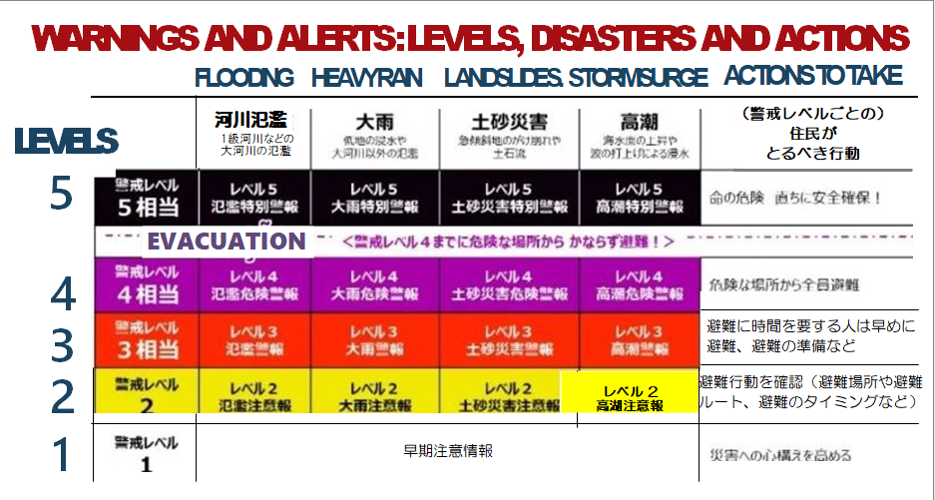
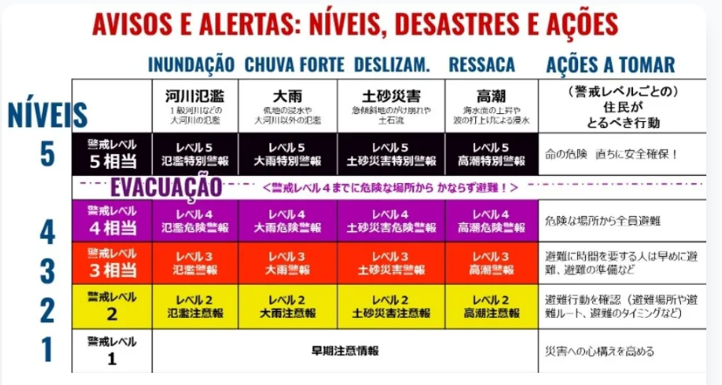
- Level 1: Early Warning Information (早期注意情報, pronounced souki chuui jouhou). At this level, people should keep in mind the importance of disaster prevention.
- Level 2 (yellow): Advisory (注意報, pronounced chuui hou). At this level, people should check the hazard map and confirm evacuation routes.
- Level 3 (red): Warning (警報, pronounced keihou). At this level, children, the elderly, bedridden people, and people with disabilities should prepare to move to a shelter. In other words, be prepared for evacuation.
- Level 4 (purple): Danger Alert (危険警報, read kiken keihou). Important: at this level, people in the alerted area must leave the danger zone and seek shelter immediately.
- Level 5 (black): Special Danger Alert (特別警報, read tokubetsu keihou). At this level, people's lives are at risk. To preserve life, it is necessary to act quickly.
