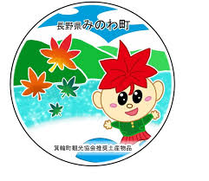
箕輪町英語ニュースレター 令和８年５月
Newsletter May 2026
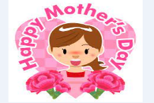
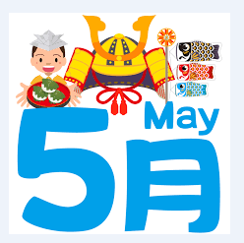
Minowa Town Hall 箕輪町役場
The Newsletter is published monthly by Minowa Town Hall.
〒399-4695 Nagano-ken. Kamiina District. Minowa Town. Oaza Naka Minowa, 10298.
399-4695 長野県上伊那郡箕輪町大字中箕輪10298
TEL:0265-79-3111 / 0265-79-3154
まちで にほんごの きょうしつ あります。There is a Japanese class in town.
◇TeL：070-5077-2420
◇Mail : m.tabunka@gmail. com
◇LINE：https://line. me/ti/p/rhMKeSYmL2
◇WHATSAPP：https://wa. me/qr/5JEBYX7J2XH5H1
◇MESSENGER:https://m. me/61574885471583?source=qr_link_share
※さいしょに れんらく してください！ ！

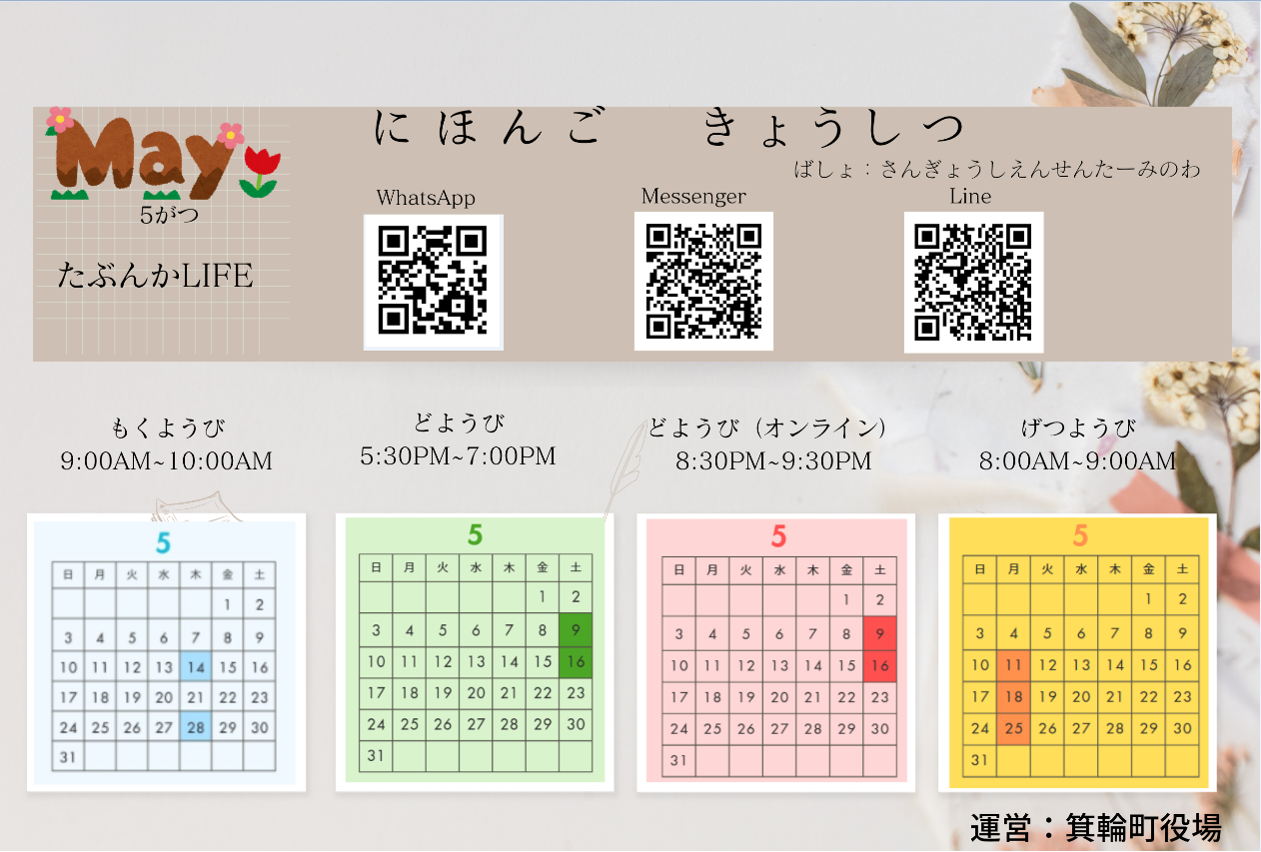
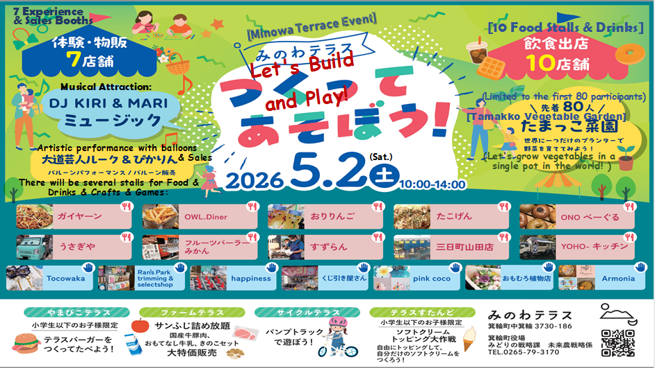

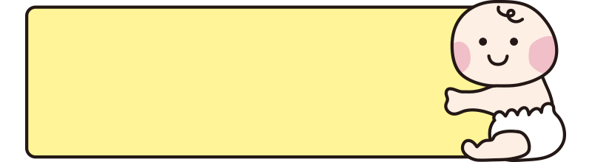
乳幼児おむつ用品購入券
交付事業のお知らせ
Notice: "Coupon Grant Program
for the purchase of diapers & baby products"

The Minowa City Hall provides a system/benefit to ease the financial burden on families raising children; vouchers will be issued for the purchase of childcare products such as diapers, wet wipes, etc. From this fiscal year 2026, dairy products will be added to the list of eligible items for purchase under this voucher program, further expanding support for child-rearing.
1 Who is eligible:
Parents or guardians who reside in Minowa City and are raising children who are 0 years old or who will turn 1 year old in Reiwa 8 (2026).
2 Details about the coupon:
Amount/quantity: 30,000 yen (1,000 yen x 30 coupons) per beneficiary child
・Usage period: until the end of the year following the date of issuance
・Reissue: We will not reissue in case of loss or other inconveniences, so
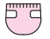
keep them carefully.
3 Childcare products/Dairy products:
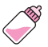
・disposable diaper ・cloth diaper ・diaper liner ・diaper cover ・wet wipes
・powdered milk ・liquid milk ・baby bottle ・bottle nipple
4 How and Period of application:
Application period: from the child's birth month or first birthday until the end of the following 6 months.
Parents or guardians of the child must fill out the registration form and make the request at the Counter of the Children's Future Department (Counter 5). The purchase coupon will be handed over at the counter after the form is confirmed.
The registration form is provided on the following occasions:
・For 0-year-old infants: the registration form is provided at the Counter of the Children's Future Department when registering the birth.
・For 1-year-old children: the registration form is sent together with the notice of the 1-year health check.
＊For more details or questions, call or come directly to City Hall, Counter 5 or Counter 11 (interpreting service).

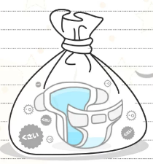

紙おむつをお使いの方へ、ごみ袋の支給制度がありがます
[Garbage bag supply system for disposable diapers]

The Minowa City Hall has restarted the system that provides “burnable garbage bags” for the disposal of disposable diapers for babies and persons certified as requiring nursing care. Applications are being accepted and distribution will begin on April 1. This system aims to reduce the financial burdens of living for users of disposable diapers, provide support for childcare, and improve wellbeing.
Who can receive: *Babies (children under 3 years old) *those who use disposable diapers *other special cases
Benefit details: For each eligible person upon request, up to 60 burnable garbage bags (medium size). ※In some special cases, an additional up to 100 diapers per year may be requested.
Application method: Please apply at Minowa City Hall, Counter 11.
Attach the following documents: ①Proof of eligibility (boshitechô, disability handbook, etc.)
②Proof of purchase of disposable diapers (receipt, etc.)
※The document is not necessary for infants.

Department of Safety and Life Protection, Environment/Transportation Section (Counter 11)
※The City Hall has been sending “garbage tickets” to households around mid-March.
If you have not yet received these tickets, please contact us.
Have you already received the 2026 "Household selective waste collection calendar"? ?
If not yet, it can be obtained at City Hall, Counter 11.

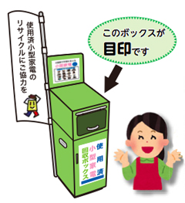
[Collection of Batteries and Small Appliances]
This is
the box
Free collection in the City Hall Lobby

- Remove batteries from electronics.
- Small appliances are collected in the "Collection Box" installed in the City Hall lobby. (Small appliances must be no larger than 30 cm x 10 cm).
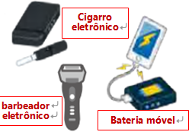
When to dispose of rechargeable electronic devices. . .
Always be sure to remove removable batteries and cells.
If you cannot remove the removable batteries and cells from an electronic device, use the recycling boxes available at City Hall.
If you have difficulty disposing of electronic devices, contact us below for guidance.

Electronic
cigarette

Electric
shaver
Mobile battery

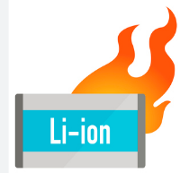
About Safety:

[ A fire can start in a lithium-ion battery ]
Rechargeable electronic devices that contain lithium-ion batteries or built-in lithium-ion batteries pose explosion and fire risks, so they should never be placed in "non-burnable waste", "burnable waste" or "recyclable plastic" garbage bags.
Some examples of electronics that contain lithium-ion batteries:
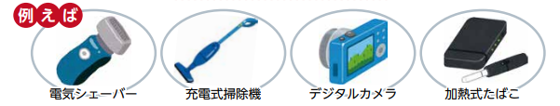

Electric shaver rechargeable vacuum cleaner digital camera electronic cigarette

Why products that use mercury should not be placed
in designated garbage bags (burnable trash, plastic, etc.)?

At waste collection facilities, such as "Clean Center Yaotome," there have been fire accidents believed to have been caused by lithium-ion batteries mixed with combustible materials. Lithium-ion batteries have the property of igniting when subjected to external impacts. For these main reasons, please do not put them in the designated garbage bags (burnable waste, non-burnable, recyclable plastics). Be sure to remove batteries (lithium-ion batteries, batteries, etc.) from appliances. When mercury is released into nature, it causes harm such as environmental pollution and health damage. Furthermore, if mercury is emitted at a concentration exceeding the legal standard value, it will be necessary to shut down the waste treatment plant for a long period, and it will not be possible to process all the waste generated in households.
Please place lithium-ion batteries in the municipality's "battery recycling box".
If electronic devices cannot be separated from their lithium-ion batteries, place them in the municipality's "small electronic devices recycling box" (up to 10 cm x 30 cm).
Items larger than 10 cm x 30 cm can be consulted with the Municipality for possible disposal.
Department of Safety and Life Protection, Environment/Transportation Section (Counter 11)

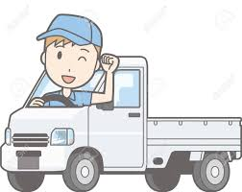
ATTENTION! ! !
Light Vehicle Tax (Kei Jidousha)

Minowa Town Hall will send in May a hagaki (card/bill) for payment of the "light vehicle tax" for light vehicles (kei jidousha) to people who own light vehicles and who are registered as of April 1, 2026.
The proof of payment of this tax will be required for the shaken (annual vehicle inspection); therefore, please make the payment and keep the receipt carefully in a safe place.
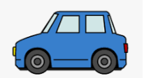
Automobile Ownership Tax (Jidousha zei)

The automobile ownership tax (does not include light vehicles or motorcycles, etc.), is a prefectural tax and applies to everyone who owns automobiles as of April 1 of each year.
Upon receiving the tax collection notice issued by the provincial tax offices, please make the payment at banks or convenience stores by the end of May.

⚠[News about the “Payment Methods” for vehicle tax]⚠

The payment deadline for the Vehicle Tax Reduction Type for fiscal year 2026 is June 1 (Monday).
When you receive the tax notice, please make the payment by the specified deadline.
In addition to convenience stores and tax offices, payments can be made at banks, financial institutions, and post offices nationwide.
New: The tax payment notice contains a QR code that allows easy payment through mobile payment apps such as PayPay, Rakuten Pay（楽天Pay）, auPay, and d-Barai (d払い).
In addition, it is possible to make the payment using the QR code by accessing the municipal tax payment website via smartphone or computer, using a credit card, internet banking, among other options.
With this payment method, it is not necessary to go to a physical store or banking institution and there is no waiting time. How about trying to use them?
＊＊ Certain conditions and procedures are required for payment.
In addition, depending on the chosen payment method, it may not be possible to issue a receipt or tax payment certificate. Please be aware of this in advance.

Nagano-ken Nanshin Kenzei Jimusho
[Nagano Prefecture Vehicle Tax Office in Ina]
Tel.: 0265-76-6805
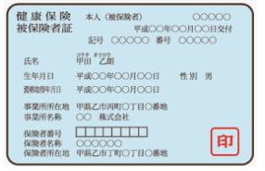
National Health Insurance (Kokumin Kenkō Hoken)

People up to 74 years old who are registered residents and do not have health insurance through their workplace or other public insurance must enroll in the National Health Insurance. Please complete the enrollment procedures at the city hall corresponding to your residence within 14 days.
Applies in any of the following situations:
- People who have a registered residence
- When moving to another municipality
- When leaving the health insurance (shakai hoken) provided by your workplace
- When the child is born (the child's portion)
In addition, people who are not subject to residence registration or who have less than 3 months of stay qualification, when their expected period of stay exceeds 3 months, will have the possibility to enroll in the national health insurance. So be careful. For more information, consult the city hall. ※[The payment postcard for fiscal year 2026 will be sent in May]

