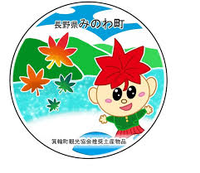
箕輪町英語ニュースレター 令和８年４月
Newsletter April 2026
Minowa Town Hall 箕輪町役場
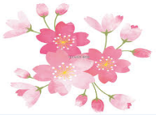
The Newsletter is published monthly by Minowa Town Hall.
399-4695 Nagano Prefecture. Kamiina District. Minowa Town. Oaza Naka Minowa, 10298.
399-4695 長野県上伊那郡箕輪町大字中箕輪10298
TEL: 0265-79-3111 Extension: 1371/1721
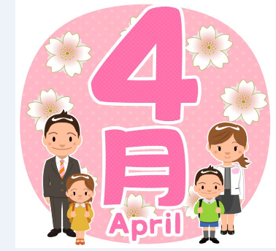
[Notice to foreign residents in Minowa]

ATTENTION! We updated the apps and the QR Code has changed! !
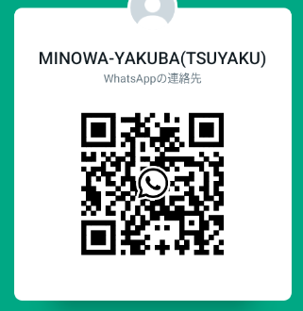
Minowa Town Hall provides means of communication through:
●Line


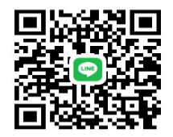
●Ｗhats
App

●Messenger
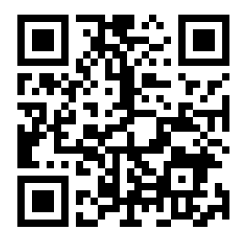
(Minowa-Yakuba)


We send updated news/information from the
Minowa Town Hall via Facebook to foreigners.
Please check via [Minowa News] on Facebook.

Applications open! !
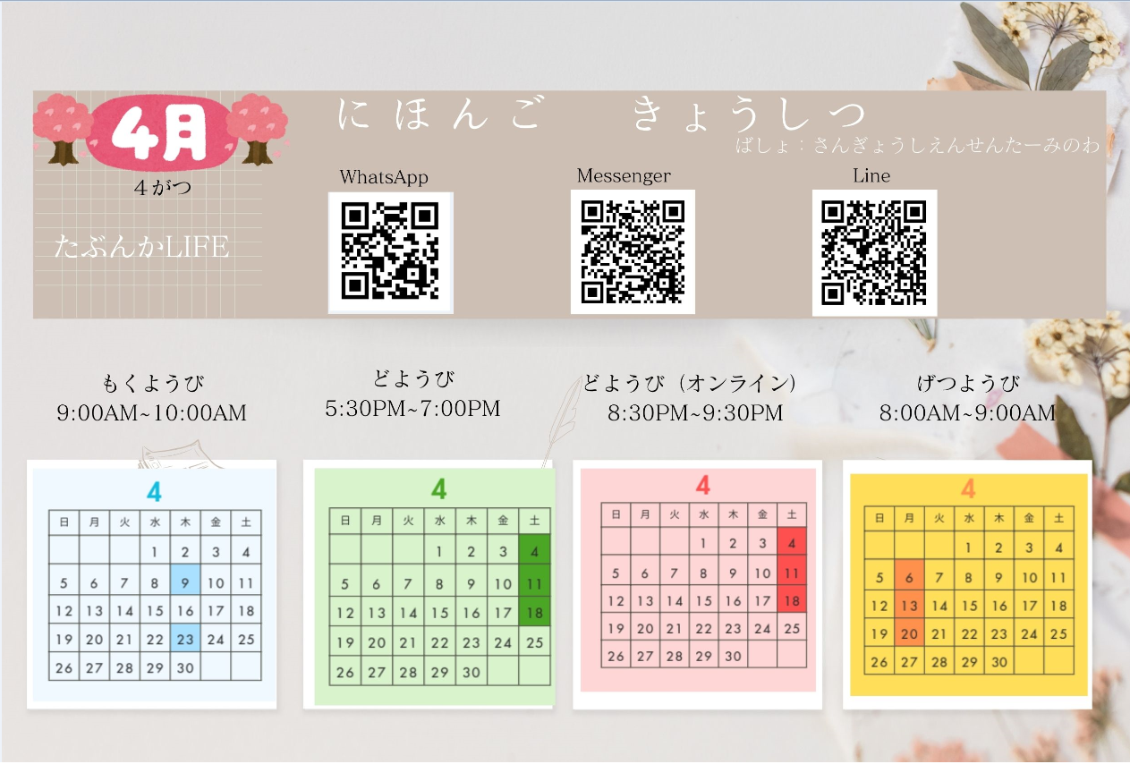
[まちで にほんごの きょうしつ あります] [There is a Japanese class in town]
◇TeL：070-5077-2420
◇Mail :m.tabunka@gmail. com
◇LINE：https://line. me/ti/p/rhMKeSYmL2
◇WHATSAPP：https://wa. me/qr/5JEBYX7J2XH5H1
◇MESSENGER:https://m. me/61574885471583?source=qr_link_share
※さいしょに かならず れんらく してください！！※First, be sure to contact! us! !
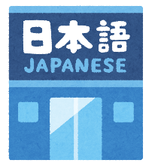

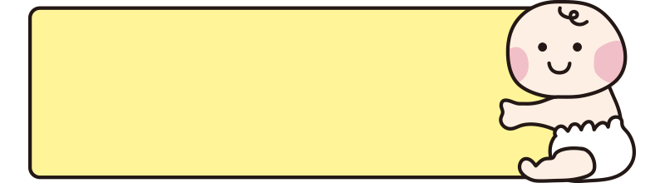
「乳幼児おむつ用品購入券」
対象用品が拡大します！
Eligible products have been expanded to
"Diaper & baby products purchase voucher"
The Minowa City Hall offers a system/benefit to ease the financial burden on families raising children; vouchers will be issued for the purchase of childcare products such as diapers, wet wipes, etc. Starting in this fiscal year 2026, dairy products will be added to the list of items eligible for purchase under this voucher program, further expanding support for child-rearing.
1 Who can receive:
Parents or guardians who reside in Minowa city and are raising children who are 0 years old or who will turn 1 year old in Reiwa year 8 (2026).
2 Details about the coupon:
・Amount/quantity: 30,000 yen (1,000 yen x 30 coupons) per beneficiary child
・Usage period: until the end of the year following the date of grant
Reissue: We will not reissue in case of loss or other inconveniences, so,Keep them carefully.
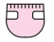

3 Childcare products/Dairy products:
・Disposable diaper ・Cloth diaper ・Diaper liner ・Diaper cover
・Wet wipes ・Powdered milk ・Liquid milk ・Baby bottle ・Bottle nipple
4 How and Period of application:
Application period: from the child's birth month or first birthday until the end of the following 6 months.
The child's parents or guardians must fill out the application form and submit the request at the Child Future Department counter (Counter 5). The purchase coupon will be delivered at the counter after the form is confirmed.
The registration form is provided on the following occasions:
・For infants aged 0: the registration form is provided at the Child Future Department counter when registering the birth.
・For children aged 1: the registration form is sent together with the 1-year health check notice.
＊For more details or questions, call or come directly to City Hall, counter 5 or counter 11 (interpretation service).

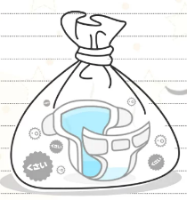
紙おむつをお使いの方へ、ごみ袋の支給制度がありがます
[Disposable diaper garbage bag supply system]

The Minowa City Hall has restarted the system that provides "burnable garbage bags" for the disposal of disposable diapers for babies and people certified as needing nursing care. Applications are being accepted and distribution starts on April 1. This system aims to reduce the financial burdens of disposable diaper users, provide support for child care, and improve well-being.
Who can receive: *Babies (children under 3 years old) *those who use disposable diapers *other special cases
Benefit contents: For each eligible person upon request, up to 60 burnable garbage bags (medium size).
※In some special cases, it may be possible to request an additional up to 100 diapers per year.
Application method: Please apply at Minowa City Hall, Counter 11.
Attach the following documents: ①Proof of eligibility (boshitechô, disability booklet, etc.)
➁Proof of purchase of disposable diapers (receipt, etc.)
※This document is not necessary for infants.
Department of Safety and Life Protection, Environment/Transportation Section (Counter 11)
※The City Hall has mailed "garbage tickets" to households in mid-March.
If you have not yet received these tickets, please contact us.
※Have you already received the "2026 Household Separated Waste Collection Calendar"? ?
If you don't have it yet, it can be obtained at City Hall, Counter 11.



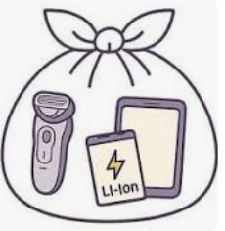
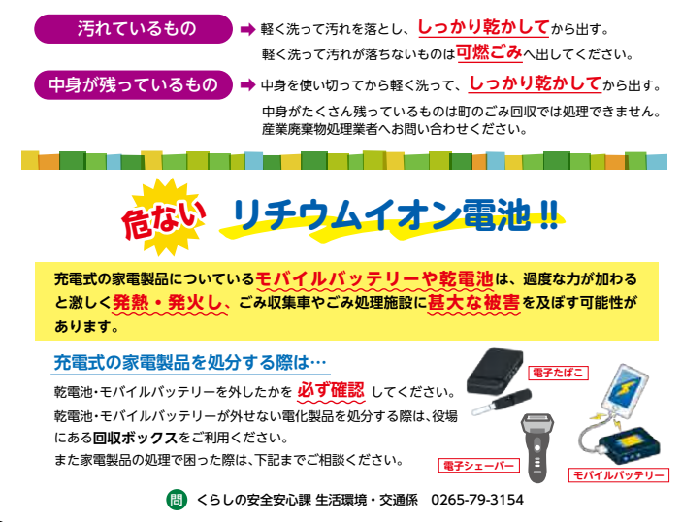
will also be collected as recyclables!
Plastic products
Items that will start to be collected as plastic products.
Plastic packaging
The items that were collected as
recyclable plastic until now.
Due to the implementation of the [Law for the Promotion of Plastic Resource Recycling], we will collect [plastic containers/packaging] and [plastic products] as recyclables.
Items that will start to be collected
as recyclable plastics.
Plastic products
Plastic packaging

The items that were collected as recyclable plastic until now.
Due to the application of the [Law for the Promotion of Plastic Resource Recycling], we will collect [plastic containers and packaging] and [plastic products]
as recyclables.
will also be collected as recyclables!
Plastic containers and plastic packaging
From April of Reiwa year 7 (2025)
Electronic cigarette
Razor
Electronic
Danger!
Lithium-ion battery !!
Rechargeable batteries or cells in appliances can overheat and ignite violently if subjected to excessive pressure, causing significant damage to garbage collection trucks and waste treatment facilities.

Mobile battery
When disposing of rechargeable electronic devices. . .
Always be sure to remove removable batteries and cells.
If you cannot remove the removable batteries and cells from an electronic device, use the recycling boxes available at city hall.
If you have difficulty disposing of electronic devices, contact us below for guidance.

[From April 2026, we will begin selective collection of small rechargeable devices
that use lithium-ion batteries (collection at waste collection points)]
Items subject to collection: Small rechargeable appliances: mobile battery, electronic cigarette, smartphone/
mobile phone, electric shaver, wireless earphones, portable fan, electric toothbrush, portable game controller, smartwatch, tablet/PC terminal, battery for cordless vacuum and power tool.
※Collection date: On recyclable collection days (bottles, cans, plastic containers, cooking oil, etc.)
※How to play: *Use the battery until it runs out.
*Place the item in a clear plastic bag (45cm x 30cm), tie the top.
⚠Caution! Do not put swollen, deformed batteries or batteries that show signs of combustion.
For disposal instructions, contact the City Hall/Safety and Protection Division, counter 11.
Life Safety and Protection Division/Environmental Sector/Transportation - Minowa City Hall Tel. :0265-79-3154

ATTENTION ! ! !
Light Vehicle Tax (Kei Jidousha)
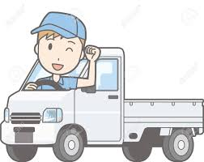
The light vehicle tax will be levied on those who own cars, motorcycles, etc. on April 1, 2026. Minowa City Hall will send in May a hagaki (postcard/bill) for payment of the "light vehicle tax" for light vehicles (kei jidousha) to people who own light vehicles and who are registered as of April 1, 2026.
The proof of payment of this tax will be required for the shaken (annual vehicle inspection), so please make the payment and keep the receipt carefully in a safe place.
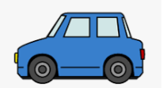
※Please be aware that there is no monthly payment (installment) system for the light vehicle tax, so if you sell your vehicle there will be no refund.

Tax on automobile ownership (Jidousha zei)

The tax on automobile ownership (does not include light motor vehicles or motorcycles, etc.) is a prefectural tax and applies to everyone who owns automobiles on April 1 of each year.
Upon receipt of the tax collection notice issued by the prefectural tax offices, please make the payment at banks or convenience stores by the end of May.
Let's liven up with the music
of the DJ!

Minowa Terrace
will give
alstroemerias

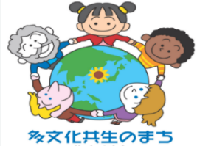
Do you know the situation of foreign residents in Minowa?
Curiosities:
Why not think about the foreign residents who live in your neighborhood?
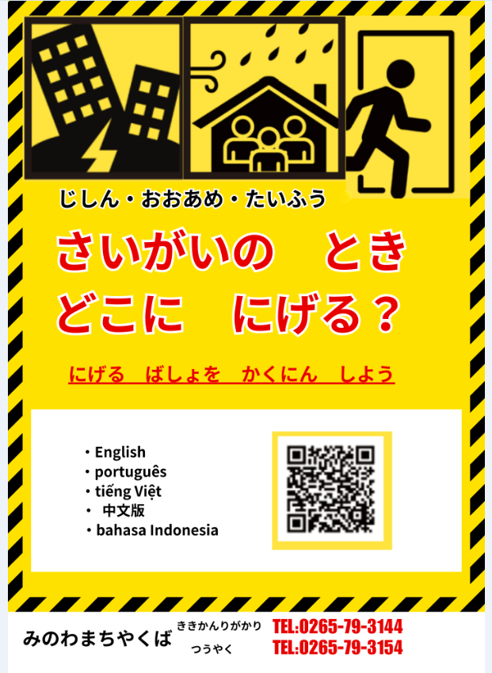
We have been sharing information about the city's multicultural coexistence projects, such as Japanese language classes, support for foreigners evacuated in case of disaster, and expanding that support to include Japanese people who wish to become volunteers. The number of foreign residents living in the city of Minowa continues to grow, and there is also an increasing number of families coming to the city.
In the city of Minowa there are 858 foreign residents, which represents 3.6% of the city’s total population. More than 60% of them are permanent residents or long-term residents who plan to live in the city of Minowa for an indefinite period.
The city of Minowa aims to be a place where foreign and Japanese residents help and support each other, and this year will formulate a
"Urban Development Promotion Plan for Multicultural Coexistence." We will share information about multicultural coexistence and the content of meetings related to the plan’s formulation so that we can develop it together with the city’s residents. Currently, important information that Japanese people should naturally know is not reaching them due to language barriers. In emergencies, it is essential to help one another regardless of nationality. You might find yourself thinking, "I'm glad I knew that person at that time." Why not start a conversation using risk maps as a starting point!
The city of Minowa makes risk maps available on its homepage in several languages to cover 90% of its foreign residents.

