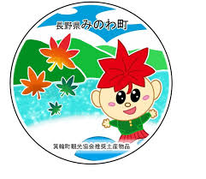
箕輪町英語ニュースレター 令和8年3月
Newsletter March 2026
Minowa Town Hall 箕輪町役場
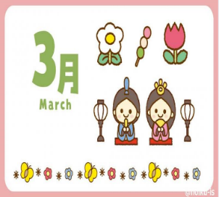
The Newsletter is published monthly by Minowa Town Hall.
〒399-4695, Nagano Prefecture. Kamiina District. Minowa Town. Oaza Naka Minowa, 10298.
399-4695 長野県上伊那郡箕輪町大字中箕輪10298
TEL: 0265-79-3111
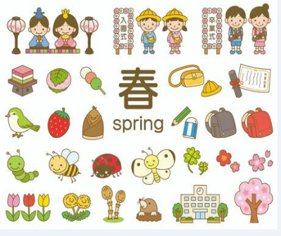
[Notice to foreign residents in Minowa]

ATTENTION! We updated the apps and the QR Code has changed! !
Minowa Town Hall provides communication channels through:
●Messenger
●Line

●Ｗhats
App

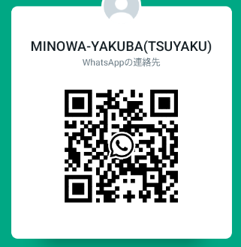
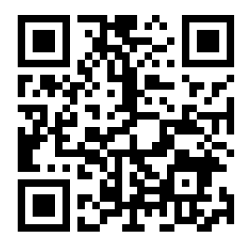

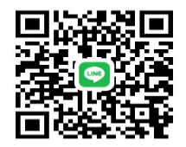
(Minowa-Yakuba)



News/Information/Important Notices
from the city on FACEBOOK [Minowa News]

We send updated news/information from the Minowa City Hall
to foreigners via Facebook.
Please confirm via [ Minowa News ] on Facebook.

"Let's join the Traffic Disaster Insurance and Mutual Aid"
(Only ¥200 per year) 南信交通災害共済
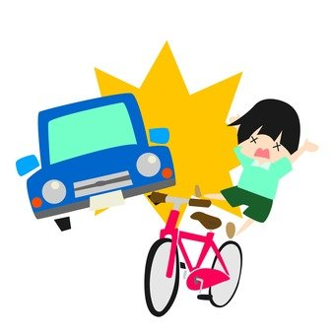

To the residents of Minowa,
Traffic accidents happen somewhere every day. . . You never know when such a disaster will strike you or your family. The purpose of this mutual aid system is to help people and municipalities come together in the event of a traffic accident, such as a car crash. For the peace of mind of your family, we recommend that all family members register. (This insurance is common to all people who live in the Nanshim/Nagano area, but the enrollment period and the amounts may vary depending on the municipality where you live). At the beginning of March, the Minowa City Hall will send a greenish envelope to all households, labeled "Let's enroll in Traffic Disaster Insurance and Mutual Aid." If you are injured in a car or bicycle traffic accident on any road within Japan, this insurance covers about ¥2,000 per day of hospitalization for injuries and ¥500 up to ¥200,000 for outpatient treatment for injuries when you are injured in a traffic accident; for compensation for sequelae the amount is ¥300,000 and ¥2,000,000 in case of death.
The amount to be paid for this insurance is only (¥200 per year) / person.
(In the case of small children, junior high school (chugakko) students and also high school (koukou) students, the city will bear the cost).
※Next to the child/student’s name, it is written: (amount borne by the city / 町負担).
It is a very cheap insurance and the registration procedure is easy, please consider it and sign up!
Inside the envelope is the "registration form" with the names of all your family members; write a circle (O) next to the name of the person you wish to register, the number of people, and the total amount for those who will be registering.
However, if you do not wish to register, you do not need to pay any amount and you do not need to return the form to the city hall.
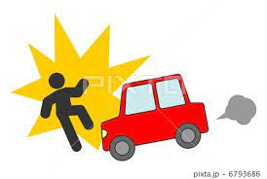
- If you are interested in registering, note the number of people and the total amount to pay, and take it to any bank in the city (Hachijuuni Bank, Alps Shinkin, Nagano Bank, Kamiina Agricultural Cooperative, etc.) and/or to Counter ⑯ at Minowa Town Hall. (Cannot be paid at Post Office branches). You must pay directly at the bank counter (from 9:00 to 15:00), not at an ATM! (At the town hall, from 8:30 to 17:00).
Registration period: March 2 ～ March 31 (After the deadline, only at the town hall).
Insurance validity: April 1, 2026 ～ March 31, 2027 (1 year).
※If you have any questions, call or visit the town hall.
You can also send messages via Messenger, WhatsApp, or LINE.

まちで にほんごの きょうしつ あります。There is a Japanese class in town.
◇Phone: 070-5077-2420
◇Email: m.tabunka@gmail. com
◇LINE: https://line. me/ti/p/rhMKeSYmL2
◇WHATSAPP: https://wa. me/qr/5JEBYX7J2XH5H1
◇MESSENGER:https://m. me/61574885471583?source=qr_link_share
※さいしょに かならず れんらく してください！

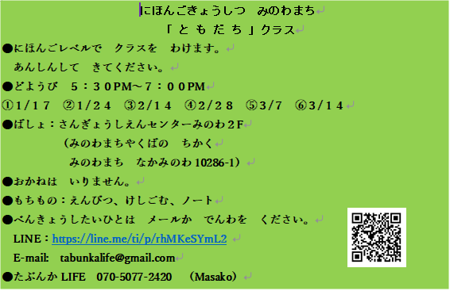

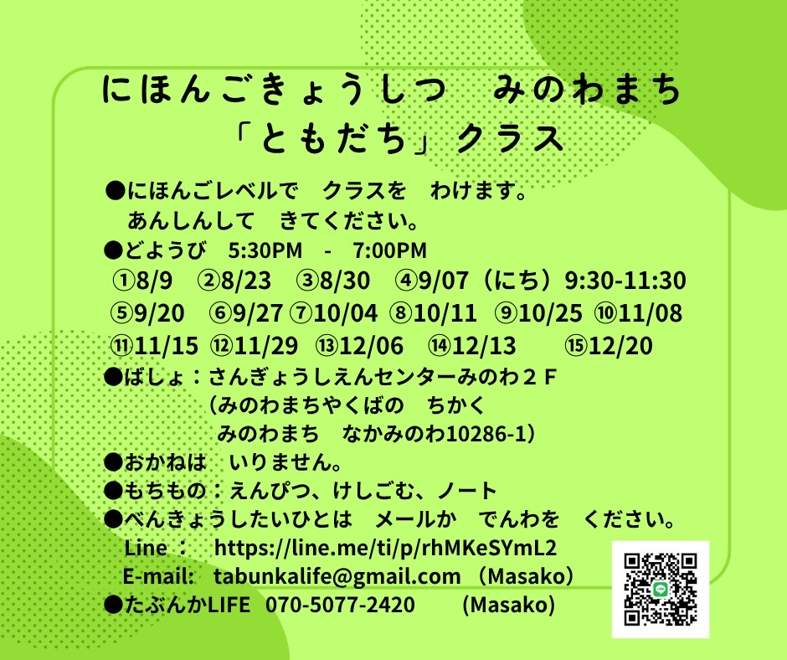

Japanese class on Saturdays
"Friends" class
Students will be divided into groups according to their level of Japanese.
Come peacefully.
Saturdays from 5:30 PM to 7:00 PM.
＊Local: Sangyo Shien Center-2ºandar
(almost in front of City Hall)
Fee: FREE
What to bring: pencil, eraser, notebook.
Dates: March days: 7, 14

Anyone who wants to participate, send an email or call: Tabunka Life: 070-5077-2420 (Massako)

[Please reconfirm the rules for placing
your trash out at the collection point]

The local "Residents' Association" is responsible for the operation of the waste collection station. If you are not a member of a local community association and wish to use a waste collection station, please make sure to follow the garbage disposal rules.

1 How to dispose of recyclable plastic waste
Please make sure that all resource plastics are marked with this symbol ➡ If they are dirty, please wash them.
If it is not clean and you cannot clean it, please dispose of it in combustible trash.
Attention! Please use the days dedicated to collecting glass bottles, cans and plastic bottles,
or put them in the collection boxes at supermarkets.

2 Separate the trash correctly
Trash that is not separated correctly will not be collected.
Trash that has not been separated correctly will not be collected.
If your trash bags are not picked up by garbage collectors, please take them home, check them again, and put them out yourself. If you have any questions, please ask at the city hall and we will tell you the correct way to separate your trash.

3 Please dispose of your trash using the garbage bags specified by the city hall.

Please write your name, the name of the building and the apartment number where you reside.

Use of the garbage collection points:
Please use the designated garbage stations in your area.
There are different types of garbage to sort for each kind of waste.
If you are not sure, contact the city hall.

Please put your garbage out at the collection point before 8:00 on the day of collection.
This excludes collection days for recyclables such as cans, bottles and plastic bottles.

Minowa Town Hall—Department of Environment and Hygiene (Seikatsu Kankyou-ka)
TEL: 0265-79-3154
※The City Hall will send "garbage tickets" to residences around mid-March.
If you do not receive these tickets, please contact us.
※Have you already received the "2026 Household Selective Waste Collection Calendar"? ?
If not yet, it can be obtained at City Hall, Counter 11 (Seikatsu Kankyou Gakari).


Attention! ! The recyclable waste collection center (Clean Center Yaotome) and the
'Midori no Shiguen' Recycling Station in Minowa is open again!
Please check the opening hours and follow the rules for disposing of waste.

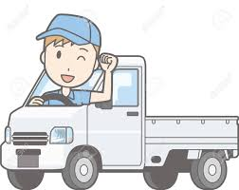
Notice about [Tax Procedures for Light Vehicles (Kei jidousha)]

The light vehicle tax will be charged to those who own vehicles, motorcycles, etc., as of April 1, 2026.
If you have disposed of your car, changed ownership, changed address, etc., please complete the procedures by April 1. Depending on the details, the procedures center may take some time to process the data and the required documents may be different, so please check in advance.
※Be careful, because there is no monthly payment (installment) system for light vehicle tax; therefore, if you sell your vehicle, there will be no refund.

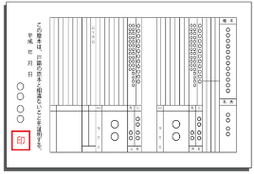
Notice regarding [Issuance of Family Register (Koseki Tohon)]

Since March 1, 2024, you can request a family register certificate (koseki tohon) or a certificate of register cancellation at the municipal counter, even if it is a different municipality than the one where you are registered.
Even if the registered address is far away, you can now request it at the city hall where you live or work.
For more information, contact the Resident Affairs Section/Residents and Environment Division/Minowa Town Hall.

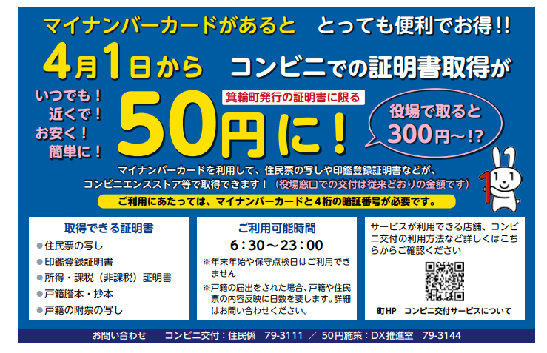
Contact: Minowa Town Hall/Resident Affairs Section 0265-79-3111
At the Town Hall it costs:

To obtain a certificate/document at
a "Kombini", it costs only. . .

HP of Minowa / Convenience stores

Check here for details of which locations and convenience stores the service can be used at.

●Not available during year-end/New Year holidays.
●If you send a family registration notification, it will take days for the details to be reflected in the family register. (Contact us for more details)

Certificates obtained:
●Copy of resident registration
●Copy of seal registration
●Income/tax certificate (tax exemption)
●Copy of family register
(koseki tohon)

To use the service, you will need your card and a 4-digit PIN.
You can use your My Number card to obtain copies of resident records,
seal registration, etc.

Limited to documents issued by the city of Minowa
Any time!
Near you!
Cheap!
Simple!

It's very convenient and advantageous if you have a "My Number Card"! !
Opening hours:

