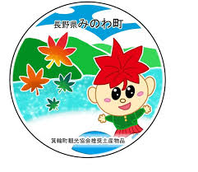
箕輪町英語ニュースレター 令和８年2月
Newsletter February 2026

Minowa Town Hall 箕輪町役場
The newsletter is published monthly by the Minowa Town Hall.
399-4695, Nagano Prefecture. Kamiina District. Minowa Town. Oaza Naka Minowa, 10298.
399-4695 長野県上伊那郡箕輪町大字中箕輪10298

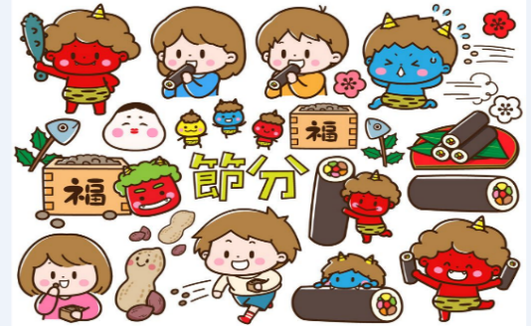
TEL:0265-79-3111 /0265-79-3154
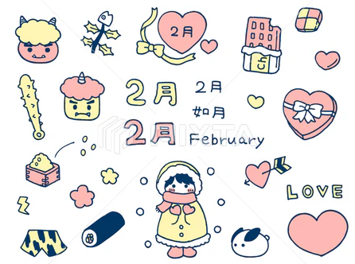
"Let's enroll in
Traffic Disaster Insurance
and Mutual Aid"
(Only ¥200 per year)
南信地域町村交通災害共済

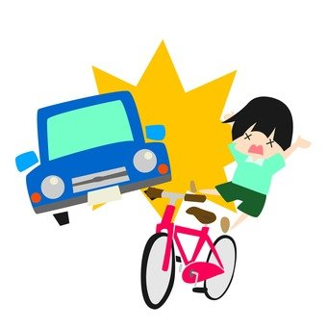
To the residents of Minowa,
Traffic accidents happen somewhere every day. . . You never know when this disaster will affect you or your family. The purpose of this mutual aid system is to help people and municipalities come together in the event of a traffic accident, such as a car accident. For your family's peace of mind, we recommend that all family members register. (This insurance is common to all people living in the Nanshim/Nagano area, but the enrollment period and amounts may vary depending on the municipality where you live). At the end of February to early March, the Minowa Prefecture will send a small greenish envelope to all families, labeled "Let's join the Traffic Disaster and Mutual Aid Insurance."
If you get injured in a car or bicycle traffic accident on any road in Japan, this insurance covers around ￥2,000 yen per day of hospitalization for injuries and ￥500 yen up to ￥200,000 yen for outpatients due to injuries when you get hurt in a traffic accident; in case of compensation for permanent disability the amount is ￥300,000 yen and
￥2 million yen in case of death.
The amount to be paid for this insurance is only (￥200 yen per year) / person.
(In case of very young children and/or those attending junior high school (chugakko), the city will cover the cost).
※Students attending high school (koukou) are also automatically included without having to pay any amount.
It is a very cheap insurance and the registration procedure is easy, please think about it and join!
Inside the envelope is the "registration form" with the names of all your family members, write a circle (O) next to the name of the person you wish to enroll, the number of people, and the total amount for those who will enroll (fill in all 3 parts equally).
※Next to the name of the child/middle school, high school, or younger students, it is written: (amount covered by the city/町負担). However, if you do not wish to register, you do not need to pay any amount and do not need to return the form to the city hall.
- If you are interested in registering, note the number of people and the total amount to pay, and take it to any bank in the city (Hachijuuni Bank, Alps Shinkin, Nagano Bank, Kamiina Agricultural Cooperative, etc.) and/or to Counter 12 at the Minowa city hall. (It cannot be paid at Post Offices). You will have to pay directly at the bank counter (from 9:00 AM to 3:00 PM), and not at the ATM! (At the city hall, from 8:30 AM to 5:00 PM).


Attention! ! The recyclable waste collection center (Clean Center Yaotome) and the
(Recycling Station "Midori no Shiguen") in Minowa will be closed
from January 30th to February 27th.
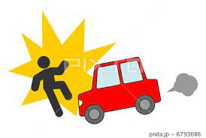
✓Registration period: March 2 ～ March 31
(After this deadline, only at the city hall)
✓Insurance validity: April 1, 2026 ～ March 30, 2027 (1 year)
※If you have any questions, call or come to the city hall in person.
You can send a message through Messenger, WhatsApp, or Line.

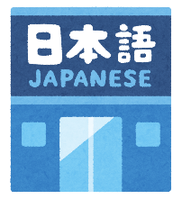
まちで にほんごの きょうしつ あります。
◇Tel: 070-5077-2420
◇Mail: m.tabunka@gmail. with
◇LINE: https://line. me/ti/p/rhMKeSYmL2
◇WHATSAPP: https://wa. me/qr/5JEBYX7J2XH5H1
◇MESSENGER: https://m. me/61574885471583?source=qr_link_share
※さいしょに かならず れんらく してください！！

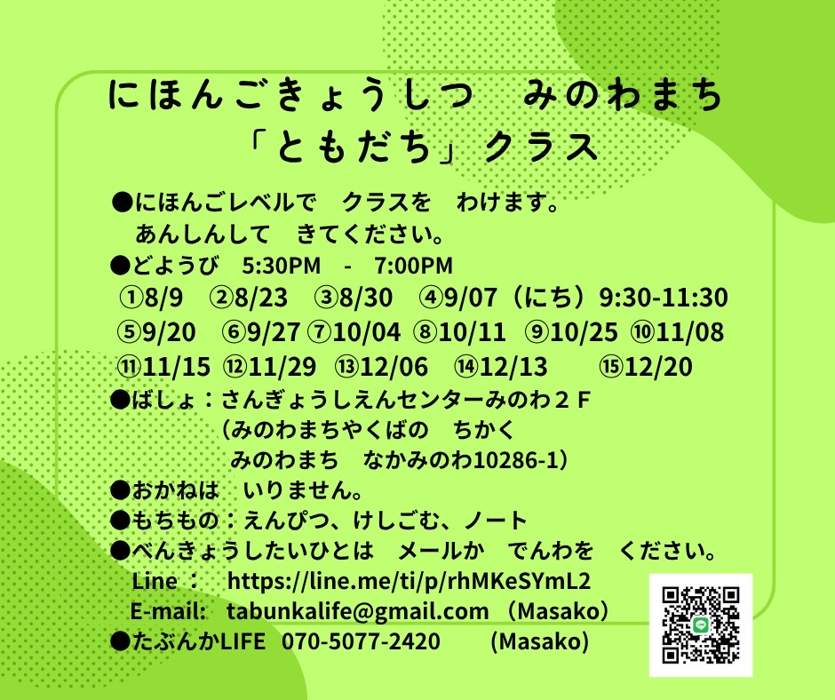
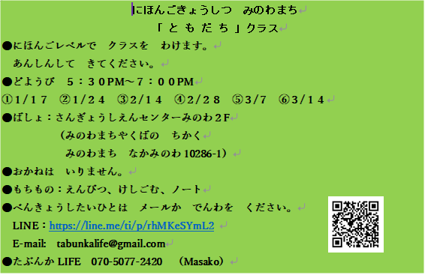

Japanese class on Saturdays
"Friends" class
Students will be divided into groups according to their Japanese proficiency level.
Come at ease.
*Saturdays from 5:30 PM to 7:00 PM.
＊Location: Sangyo Shien Center-2ºandar
(almost in front of City Hall)
*Fee: FREE
*What to bring: pencil, eraser, notebook.
*Dates: February days: 7, 14, 28

Anyone who wants to participate, send an email or call: Tabunka Life: 070-5077-2420 (Massako)

Anyone who wants to participate, send an email or call: Tabunka Life: 070-5077-2420 (Massako)

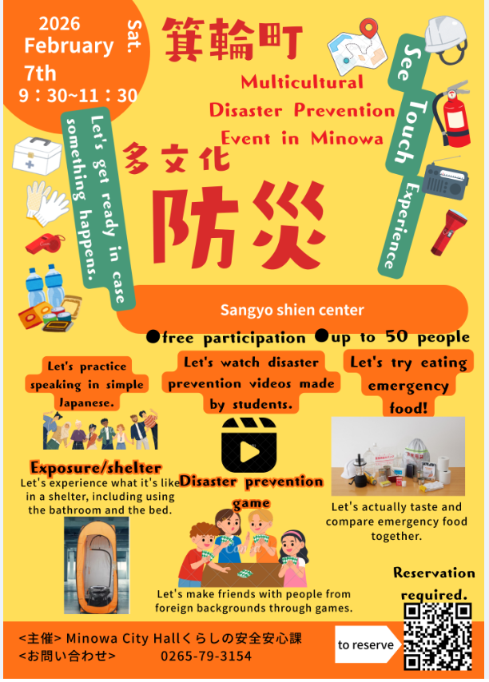
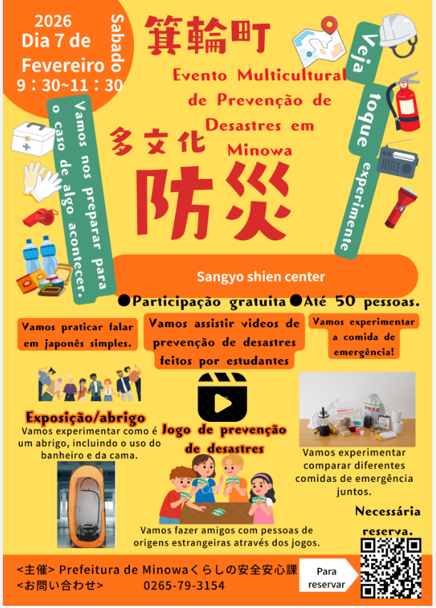
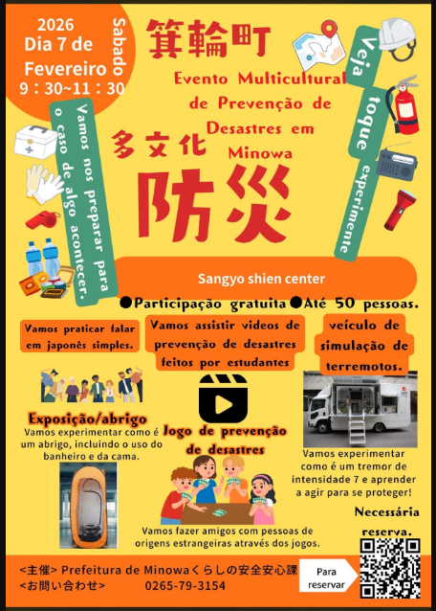


交流菜園・町民菜園（講座付き）【令和8年度利用者募集】
Minowa Community Garden
[Open registrations for Garden Users in 2026]

In the city of Minowa, we are implementing a "Community Garden System" (with lectures) [Recruiting users for the 2026 fiscal year], with lectures for beginners who want to take their first steps in gardening, aiming for others who are not farmers to enjoy "Living with Agriculture." 🍅

The first step in Gardening [Learn to grow a GARDEN with lectures]
From April to December, it is possible to learn basic notions of vegetable production such as soil preparation, planting, and crop management about once a month, mainly on Saturday mornings, with guidance from local producers. Participants use a plot of about 50m2 to grow vegetables, greens, etc., and harvest them. Seedlings, materials, fertilizers, textbooks, etc. are included in the monthly fee and do not need to be prepared. It is also possible to use the empty space to grow vegetables other than those taught. Additionally, it is necessary for the students themselves to manage and take care of the fields.
For those who want to start a "garden" as a first step to enjoy life in the countryside, and for those who have tried but couldn’t do it correctly. . .
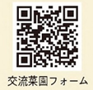
What do you think about taking this opportunity to learn the basics of growing vegetables/greens? !

- 交流菜園 [Community Garden]

- Registration period: until 2026/02/27 (Friday)
- Usage period: From April to December (Course held once a month, mainly on Saturday mornings)
- Fee: 1 plot (about 50 ㎡): ¥4,000 yen per year (including materials, course fee)
- Registration: First 15 registrations (15 lots/plots) ◎Location: Nagata Kouryuu Naen
Note: Since the number of divisions/plots is limited, registrations will be accepted in order of application.
Renewal limit: 2 years (If you still want to continue, you must rent the garden on your own)
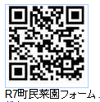
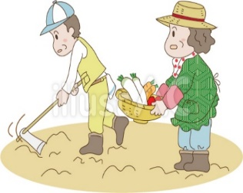
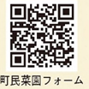

- 町民菜園 [Garden of the city/residents of Minowa]

[We are looking for users for the City Garden]:
- Application period: until 2026/02/27 (Friday)
※ Can be renewed
every year
- Usage period: From April to March 2027
- Fee: 1 block (around 100 ㎡): ¥1,600 yen per year
1 block (around 50 ㎡): ¥800 yen per year
- Locations: Neighborhoods of (Kitahara, HaraMachi Hokubu, NihonMatsu, Nagata (near Minowa Terrace)
- Registration: We accept registrations for individual participants or groups.
Write your name (representative's name), address, phone number,
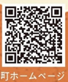
email address (if you have one) and submit it to the person in charge at the city hall.
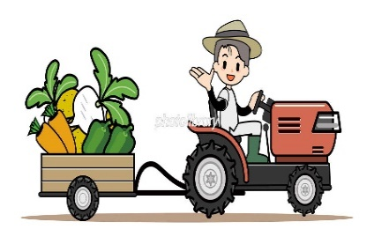
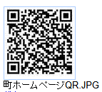
(Form available at the city hall)
※If you want to know more details about the registration method,
os terrenos (local), etc., acesse QR code ➡
(in Japanese), or contact the city hall.
For more details, send an email to: tabunka@town.minowa.lg. jp
or a message via Messenger, WhatsApp, or Line.
(write your full name, contact phone number), or
come in person to the City Hall, interpreters: Mika/Yumi.

Minowa City Hall - Green Strategy Division
Future Agricultural Strategy Department
Tel.: 0265-79-3170 (Extension 1562)

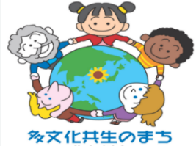
Do you know the situation of foreign residents in Minowa? Vol.5
Curiosities:
We have been sharing information about the city's multicultural coexistence projects,
such as Japanese language classes, support for foreigners evacuated in case of disaster, and expanding this support to include Japanese people who wish to volunteer.
The number of foreign residents living in the city of Minowa continues to grow, and there is also an increasing number of families coming to the city. Children who came to Japan during adolescence may understand their native language, but since they do not speak Japanese, they are not properly assessed and their future opportunities are sometimes limited. To ensure that these children receive an appropriate and fair education and can follow the path they wish, just like Japanese children, we hold lectures for educators.
From now on, the city will continue to cooperate with private organizations that regularly support foreigners and will keep working on this initiative without losing sight of its vision and purpose. To achieve this goal, the understanding and cooperation of all residents are essential. By supporting each other, we can create a more pleasant environment for both foreign and Japanese residents. Furthermore, it is crucial that the government, the local community, businesses, and residents work together as one. Let’s work together to create a city where diverse cultures and backgrounds are accepted and where everyone can live fully and be themselves!
A "Multicultural Disaster Prevention Event" is scheduled for February 7th (page 2).
We will continue planning events that involve the participation of city residents, in order to promote multicultural coexistence.
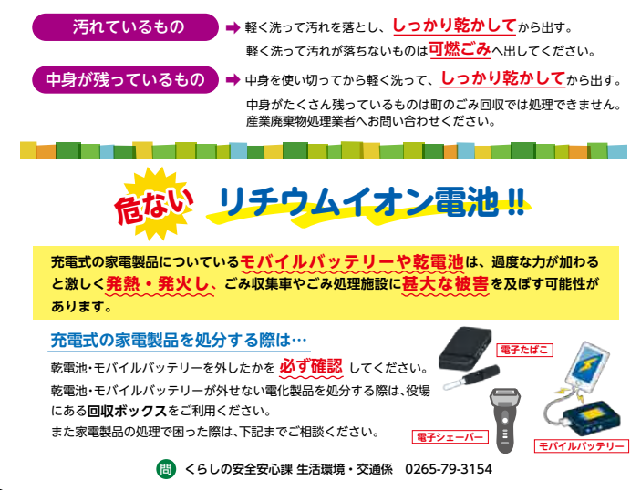
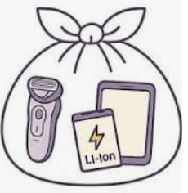
Electronic cigarette
Mobile battery
Danger!
Rechargeable batteries or cells in household appliances can overheat and ignite violently if subjected to excessive pressure, causing significant damage to garbage collection trucks and waste treatment facilities.

When disposing of rechargeable electronic devices. . .
Always make sure to remove batteries and mobile batteries.
If you cannot remove the batteries and mobile batteries from an electronic device, use the recycling boxes available at the city hall.
If you have difficulties disposing of electronic devices, contact us below for guidance.

Shaver
Electronic
Lithium-ion battery !!
"From April 2026, we will begin selective collection of small devices
rechargeable using lithium-ion batteries (collections at garbage collection points)"
Items subject to collection: Small rechargeable appliances: Mobile battery, Electronic cigarette, Smartphone/
mobile phone, Electric shaver, Wireless headphones, Portable fan, Electric toothbrush, Portable game controller, Watch (smart watch), Tablet/PC terminal, Cordless vacuum battery and power tool.
※Collection date: On recyclable collection days (bottles, cans, plastic packaging, cooking oil, etc.)
※How to dispose: *Use the battery until it runs out.
*Place the item in a transparent plastic bag (45cm x 30cm) and tie the top part.
⚠Caution! Do not place swollen, deformed batteries or batteries showing signs of combustion.
For disposal instructions, contact the City Hall/Life Safety and Protection Division, counter 11.
Life Safety and Protection Division/Environmental Sector/Transport - Minowa City Hall Tel. :0265-79-3154
Minowa City Hall
Life Safety and Protection Division/
Environmental Sector/Transport

