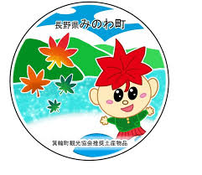
箕輪町英語ニュースレター 令和８年７月
Informative July 2026
Minowa Town Hall 箕輪町役場

The Newsletter is published monthly by the Minowa Town Hall.
399-4695 Nagano-ken.Kamiina-gun. Minowa-machi. Oaza Naka Minowa ,10298.
399-4695 長野県上伊那郡箕輪町大字中箕輪10298
TEL:0265-79-3111 / 0265-79-3154

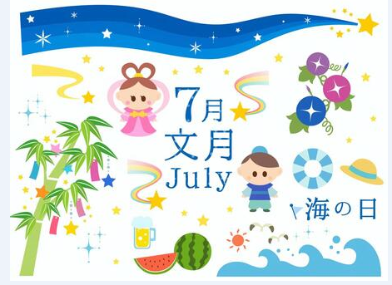
[Notice to foreign residents in Minowa]

ATTENTION! We are continuing to provide service through the apps and the QR code below! !
For those who are unaware, the Minowa Town Hall provides communication methods through:
●Line


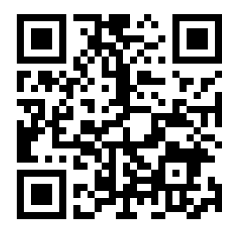

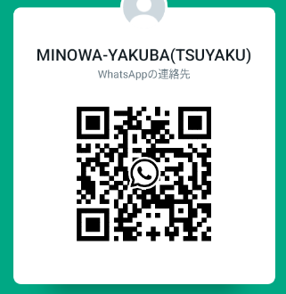
●Messenger
●Ｗhats App

●Messenger
(Minowa-Yakuba)


News/Information/Important announcements from the city on FACEBOOK

We send updated news/information from the Minowa Town Hall through Facebook
to foreigners. Please check [Minowa News] on Facebook.
Note. : We also have an email address for foreign residents: tabunka@town.minowa.lg. jp

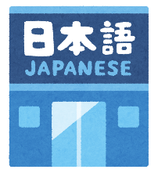
まちで にほんごの きょうしつ あります。 [Japanese language class]
◇Tel: 070-5077-2420
◇Mail: m.tabunka@gmail. com
◇LINE: https://line. me/ti/p/rhMKeSYmL2
◇WHATSAPP：https://wa. me/qr/5JEBYX7J2XH5H1
◇MESSENGERhttps://m. me/61574885471583?source=qr_link_share
※さいしょに かならず れんらく してください！Please be sure to contact us first!
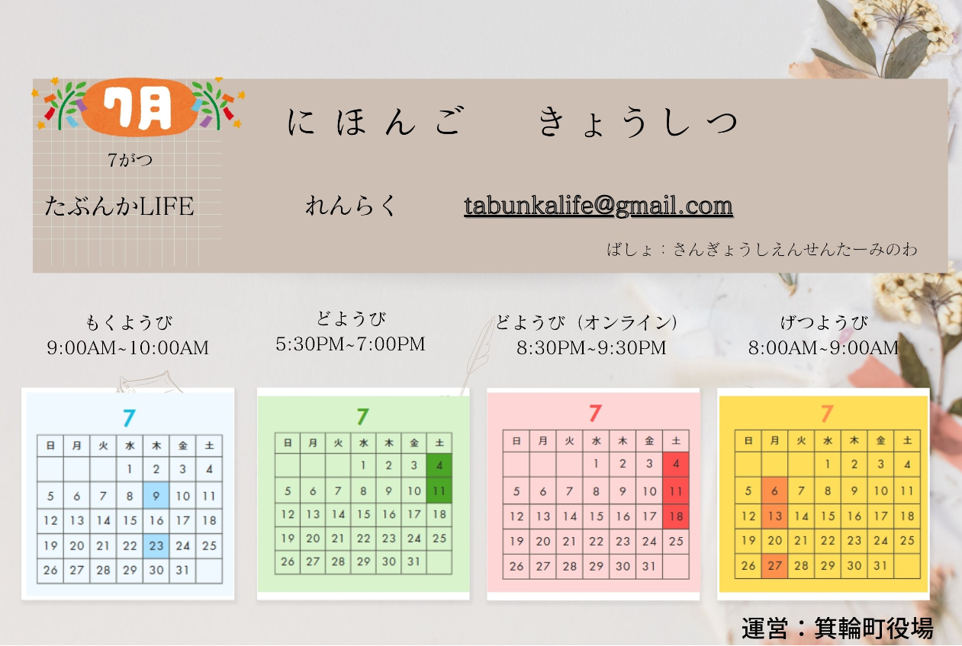

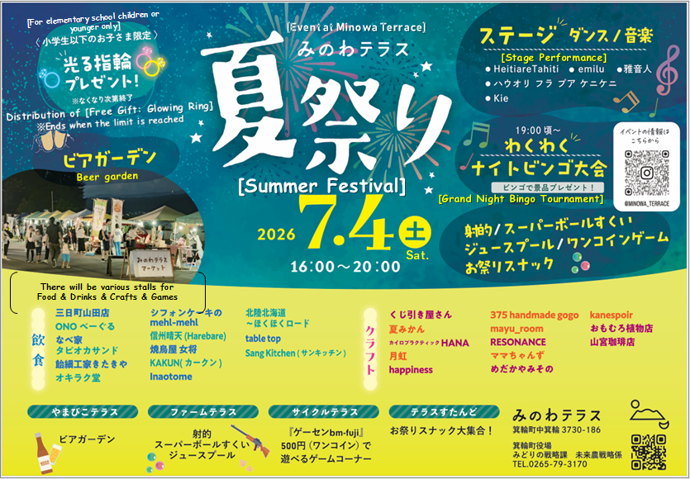

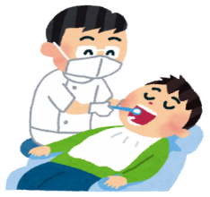
Notice about [Adult dental examination (free)]

To people who will be 21, 31, 41, 51, 61, or 71 years old this year, a"Free Dental Coupon"
that can be used at designated dental clinicsin Kamiina District.
Period: June 2026 to February 2027
＊(If you are pregnant, please use the coupon (pink) for a free dental examination for pregnant women).
It has been proven that periodontal disease is associated with diabetes, heart disease, and dementia. Preventing oral diseases helps protect overall health.
*Examination contents: Consultation, oral examination (saliva), X-ray, dental examinations.
[Mercury thermometer
of mercury]

Product
[Mercury blood pressure monitor]
[Fluorescent tube/bulb]
[Batteries/cells]
Do not dispose of these items in the designated trash bag! ! (combustible waste, plastics, etc.)
Be careful when disposing of waste containing mercury! !
If waste containing mercury is not properly separated and disposed of, there is a risk that waste disposal facilities will stop accepting it.
Currently, the town of Minowa is collecting waste containing mercury and separating it as follows. We ask for your cooperation.
Please dispose of incandescent bulbs, LED bulbs, and broken fluorescent tubes as "non-combustible" waste.
Collection method: ※ Please place your fluorescent lamps at the designated collection point on the two specific collection days each year. Broken fluorescent lamps should be disposed of as non-combustible waste. ※Mercury thermometers, mercury blood pressure monitors, and button batteries should be taken to the designated collection point on the two annual collection days (dry-cell battery collection (containing mercury)). In addition, mercury thermometers, mercury blood pressure monitors, and button batteries are collected at City Hall. We also collect lithium-ion batteries, heated cigarettes with built-in batteries, electronic cigarettes, dry-cell batteries, and materials containing mercury. (Minowa Town Hall/Counter 11)
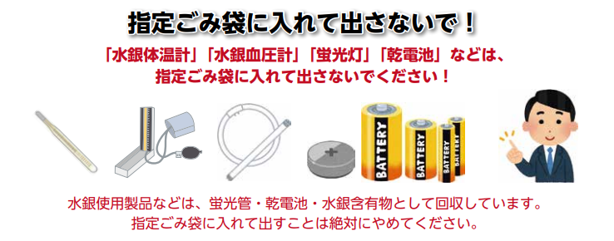

Minowa Town Hall/Environmental and Sanitation Division (Seikatsu Kankyou-ka) Tel.: 0265-79-3154.
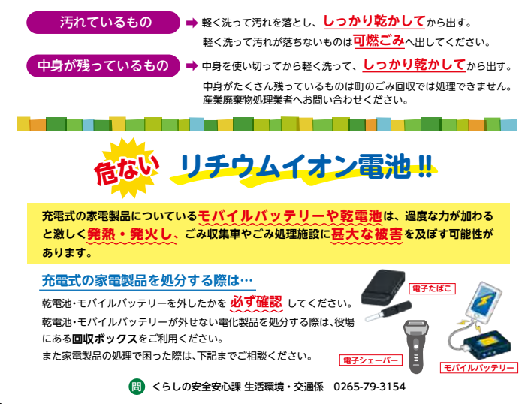
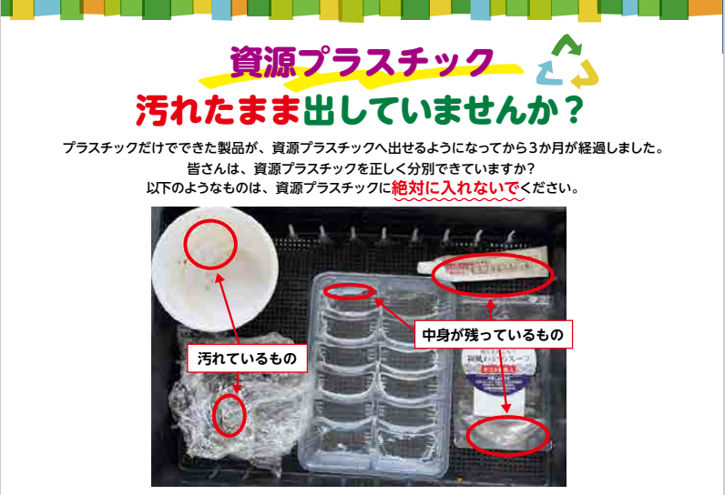
Use up the contents completely, then wash lightly and dry thoroughly before discarding.
If there is a lot of content left over, it cannot be processed by the city’s garbage collection.

Lithium-ion battery! !
Electronic cigarette
Rechargeable batteries or batteries found in household appliances can overheat and catch fire violently if subjected to excessive pressure, causing significant damage to garbage collection trucks and waste treatment facilities.

Container with persistent dirt
Dirty container
Wash lightly to remove dirt and dry thoroughly before discarding.
If the dirt does not come off with light washing, dispose of it as burnable waste.

Danger!
Dirty containers
Containers with persistent dirt
Since last year, products made entirely of plastic
can be disposed of as recyclable plastics.
But. . . Is everyone sorting recyclable plastics correctly?
The following items should never be discarded as recyclable plastics:
Recyclable plastics!
"Project [Summer Vacation]"
Are you not discarding dirty containers?
Minowa Town Hall/Life Safety and Protection Division/Environmental and Transportation Division
Mobile battery
Electric
shaver
Danger!
Since last year, products made entirely of plastic
can be discarded as recyclable plastics .
But...Is everyone separating recyclable plastics correctly?
The following items should never be discarded as recyclable plastics:
Are you not ruling out dirty containers?
Dirty container
Container with persistent dirt
Recyclable Plastics!
Dirty containers
Containers with persistent dirt
Lightly wash to remove dirt and dry well before discarding.
If the dirt does not come off with a light wash, discard it. as burnable trash.

Use up the contents completely before lightly washing and dry well before discarding.
If there is too much remaining content, it cannot be processed by the city's trash collection.

Rechargeable batteries or dry cells present in household appliances can overheat and violently catch fire if subjected to excessive pressure, causing significant damage to trash collection trucks and waste treatment facilities.

When discarding rechargeable electronic devices. . .
Make sure to always remove batteries and mobile batteries.
If you cannot remove the batteries and mobile batteries from an electronic device, use the recycling boxes available at the city hall.
In case of difficulties when discarding electronic devices, please contact us below for guidance.

Electronic
cigarette
Lithium-ion battery !!
