
箕輪町英語ニュースレター 令和７年12月
Informativo December 2025
We wish everyone a "Merry Christmas" and a "Happy New Year"!

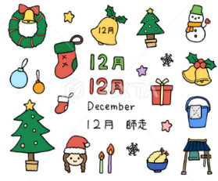
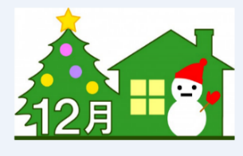
Minowa Town Hall 箕輪町役場
The newsletter is published monthly by Minowa Town Hall.
〒399-4695 Nagano-ken.Kamiina-gun. Minowa-machi. Oaza Naka Minowa ,10298.
399-4695 長野県上伊那郡箕輪町大字中箕輪10298
TEL:0265-79-3111 /0265-79-3154

「Festa de Confraternização de fim de ano」
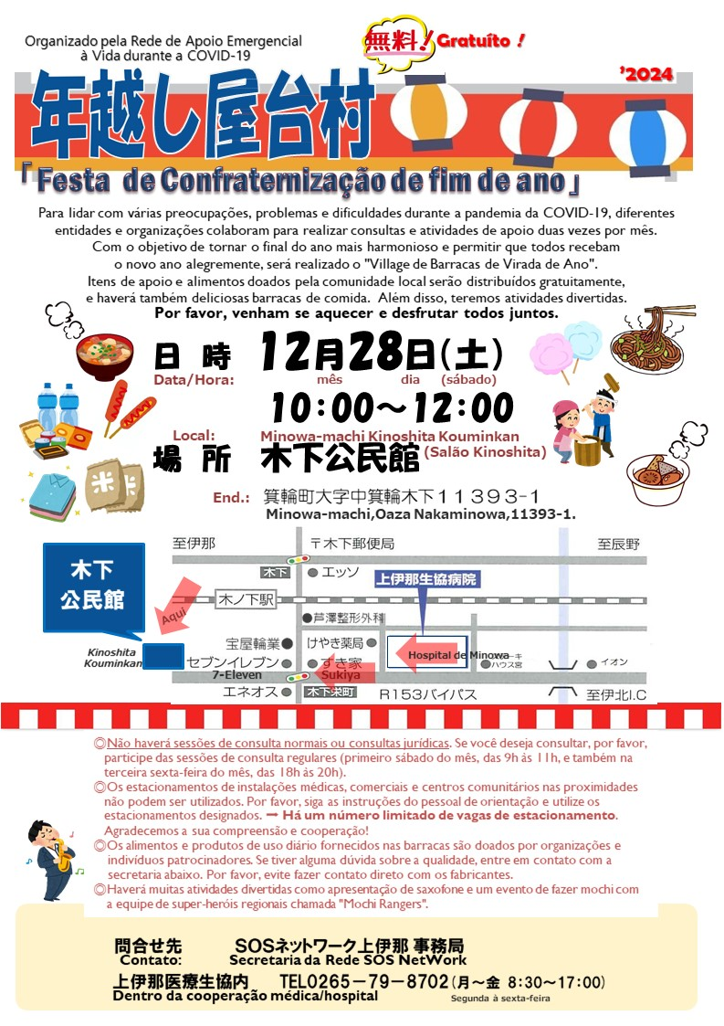
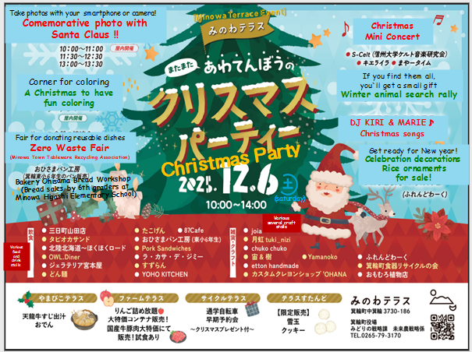
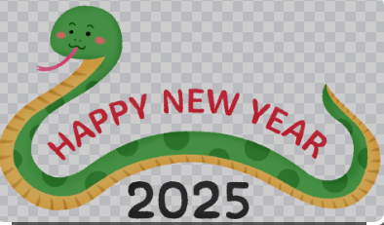
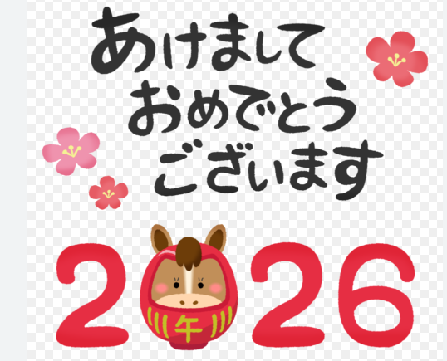
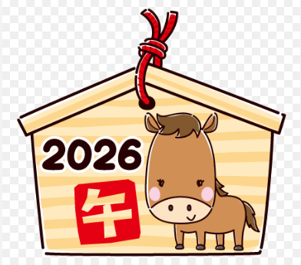
Important announcement regarding:

[ Year-end and New Year's Holiday
of Minowa City Hall ]

Minowa City Hall will be closed from
December 27, 2025 (Saturday) ～
until January 4, 2026 (Sunday).
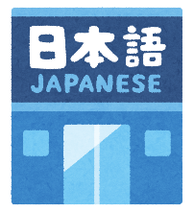
まちで にほんごの きょうしつ あります。
◇TeL：070-5077-2420
◇Mail :m.tabunka@gmail.com
◇LINE：https://line.me/ti/p/rhMKeSYmL2
◇WHATSAPP：https://wa.me/qr/5JEBYX7J2XH5H1
◇MESSENGER https://m.me/61574885471583?source=qr_link_share
※さいしょに かならず れんらく してください！！

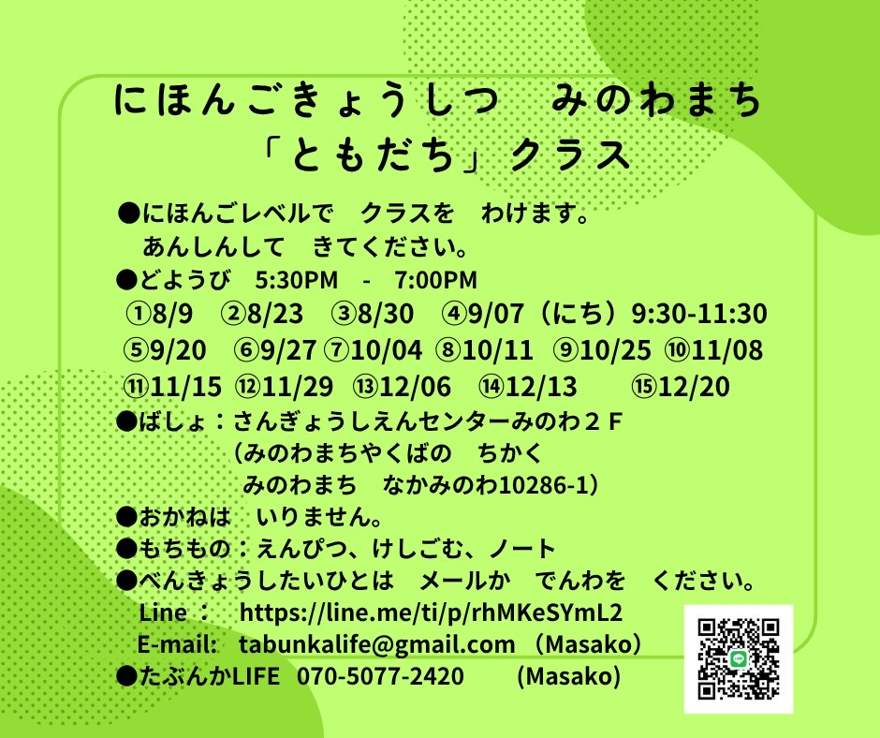
Japanese Class on Saturdays
"Tomodachi/Friends" Class
Students will be divided into groups according to their level of Japanese.
Come with peace of mind.
*Saturdays from 5:30 p.m. to 7:00 p.m.
*Location: Sangyo Shien Center-2nd floor
(almost in front of the Minowa City Hall)
＊Fee: FREE
＊What to bring: pencil, eraser, notebook.
＊Dates:
December days: 6, 13, 20
January`2026: 17,24,31

Whoever wants to participate, send an email or call: Tabunka Life: 070-5077-2420 (Massako)
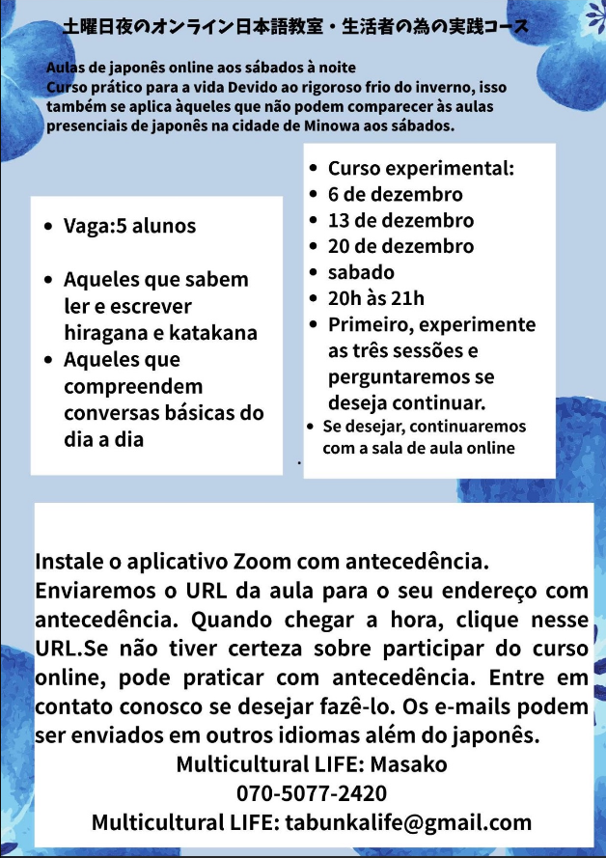

[Japanese lessons] with Japanese volunteers
(On Saturdays – from 1:00 p.m. to 3:00 p.m.)

*December 6th: Starting 1:00 pm～(location: Kōryu Center Minowa, rooms A,B)
*December 13th: Starting 1:00 pm～(location: Bunka Center Minowa, rooms 5,6)
*December 20th: Starting 11:00 am～(Bounenkai/End-of-year party)
*December 27th: (Yassumi) Day off


*(Fee of \200 yen/per visit)

If possible,
we ask that
you wear a mask

※ Attention: Caution!! For those who need to obtain documents such as: Juminhyo, inkam shomeisho, kosseki tohon, shotoku shomeisho at (kombini), these will also not be available on the dates mentioned above.(If necessary, you may come to the city hall until the 26th).
※ If you plan to change your address, the “change of address registration” can be done up to 2 weeks prior to the planned date of the move, so please submit your request to the city hall by December 26, 2025!
※ For those who wish to register their new address after the New Year's holiday, this will only be possible from January 5, 2026.


Attention!! The recyclable waste collection center (Clean Center Yaotome) will be open until December 31, however, the (Midori no Shiguen Recycling Station) in Minowa will be closed from December 25 to January 3.

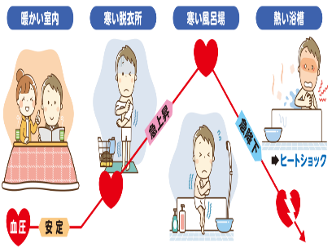
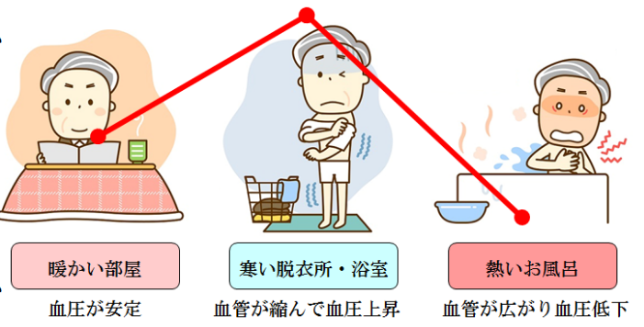
⚠Caution!! Thermal shock: high risk on very cold days⚠

One of the major concerns with severe cold is thermal shock during bathing, which causes thousands of fatal victims every year.

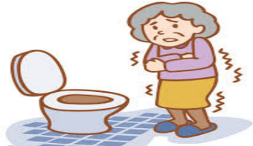
The forecast indicates that even the provinces bathed by the Pacific Ocean will have minimum temperatures below zero. This weather condition puts people at risk of thermal shock. This occurs due to the sudden change in temperature outside, which affects the body. According to the Medical Association, the annual average number of deaths from thermal shock across the country is about 14 thousand victims while they were in the shower. The highest numbers are in January, December, and February, in that order.

How does thermal shock (ヒートショック/heat shock)?
In general, bathrooms and toilets are located on the north side of the house or apartment, which is considered the colder side. Upon entering the bathroom, one goes from a heated environment to one with a much lower temperature. This sudden contrast causes thermal shock. The blood vessels contract to keep the heat away and the blood pressure increases. When immersing in the hot water of the ofuro, the blood vessels expand and your blood pressure drops suddenly, causing it to fluctuate several times. As blood pressure fluctuations overload the heart and can lead to a heart attack or a stroke.
What to do to avoid thermal shock: There is nothing more relaxing than a good shower after a day of work. But in winter, with the outside temperature very low, there are 8 essential prevention recommendations.
- The water temperature of the shower should be set to up to 41ºC
- Before taking off your clothes, it is recommended to turn on the shower and heat up the bathroom
- If you are going to get into the hot tub, let it be for no more than 10 minutes and preferably only up to your waist.
- If you feel cold on your shoulders, you can cover them with a towel heated in hot water.
- If you have consumed alcoholic beverages, you should avoid taking a hot tub bath
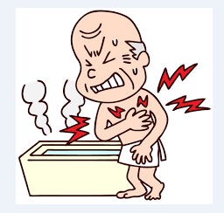
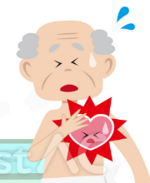
- Never get out of the bathtub or the hot tub quickly. The ideal is to leave slowly.
- Place a wooden platform or a thick rug to avoid feeling the bathroom floor's coldness on your feet.
- Avoid bathing late at night when the temperature drops even further
After dressing normally, it is recommended to wear a sweater over your clothes or pajamas, even if you are staying indoors, moving from one room to another.
「ANNOUNCEMENT from the Minowa City Hall」
令和7年分所得の申告予約受付について
¨Reserves for income Tax Return (Municipal)¨ ref.year R7 (2025)

We would like to thank the Minowa Tax Administration for their understanding and cooperation.
Will accept the income tax return for the year 2025 (Reiwa year 7), for income generated between January 1, 2025 and December 31, 2025, according to the following schedule below.

Subject: Acceptance of Declaration for the 7th Year of Reiwa

Declarations at the Minowa City Hall will only be accepted with a prior and complete reservation for the entire day. Those who wish to make a declaration must fill out the reservation request form on the reverse side and send it by mail or bring it in person to the Municipal Tax Department. It is also possible to make the request on the city hall's website. Please understand that
we do not accept reservations by phone or email. We apologize for the inconvenience and appreciate your understanding and cooperation.
Please check the content below for the schedule and booking method.

Schedule for receiving/serving documents at Minowa Town Hall:

Date of  declaration: | [ By appointment only ]  February 16, 2026 (monday)  ～ March 16, 2026 (monday)  (Except saturdays,sundays and holidays)
Time: | [Morning] : from 9:00 AM～11:30 AM [Afternoon] : 13:00 PM～3:30 PM  - 9:00 hrs ④ 10:30 hrs ⑦ 13:00 hrs ⑩ 14:30 hrs  - 9:30 hrs ⑤ 11:00 hrs ⑧ 13:30 hrs ⑪ 15:00 hrs  - 10:00 hrs ⑥ 11:30 hrs ⑨ 14:00 hrs ⑫ 15:30 hrs  - On February 20th (friday), service will be available from 4:00 PM～6:30 PM.
Place: | Minowa City Hall – 3rd floor
Statements that cannot  be accepted  at city hall: | ・Blue declaration, Consumption tax return  ・Special deduction for housing loan credit in the first year  ・Transfer income and dividends from stocks and trust investments  ・Income declaration for future transactions and other special declarations (cryptocurrency, FX, etc.)  ・Gift tax and inheritance tax declaration  ・Capital gain declaration, such as for land and houses, etc.

About booking request :

If you wish to make the declaration, please fill out the "Reservation Request Form" and send it by mail to the Tax Department of Minowa Town Hall or bring it directly to the Town Hall.
- (Reservations will not be accepted by telephone or email.)
- The "Reservation Request Form" can be downloaded from the town hall website or obtained directly at the town hall counter.
Registration deadline December 10, 2025 (wednesday) ～
for reservations: December 24, 2025 (wednesday)
Hours: 8:30 AM to 5:15 PM

※ Forms submitted before December 10th (Wednesday) will not be accepted.
※ Depending on the status of reservation requests, the requested date and time may change.

