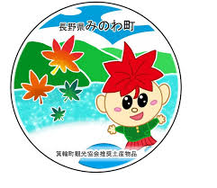
箕輪町英語ニュースレター 令和７年10月
Informativo October 2025
Minowa town hall 箕輪町役場
O informativo é publicado mensalmente pela prefeitura de Minowa.

〒399-4695 Nagano Prefecture, Kamiina District. Minowa Town. Oaza Naka Minowa, 10298.
399-4695 Nagano Prefecture, Kamiina District, Minowa Town, Oaza Naka Minowa 10298
TEL:0265-79-3111 Extentions:1371/1721

[ Census 2025 ]
Important statistical survey
conducted in Japan

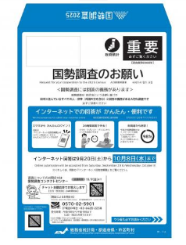

The Minowa city hall has been sending a "Large Blue Envelope" to its residents in mid-September, containing the "2025 National Census" form.
Inside the blue envelope is the "User Guide for the 2025 National Census Online." If you have a smartphone, you can easily respond in either Portuguese or Japanese by scanning the QR code printed on the notice.
If you do not know how to fill out this form, please make sure to bring this blue envelope to Minowa City Hall. We are available to assist you.
Completing this 'Census' is very important! All residents in Japan, including foreigners, are legally required to participate in the Census and can respond online or by mail until October 8, 2025.
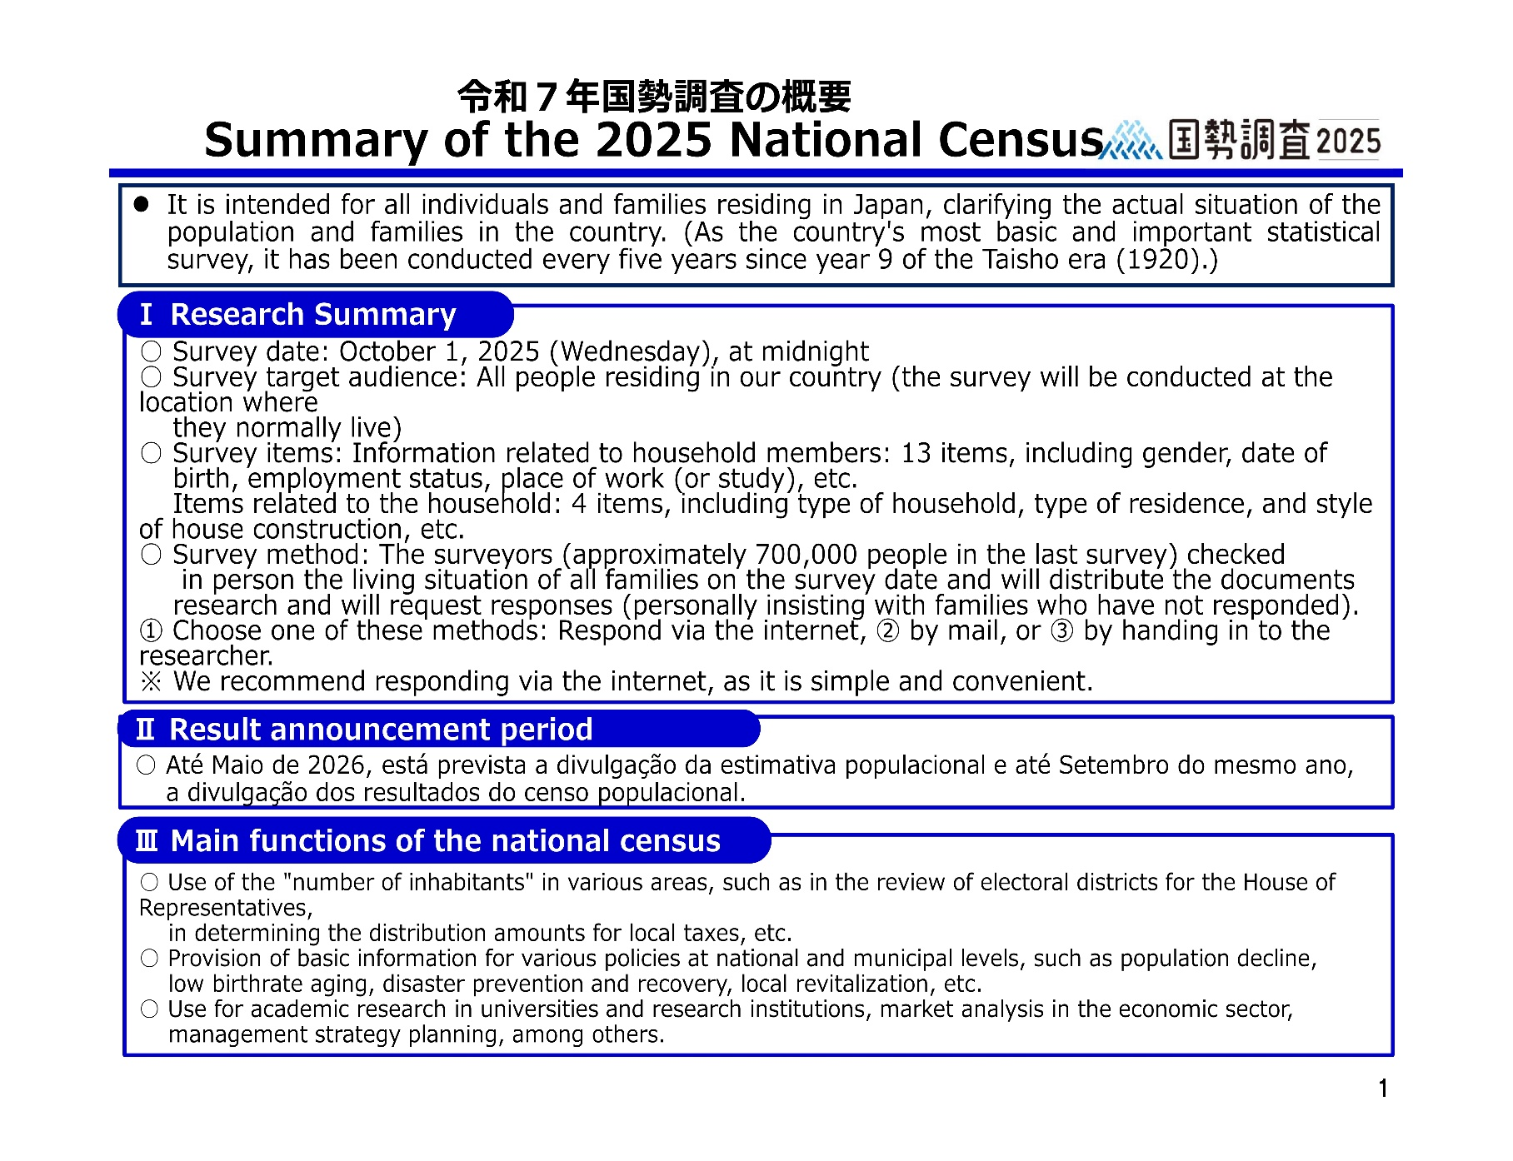



町内定額タクシー
【TAXI with fixed price within the city】


With the aim of improving the lives of the elderly and other people with mobility difficulties, the city of Minowa operates a fixed-fare taxi service called 'Machinaka Taxi' in the city, alongside the Minochan bus and the Ina main line, in order to create a public transportation network that will be connected to the future. We would like to inform you about how to use the fixed-fare taxi service.
Who can use it: If you fit into any of the situations below, you can register.
After registration, a registration certificate will be sent to you by mail..
The service can be used for up to 20 one-way trips per month.

Usage fee: ￥500 per time
Discounted rate:
￥250 per use
・People who have returned their
driver’s license
・Holders of disability certificates:
(physical disability, rehabilitation, mental health and well-being, mental disabilities)
・Holders of specific medical expense certificates (incurable diseases)
・People aged 75 or older who have never had a driver’s license
・Those who receive social assistance (seikatsu hogo) do not have a car
・Households made up only of people aged 75 or older who do not own a car
・People over 65 years old
・Pregnant women and others with mobility difficulties
(People with mobility problems are those who have difficulty
getting around, such as those who cannot drive due to a chronic illness)

Available area: Limited to the city of Minowa

Available hours: Weekdays from 9:00 a.m. to 3:00 p.m.
*Not available on weekends, public holidays, or Obon holiday
（August 13th to 16th), and year-end (December 29th to January 3rd)
・Please contact between 9:00 a.m. and 2:30 p.m. on the day of use
・Depending on the situation, use may not be possible

How to apply: By phone only
(The phone number for Machinaka Taxi will be provided along with your registration certificate)
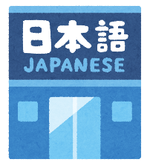
まちで にほんごの きょうしつ あります。
◇TeL：070-5077-2420
◇Mail :m.tabunka@gmail.com
◇LINE：https://line.me/ti/p/rhMKeSYmL2
◇WHATSAPP：https://wa.me/qr/5JEBYX7J2XH5H1
◇MESSENGER https://m.me/61574885471583?source=qr_link_share
※さいしょに かならず れんらく してください！！

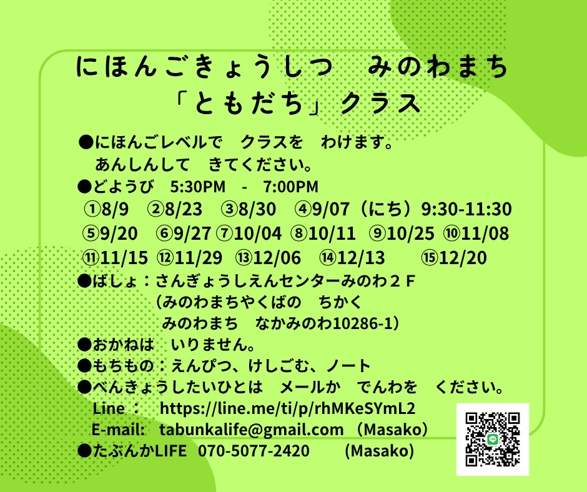
Japanese class on Saturdays
"Friends" class
Students will be divided into groups according to their level of Japanese.
Come without worries.
*Saturdays from 5:30 p.m. to 7:00 p.m.
＊Local: Sangyo Shien Center-2ºandar
(almost in front of City Hall)
*Fee: FREE
*What to bring: pencil, eraser, notebook.

*Dates: October 11, 25
November 8, 15, 29
December 6, 13, 20.

Those who wish to participate, please send an email or call: Tabunka Life: 070-5077-2420 (Massako)
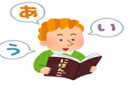
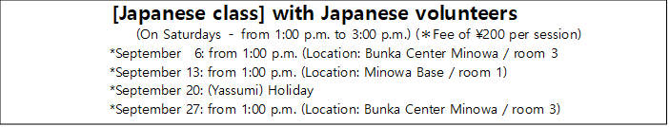
Serviço de empresa de Telefone Celular
¨Kinkyu Sokuho Mail¨ (Alerta de E-mail de Emergência)
Este serviço é fornecido por empresas de telefone
celular. As informações locais sobre desastres
serão enviadas por e-mail.
Por favor, tome medidas para se proteger assim
que receber esses e-mails.
※Cadastre-se no [Minowa-mate], para receber
¨Avisos e Alertas¨ locais.

Dica: Guarde e memorize estes números
em casos de emergências!

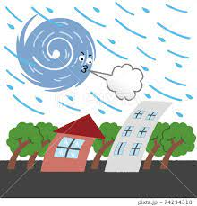
Typhoon season (taifu) in Japan

The typhoon season in Japan ranges from May to October each year, peaking between September and October. Japan is susceptible to natural disasters such as earthquakes, tsunamis, and, of course, typhoons. In the past, landslides and floods resulting from typhoons have caused countless damage and claimed thousands of lives.

Local governments prepare instruction manuals and conduct regular safety drills to prepare for emergencies, usually in schools and local neighborhoods.

There are also sirens that alert people to imminent occurrences. But of course, depending on the intensity, damage will be caused, especially to older buildings, and many houses will not get through the event unscathed. Not to mention that there may also be interruptions in water and electricity, as well as delays in public transportation.

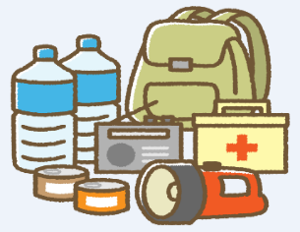
Typhoons usually move slowly and their path can be predicted with accuracy. If you are prepared, typhoons will have little impact on your life.

Make safety your top priority. Do not attempt to travel to areas affected by floods and do not enter the sea under any circumstances. If a typhoon is forecast to hit the area where you are, ask about the location of shelters (usually schools).

※It is advisable to assemble a "typhoon kit"..

Your emergency kit should include bottled water, non-perishable food items, a first aid kit, a flashlight, extra batteries, changes of clothes, and warm clothing. These items will help you be prepared in case of an evacuation or a few days at home without electricity.
[Collection Box] for
Small appliances/
Batteries. (It is located in the City Hall lobby)

[Collection of Batteries and Small Appliances]
Free collection in the City Hall Lobby
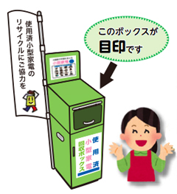
- Remove batteries from electronic devices.
this is the box
- Small appliances are collected in the "Collection Box" installed in the City Hall lobby. (Small appliances must be no larger than 30 cm x 10 cm).

Important notice to residents:

The Clean Center Yaotome recyclable waste collection center informs residents of Minowa and the surrounding area that this October the company will be open, operating as usual, and the Minowa "Midori no Shiguen/Recycle Station" Recycling Station will also be open.

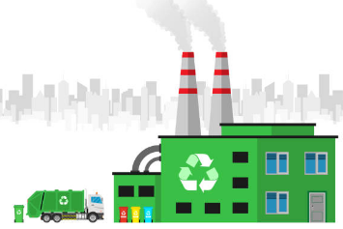

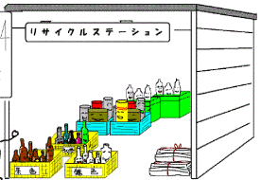

[Notice from the Health Promotion Support Sector
about the 'Autumn Medical Examination (さわやかけんしん)'
Early detection of lifestyle-related diseases and cancer requires regular checkups and proper medical care. At a time when we are especially concerned about our health due to coronavirus, how about getting the necessary checkups?!
The 'Sawayaka Kenshin/Cardiovascular Examination (City Hall)' is a checkup available to people aged 20 to 39, people aged 40 to 74 enrolled in National Health Insurance (Kokumin Hoken), and people aged 75 and over. Those enrolled in Social Insurance (Shakai Hoken) can also undergo various cancer screenings, among others. * (Unavailable depending on age.)
If you are interested in taking these exams, please contact your City Hall.
*Dates: October 24: from 8:00 to 11:00 / October 25: from 8:00 to 11:00
*Location: Hoken Center (behind the City Hall)
*Medical examinations that can be performed: ・Cardiovascular (for youths, specific to Kokuhō, for the elderly)
・Stomach cancer screening with barium (ages 41 and 50, 74 or older)
・Colon/intestinal cancer screening (age 41 or older) ・Hepatitis virus test (41 years old)
・ABC screening (stomach cancer risk screening) (ages 44 and 47)
(※The age for cancer screening refers to the age at the end of the fiscal year)

