**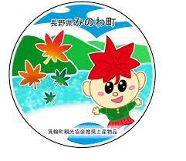**

**箕輪町英語ニュースレター 　　　　 令和7年８月**

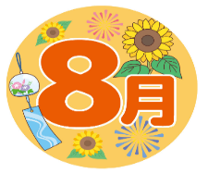**Newsletter** August 2025

**Minowa City Hall 箕輪町役場**

**The Newsletter is published monthly by the Minowa Town Hall.**

〒399-4695 Nagano-ken.Kamiina-gun. Minowa-machi. Oaza Naka Minowa ,10298.

399-4695 長野県上伊那郡箕輪町大字中箕輪10298

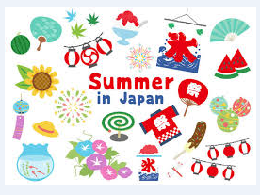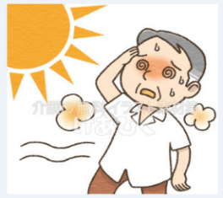 TEL:0265-79-3111 内線・extensions: 1371/1720

**[The dangers of excessive heat,**

**¨netyushō¨(Heatstroke) can be fatal]**

**Temperatures in Japan are rising, and it has been experiencing a dangerous heat wave in recent days, especially between the Kyushu and Kanto regions, with temperatures potentially exceeding 40°C in several areas. Extreme heat levels are expected, requiring maximum attention and strict preventive measures against heat stroke and hyperthermia. There has been a lot of talk about 'netyusho', which means heatstroke in english, as excessive exposure to the sun can be fatal if we do not take certain precautions.**

**'Netyusho' in english is heatstroke,** a condition caused by excessive exposure to the sun, or by staying in a hot, unventilated environment for too long.

Symptoms of heat stroke typically include: **dizziness, lightheadedness or fainting due to excessive heat, muscle pain, body aches and nausea, sweating, and high body temperature.** In more severe cases, the person cannot speak or walk due to the excessive heat.

**Which place is most likely to get heatstroke?**

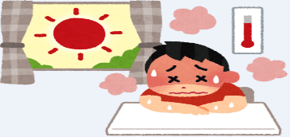When we talk about 'netyusho', we immediately think of a whole day under the blazing sun, or when we exercise for many hours in the summer, but the reality is that heatstroke can happen in places we wouldn't even imagine. For example:

＊High temperature and very humid places;

＊Poor ventilation in the room and very strong sunlight;

＊When the temperature rises suddenly

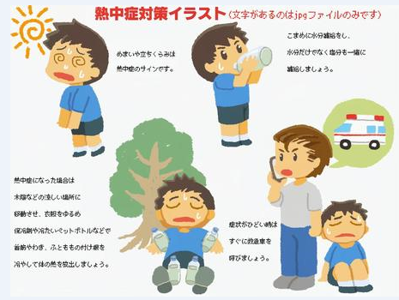**Even on days when the temperature is not high, but the environment is very humid, it can cause heat stroke.** Anyone who assumes that staying at home is a guarantee against heat stroke is mistaken: 37% of cases in Japan occur at home, and 25% occur when walking outside on very hot days. There is a lot of talk these days about 'netyusho' at home — which can be fatal for the elderly.

**What to do when you have heatstroke symptoms?**

＊Go to the nearest clinic/hospital, or call an ambulance;

＊Move to a cooler place;

＊Take off your clothes and cool your body to lower your body temperature;

＊Drink liquids or eat foods with mineral salts, but if the person feels nauseous, do not force them to drink liquids.

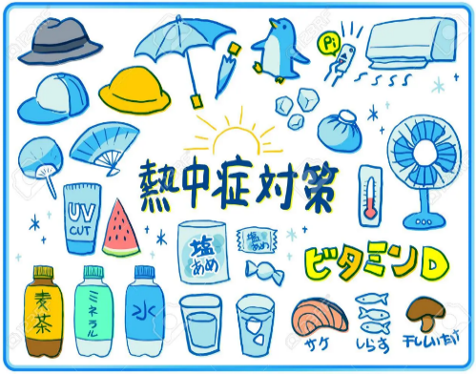**How to take care to avoid heatstroke?** The important thing is to take care not to get heatstroke before the first symptoms appear. Care needs to be taken when spending a whole day at the beach, or even if you're staying at home on a hot day.

＊Drink plenty of fluids; 　　　　　 ＊Use air conditioning and fans;

＊Take a shower or use a wet towel on your neck to cool your body;

＊Measure the ambient temperature;

＊Do not overexert yourself on hot days;

＊Wear cool clothing, an umbrella and a hat on very hot days.

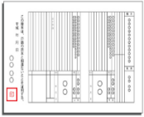

**Notice on [Delivery to a Wide Area of Family Registry (Kosseki Tohon)]**

From March 1, 2024, you can apply for a family registration certificate (kosseki tohon) or a

certificate of deregistration at a city hall counter other than the registered municipality.

Even if your registered address is far away, you can now apply at the city hall where you live or work.

For more information, please contact the Residents Affairs Section/Residents and Environment Division/Minowa City Hall.

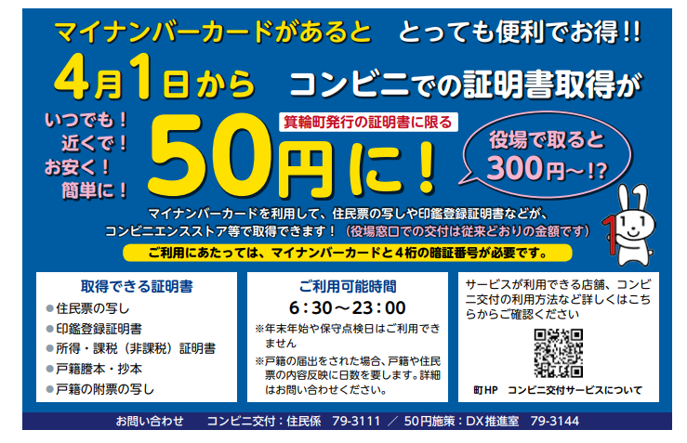

**●Not available during public holidays end of year/new year.**

**●If you submit family registry notification, it will take days for details to be reflected in the family registry. (Contact us for more details)**

**You can use your my number card to obtain copies of resident registration,**

**seal registration, etc.**

**Limited to documents issued**

**by the City of Minowa**

**Anytime!**

**Near you!**

**Cheap!**

**Simple!**

**To obtain a certificate/document in a ¨Kombini¨, it only costs...**

**At City hall it costs:**

**To use the service, you will need your card and 4-digit password.**

**Contact: Minowa City Hall/Sector matters of residents 0265-79-3111**

**Minowa HP / Convenience Stores**

**Check here for details on which locations,convenience stores the service can be used at.**

**Opening hours:**

**Certificates obtained:**

**●Copy of resident registration**

**●Copy of stamp registration**

**●Income/taxation certificate (tax exemption)**

**●Copy of family registration**

**(kosseki tohon)**

**It is very convenient and lucrative if you have a ¨My Number Card¨!!**

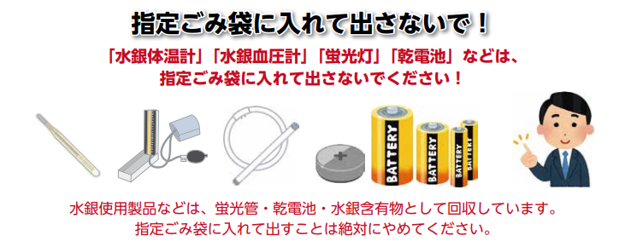

**Why should products that use mercury not be placed in a designated**

**garbage bags (burnable garbage, plastic, etc.?**

**In waste collection facilities, such as the ¨Yaotome Clean Center¨, there have been fire accidents believed to have been caused by lithium-ion batteries mixed with non-combustible materials. Lithium-ion batteries have the property of igniting when subjected to external impacts. For these main reasons, please do not place them in designated garbage bags (burnable garbage, non-incinerable garbage, recyclable plastic). Be sure to remove batteries (lithium-ion batteries, batteries, etc.) from household appliances. When mercury is released into nature, it causes damage such as environmental pollution and health hazards. Moreover, if mercury is emitted in a concentration exceeding the standard value set by law, it will be necessary to shut down the "waste treatment station" for a long period, and it will not be possible to treat all waste generated in households. In Minowa City Hall, we also collect "lithium-ion batteries", "heated cigarettes with built-in batteries, electronic cigarettes" from "dry cells, materials containing mercury"**

**(Minowa City Hall/Safety and Life Protection Division) Tel.: 0265-79-3154**

**[Fluorescent**

**Tube/Lamp]**

**Product**

**[Batteries]**

**Product**

**[Mercury Blood Pressure Monitor]**

**[Mercury**

**thermometer]**

**Product**

**Products containing mercury are collected as ¨hazardous waste¨,**

**so never place them in designated trash bags.**

**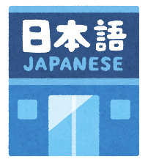**

まちで にほんごの きょうしつ あります。

◇TeL：070-5077-2420

◇Mail:[m.tapunka@gmail.com](mailto:m.tabunka@gmail.com)

◇LINE：[https://line.me/ti/p/rhMKeSYmL2](https://line.me/ti/p/rhMKeSYmL2" \t "_blank)

◇WHATSAPP：[https://wa.me/qr/5JEBYX7J2XH5H1](https://wa.me/qr/5JEBYX7J2XH5H1" \t "_blank)

◇MESSENGER[https://m.me/61574885471583? source=qr\_link\_share](https://m.me/61574885471583?source=qr_link_share)

**※さいしょにかならずれんらく してください！！**

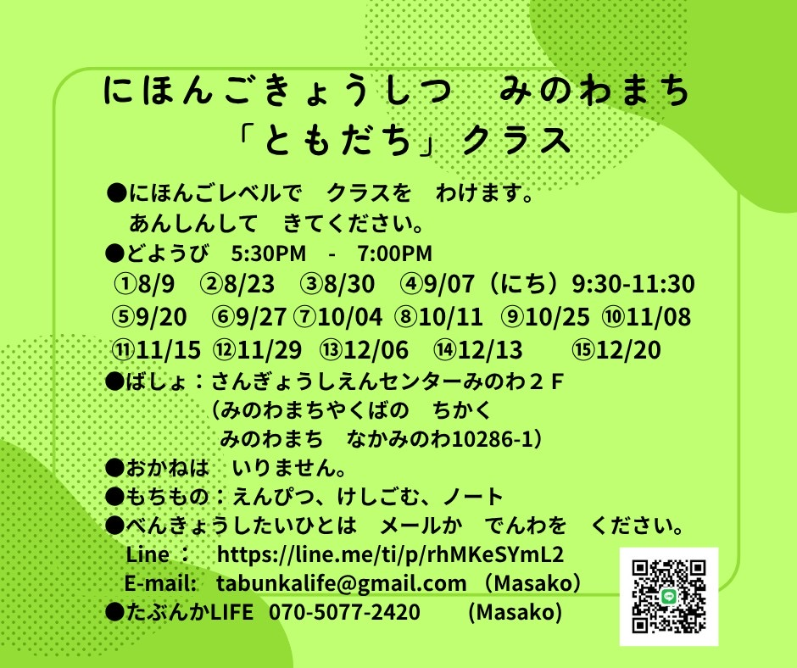

**Japanese class on Saturdays**

**Class "Friends"**

Students will be divided into groups according to their Japanese level.

Come with peace of mind.

＊Saturdays from 5:00 pm to 7:00 pm.

＊Location: Sangyo Shien Center-2ºto walk

(almost in front of City Hall)

＊Rate: **FREE**

＊What to bring: pencil, eraser, notebook.

＊Dates: August 9th, 23rd, 30th

September 7th (Sun.) 9:30～11:30

September days20.27

⇦Other dates on the side.⇦

**Whoever wants** to participate, please email or call: Tabunka Life: 070-5077-2420 (Massako)

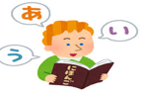



**[Japanese class] with Japanese volunteers**

(On Saturdayss – from 1:00 pm to 3:00 pm) (＊**Rate of \200yen/por time**)

\*August 2nd: from 1:00 pm～(location: Bunka Center Minowa/ room 3)

\*August 9th, 16th: (Yassumi) Day off

\*August 23rd: from 1:00 pm～(location: Minowa Base/ Room 1)

\*August 30th: from 1:00 pm～(location: Bunka Center Minowa/ room 3)

**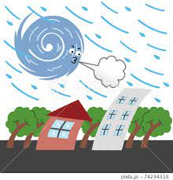**

**Typhoon season(taifu) in Japan**

# Japan's typhoon season runs from **June to October** each year, peaking between **August and September.** Japan is susceptible to natural disasters such as earthquakes, tsunamis, and, of course, typhoons. In the past, landslides and floods resulting from typhoons have caused extensive damage and claimed thousands of lives.

# Local governments prepare instruction manuals and conduct regular safety training to prepare for emergencies, often in local schools and neighborhoods.

# There are also sirens that warn of imminent occurrences. But of course, depending on the intensity, damage will be caused, especially to older buildings, and many homes will not be unharmed by the event. Not to mention that water and electricity supply interruptions can also occur, as well as delays in public transport.

# Typhoons tend to move slowly and their path can be accurately predicted. If you are prepared, typhoons will have little impact on your life.

# **Make safety your top priority.** Do not attempt to travel to flood-affected areas and do not enter the sea under any circumstances. If a typhoon is forecast to hit your area, ask about the location of shelters (usually schools).

# It is advisable to assemble a “typhoon kit”.

# Your emergency kit should contain bottled water, non-perishable food items, a first aid kit, a flashlight, extra batteries, a change of clothes, and warm clothing. These items will help you be prepared in the event of an evacuation or a few days at home without power.

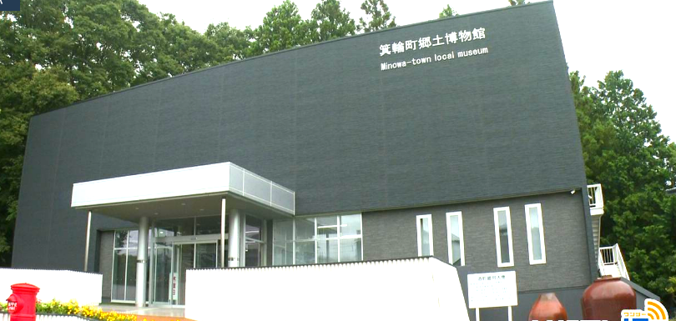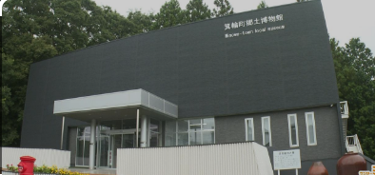

**[Minowa Museum]**

The **Minowa Local Folk Museum** opened in November 1974 and has been used by people from within and outside the town as a facility that collects, stores, displays, and allows the study of the town of Minowa through various related documents. After more than 40 years since its opening, renovation work began and was carried out in 2023 to address issues such as lack of seismic resistance, the danger of asbestos and the risk of electrical fires. Improvements were made to the exhibition facilities, air conditioning, accessibility and the reading room, in addition to securing storage space, including other innovative facilities. With exhibition preparations complete, the museum reopened on September 28, 2024.

The recently reborn Minowa Folk Museum wants more people to know about Minowa, so it has decided to make the **¨** **Entrance Free¨** so that everyone can visit it easily. We also care about creating a cozy environment with a pleasant atmosphere.

Some of the attractions/novelties of each exhibition are:

●¨Art Exhibition Hall¨: The exhibition now features lower overall lighting, effectively highlighting the works of local artists such as Shirotori Hakku and his Japanese paintings, as well as the sculptures of Fujisawa Furumi. Additionally, we've also included displays of local crafts, such as Furuta-yaki pottery, allowing visitors to learn even more about Minowa.

●¨Historic Exhibition Hall¨: The interior decoration is dominated by black, with spotlight lighting installed. Four three-dimensional display cases have been added, allowing you to see cultural treasures that appear to float from every angle. In addition, there are many displays of items designated as cultural heritage by the province and city. While we present the history of Japan, we also relate it to the history of Minowa, offering a deeper understanding of the history of this city.

●¨Folklore Exhibition Room¨: We transferred the 1930s living room that was installed in the old museum. The area is free to enter and touch the furniture. Enjoy the nostalgic atmosphere.

●¨Natural Display Area¨: In the corner of the 3D models, you can watch aerial videos of characteristic places in Minowa City through your smartphone. Additionally, you'll be able to hear the sounds of Minowa's nature, allowing for a wildlife viewing experience that engages all 5 senses.

●¨Library and Classroom¨: Those who wish to deepen their learning through reading can now use it for free. The materials shelf was stylishly renovated and the desk was also replaced. We can now offer classes for groups of 20 to 30 people.

These and other new features are available for everyone to see.

"We hope everyone can enjoy the many innovations we have made to the museum."

¨Please come visit us without hesitation!! ¨

※The museum is located in front of Minowa City Hall.

