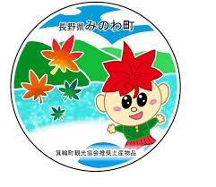**箕輪町英語ニュースレター 令和７年７月**

**Newsletter July 2025**

**Minowa Town Hall 箕輪町役場**

**The Newsletter is published monthly by the Minowa Town Hall.**

〒399-4695 Nagano-ken.Kamiina-gun. Minowa-machi. Oaza Naka Minowa ,10298.

399-4695 長野県上伊那郡箕輪町大字中箕輪10298

TEL:0265-79-3111 内線・extensions: 1371/1720

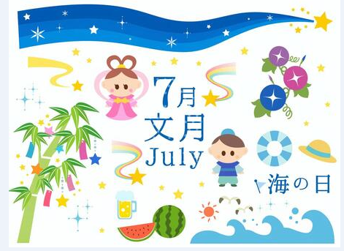****

**[Notice to foreigners residing in Minowa]**

**ATTENTION ! We updated the apps and the QR Code has changed!!**

**For those who are unaware, Minowa City Hall provides means of communication through:**

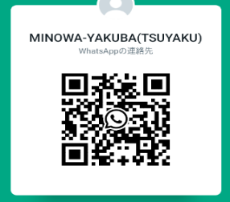

**●Messenger**

**●Line**

**●Ｗhats App**

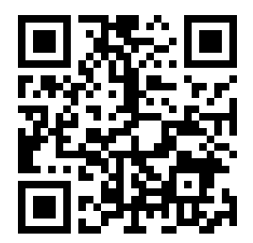

**(Minowa-Yakuba)**



**Important News/Information/Announcementsof the city on FACEBOOK**

We send updated news/information from the City Hall dandMinowa via Facebook

to foreigners. Please confirm via**[ Minowa News ]**on Facebook.

Note.: We also have an email address for foreigners:**tabunka@town.minowa.lg.jp**

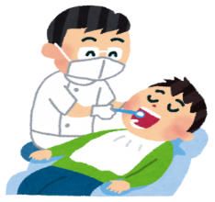**Announcement about [Free dental examination for adults]**

People aged 21, 31, 41, 51, 61, 71 this year will be sent a "Free Dental Coupon" that can be used at a designated dentist in Kamiina District.

**Period: 2025/June ～ 2026/February**

**＊(If you are pregnant, please use the coupon (pink color) for Free Dental Examination for Pregnant Women.)**

Periodontal disease has been shown to be associated with diabetes, heart disease and dementia. Preventing mouth diseases helps protect overall health.

**＊Examination content: Consultation, oral examination (saliva), X-ray, dental examinations. You are asked not to eat, drink, smoke or brush your teeth 1 hour before the exam to take the saliva test.**

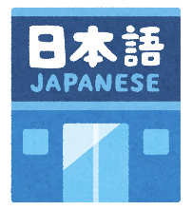

まちで にほんごの きょうしつ あります。

◇Tel：070-5077-2420

◇Mail :m.tapunka@gmail.com

◇LINE：https://line.me/ti/p/rhMKeSYmL2

◇WHATSAPP：https://wa.me/qr/5JEBYX7J2XH5H1

◇MESSENGER https://m.me/61574885471583? source=qr_link_share

**※さいしょに かならず れんらく してください！！**

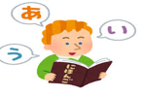

**[Japanese class[ês] with Japanese volunteers**

(On Saturdayss – from 1:00 pm to 3:00 pm)(＊**Rate of \200yen/por time**)

*dayJuly 5tho: from 1:00pm～(location:Minowa Base/ room 1)

*dayJuly 12ththe:from 1:00pm～(location:Minowa Base/ room 1))

*dayJuly 19ththe: from 1:00pm～(location: Bunka Center Minowa/ eastern room(Washitsu))

*dayJuly 26th:( Yassumi ) Break

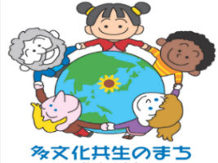

**Do you know the situation of foreign residents in Minowa?**

In this edition, we will learn and meet foreign residents in each district.

Last time, we mentioned that 3.4% of Minowa's population is made up of foreign residents, with the majority being of Brazilian, Filipino, Vietnamese, Chinese and Indonesian origin, representing over 80% of the total.

But why did these foreign residents choose the city of Minowa? Overall, 65% of them are permanent or long-term residents, such as Japanese descendants with roots in Japan or spouses of Japanese, while 25% are technical interns and the like, whose number has increased in recent years. In other words, the majority are not just visitors, but local residents who have always lived in Minowa.

Most of Minowa's foreign residents have never experienced an earthquake. What they would do in an emergency, what is a shelter, things that are considered natural to Japanese people may not be to foreigners. How can we support these residents in the event of an unforeseen emergency? Foreign residents live in various areas/districts as shown in the table below.

|  |  |  |  |  |  |  |  |  |
| --- | --- | --- | --- | --- | --- | --- | --- | --- |
| **District:** | **Brazil** | **Philippines** | **Vietnam** | **China** | **Indonesia** | **Others** | **Total** | **Percentage** |
| Sawa | 49 | 7 | 12 | 7 | 40 | 26 | 141 | 17% |
| Ooid | 22 | 12 | 3 | 12 | 8 | 1 | 58 | 7% |
| Yaotome |  | 2 |  | 5 |  | 1 | 8 | 1% |
| ShimoFuruta |  |  |  | 1 |  | 15 | 16 | 2% |
| KamiFuruta | 1 | 2 |  |  |  | 0 | 3 | 0% |
| Nakahara | 15 |  | 12 |  |  | 11 | 38 | 5% |
| Matsushima | 107 | 88 | 20 | 16 | 8 | 6 | 245 | 30% |
| Kinoshita | 100 | 27 | 21 | 19 | 5 | 5 | 177 | 22% |
| Tomida | 3 |  |  | 1 |  | 1 | 5 | 1% |
| Nakazone | 3 | 1 | 8 | 2 |  | 19 | 33 | 4% |
| Mikkamachi | 25 | 7 | 15 | 1 | 3 | 0 | 51 | 6% |
| Fukuyo | 2 | 4 |  | 1 |  | 0 | 7 | 1% |
| Nagaoka | 4 | 1 |  | 5 |  | 2 | 12 | 1% |
| Minami Ogouchi | 9 | 2 |  |  |  | 1 | 12 | 1% |
| KitaOgouchi |  | 3 | 1 | 2 | 2 | 7 | 15 | 2% |
| Total | 340 | 156 | 92 | 72 | 66 | 95 | 821 | 100% |

In the next issue, we will share information about the projects the city is implementing to ensure that foreign residents can live in Minowa with peace of mind.

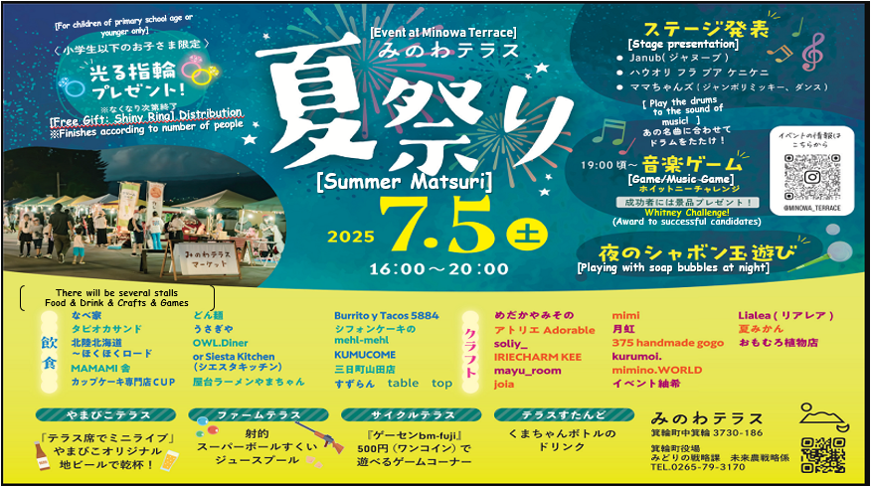

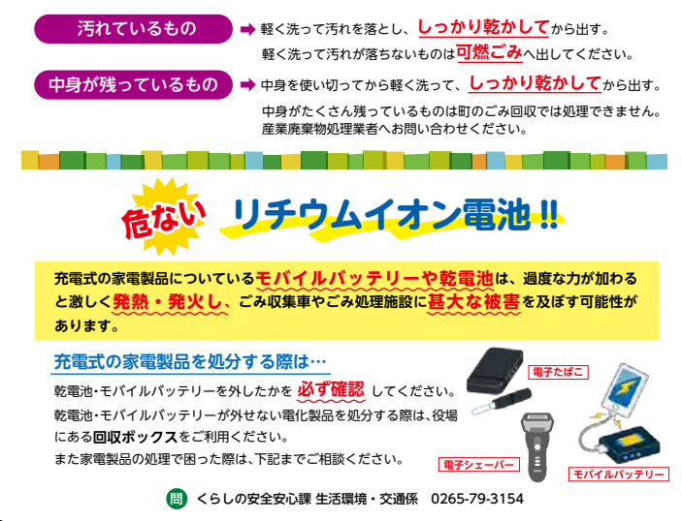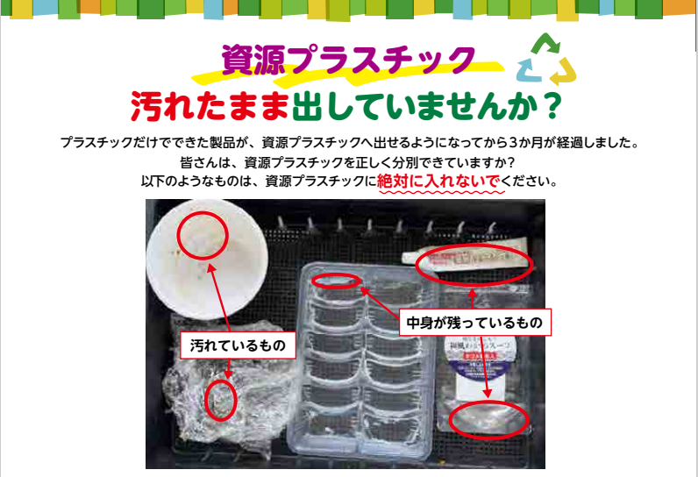

**Plasticsrecyclable!**

Life Safety and Security Division/Environmental Sector/Transportation-Minowa Town Hall

**Mobile battery**

**shaver**

**electronic**

**Wigarroelectronic**

**When to dispose of rechargeable electronic devices…**

**Make sure always remove batteries and mobile batteries.**

**If you cannot remove the batteries and mobile batteries from an electronic device, use therecycling boxes available at the city hall.**

**If you experience difficulties disposing of electronic devices, please contact us below for guidance.**

**To therechargeable batteries or cells present in household appliances canoverheat and catch fire violently subjected to aexcessive pressure, causingsignificant damage to garbage collection trucks and waste treatment facilities.**

**Lithium-ion battery!!**

**Danger!**

Use the contents completely before washing lightly anddry well before discarding.

If there is too much content left, it cannot be processed by the city's garbage collection.

Wash lightly to remove dirt anddry well before discarding.

If the dirt does not come off with a light wash, discard it.asburn trashthevel.

**Recdirty ipient**

**Recipientwith persistent dirt**

**It's been three months that products made entirely of plastic**

**can be discardedasplastics recyclable.**

**But...To beto which allAre you separating recyclable plastics correctly?**

**The following itemsshould never be discarded as recyclable plastics:**

**Vtheyou are not ruling outdirty containers?**

Use the contents completely before washing lightly anddry well before discarding.

If there is too much content left, it cannot be processed by the city's garbage collection.

**Lithium-ion battery!!**

**Wigarroelectronic**

**When to dispose of rechargeable electronic devices…**

**Make surealways remove batteries and mobile batteries.**

**If you cannot remove the batteries and mobile batteries from an electronic device, use therecycling boxes available at the city hall.**

**If you experience difficulties disposing of electronic devices, please contact us below for guidance.**

**To therechargeable batteries or cells present in household appliances canoverheat and catch fire violently subjected to aexcessive pressure, causingsignificant damage to garbage collection trucks and waste treatment facilities.**

**Recipientwith persistent dirt**

**Recdirty ipient**

Wash lightly to remove dirt anddry well before discarding.

If the dirt does not come off with a light wash, discard it.asburn trashthevel.

**Danger!**

**It's been three months that products made entirely of plastic**

**can be discardedasplastics recyclable.**

**But...To beto which allAre you separating recyclable plastics correctly?**

**The following itemsshould never be discarded as recyclable plastics:**

**Vtheyou are not ruling outdirty containers?**

**Plasticsrecyclable!**

**"Project [Summer Vacation]"**

