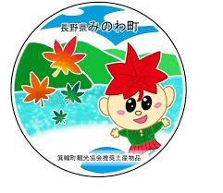**箕輪町英語ニュースレター 令和7年６月**

**Newsletter June 2025**

**Minowa City Hall 箕輪町役場**

**The Newsletter is published monthly by the City of Minowa.**

〒399-4695 Nagano-ken.Kamiina-gun. Minowa-machi. Oaza Naka Minowa ,10298.

399-4695 長野県上伊那郡箕輪町大字中箕輪10298

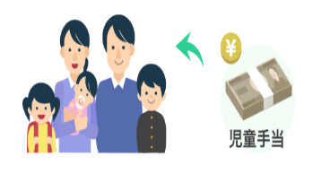TEL:0265-79-3111 内線・extensions: 1371/1720

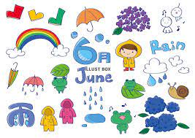

**ATTENTIONTO THE !!!**

**Announcement about [Jidou Teatê (Milk Help)]**

Minowa City Hall informs that (for some families) a Family Allowance Letter/Notification (Current Situation Report) will be sent.

Currently in the city of Minowa, as a general rule, it is no longer necessary to send the "Status Report/Family Status and Income" for the renewal of the Milk Aid. However, for some families it will be necessary to update their family situation, so we ask that you send or bring it directly to the city hall within the deadline, otherwise you may not receive the subsidy (milk aid) from August onwards. We ask for everyone's understanding and cooperation.

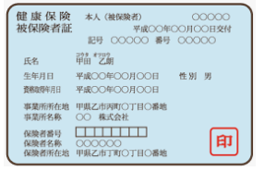

**National Health Insuranceúde (Kokumin Kenkthe (Hoken)**

People up to 74 years of age who are subject to residence registration and do not have health insurance where they work or other public insurance must register with the National Health Insurance. Please complete the registration process at the city hall corresponding to your place of residence within 14 days.

Applies in any of the following situations.

* People who have a residence registration
* When moving to another municipality
* When to leave your health insurance plan
* When the child is born (the child's part)

In addition, people who are not subject to residence registration or who have less than 3 months of residence qualification, when their intended period of stay exceeds 3 months, will be able to enroll in national health insurance. So be careful. For more information, contact the city hall.

**Insurance rate**

If you have a family member who is registered with the national health insurance, the head of the family must pay the fee (tax). The insurance rate (tax) is determined based on the number of people enrolled in the family and the previous year's income. The head of the family pays the annual insurance fee, which is divided into installments with a payment term. You can pay the fee (tax) at city hall, convenience stores or financial institutions using payment slips sent by city hall and also using bank transfer.

There are cases in which the insurance rate is reduced for people who have difficulty paying due to catastrophes, unemployment, bankruptcy, etc. For more information, contact the city hall.

**※This year's (Kokumin Hoken)/National Health Insurance Fee**

**will be sent to homes in ¨June¨.**

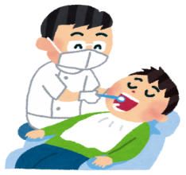

**Announcement about [Free dental examination for adults]**

People aged 21, 31, 41, 51, 61 this year will be sent a "Free Dental Coupon" that can be used at a designated dentist in Kamiina District.

**＊(If you are pregnant, please use the Free Dental Examination Coupon for Pregnant Women.)**

Periodontal disease has been shown to be associated with diabetes, heart disease and dementia. Preventing mouth diseases helps protect overall health.

**＊Examination content: Consultation, oral examination (saliva), X-ray, dental examinations. You are asked not to eat, drink, smoke or brush your teeth 1 hour before the exam to take the saliva test.**

****ATTENTION !!!

**Light Vehicle Tax (Kei Jidousha)**

In May, Minowa City Hall sent a hagaki (card/invoice) for payment of the "vehicle tax" for light vehicles (kei jidousha) to people who own light vehicles and are registered on April 1, 2025.

Proof of payment of this tax (due at the end of May) will be required for the shaken (annual vehicle inspection), therefore, we ask that you make the payment and keep the receipt carefully and in a safe place.

If you have any questions, please come to Minowa City Hall, Tax Department (Counter 2).



**Automobile Property Tax (Jidousha zei)**

The automobile ownership tax (does not include light motor vehicles or motorcycles, etc.) is a provincial tax, levied on all those who own automobiles on April 1st of each year.

Upon receiving the tax collection notice issued by the provincial tax offices, please make payment at banks or convenience stores.

For more information, Car Tax Office/State Building in Ina.

**⚠⚠**

When you receive your tax notification, please make the payment by the specified deadline.

In addition to convenience stores and tax offices, payment can be made at banks, financial institutions and post offices throughout the country.

**New: The tax payment notice contains a QR code that allows you to easily pay via mobile payment apps such as PayPay, Rakuten Pay（楽天Pay）and払い.**

In addition, it is possible to make the payment using the QR code when accessing the municipal tax payment website via smartphone or computer, via credit card, internet banking, among other options.

With this payment method, there is no need to go to a physical store or banking institution and there is no waiting time. How about trying to use them.

＊＊ There are certain conditions and procedures required for payment.

Additionally, depending on the payment method chosen, it may not be possible to issue a receipt or tax payment certificate. Please be aware of this in advance.

Nagano-ken Nanshin Kenzei Jimusho Kanri-ka

[Nagano Prefecture Automobile Tax Office]

Tel.: 0265-79-3146

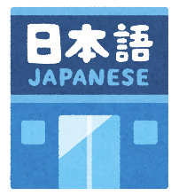

まちで にほんごの きょうしつ あります。

◇Tel：070-5077-2420

◇Mail :m.tapunka@gmail.com

◇LINE：https://line.me/ti/p/rhMKeSYmL2

◇WHATSAPP：https://wa.me/qr/5JEBYX7J2XH5H1

◇MESSENGER https://m.me/61574885471583? source=qr_link_share

**さいしょに かならず れんらく してください！！**

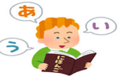

**[Japanese class[ês] with Japanese volunteers**

(On Saturdayss – from 1:00 pm to 3:00 pm)(＊**Rate of \200yen/por time**)

*dayJune 7tho: from 1:00pm～(location: Bunka Center Minowa/ room 3)

*dayJune 14ththe:from 1:00pm～(location: Bunka Center Minowa/ room 3)

*dayJune 21stthe:( Yassumi ) Break

*dayJune 28tho: from 1:00pm～(location: Bunka Center Minowa/ room 3)

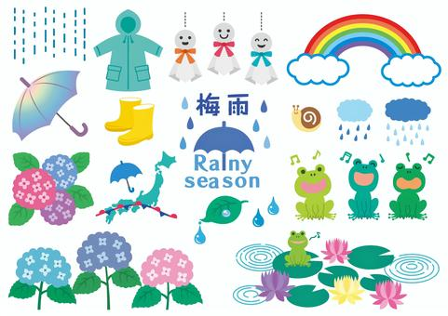**Tsuyu – Rainy season**

梅雨 (Tsuyu)

As June approaches, Japan experiences a very rainy and cloudy period, called tsuyu.

It's a time when it rains a lot. However, the image we have is not of torrential rains, but of a long period with mild rains and grey days. In other words, days and days go by without the presence of the sun.

The beginning of this period is called tsuyu iri, or it is said that “tsuyu ni hairu” (the rainy season begins). And its end is called tsuyu ake, or it is said that “tsuyu ga akeru” (the rainy season ends). And then comes the arrival of the hot summer season. ^^

During the rainy season in Japan, the ajisai (hydrangea) blooms, a flower that is not as famous as the sakura, but is still one of the Japanese people's favorites.

Besides, it's also ume plum season. Also known as Chinese plum or Japanese apricot.

During this rainy season, be aware of possible landslides, etc., in this case:

・Go to a safe place ・Go to an evacuation site

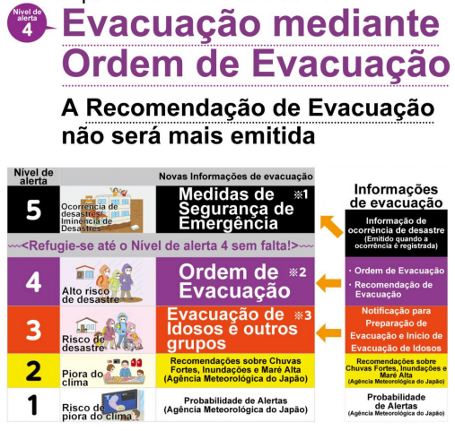**[Alert Level and Action to be Taken Table]**

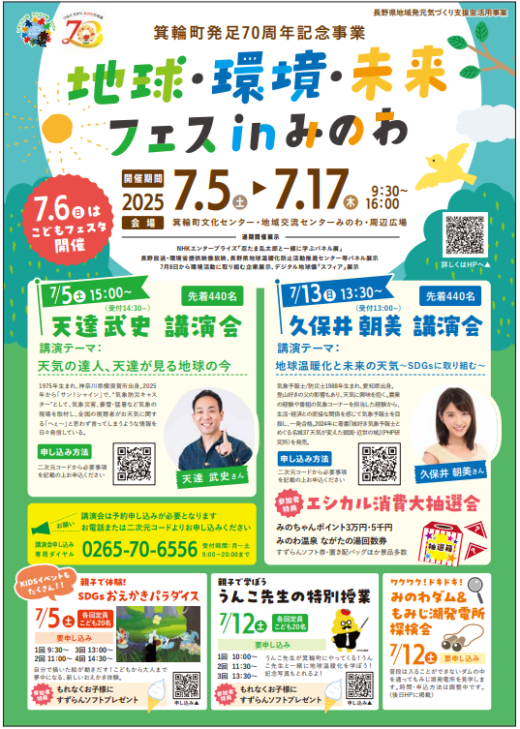

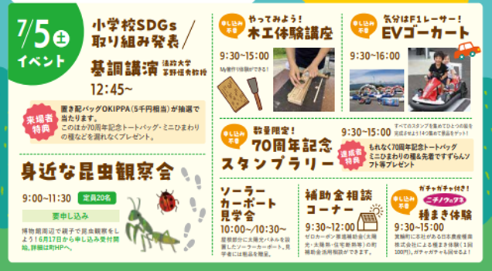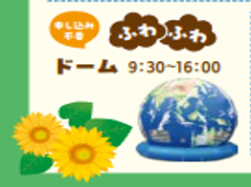

**Group ofWatch insects nearby! (museum surroundings)**

**(You need to book in advance)**

Registration:THEfrom June 17th on the homepage.

Presentation of theSDG initiative

of students

from primary

**Kids and adults can have fun together! New experience, where your drawing moves. (advance reservation required)**

**Fisigolfrom the**

**TandrfrogMandioTHEmbientandFuturthe**

**andmMinowthe**

**Collect prints and win free gifts. The first people will be able to win**Sacollasorganic, sunflower seeds and soft ice cream.

**[Commemoration of the**

**70th anniversary] Limited quantity!**

**Collect prints**

**Feel like an F1 driver!**

**Kart EV/electronic**

**Let's try it!**

**Experience classence**

**inbadr**scenario

**We will haveseveral**

**Events:**

**Bunka Center&KtheRyu Center Minowa&surroundings**

**This year, Reiwa Year 7 (2025), marks the third year since the city declared “Zero Carbon Emissions” and also celebrates the 70th anniversary of the founding of the municipality. On this occasion, it is crucial to reflect on the issue of climate change and the need and benefits of working towards zero carbon emissions, understand the principles of the “Sustainable Development Goals (SDGs)” for building sustainable cities and involve citizens, businesses and local authorities to promote behavior change and accelerate initiatives. To this end, the "Land, Environment and Future Festival" will be held.**

**Location**

**Period**

**[Celebration of the 70th anniversary of the foundation**

**from the city of Minowa]**