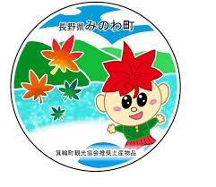**箕輪英語ニュースレター 令和７年５月**

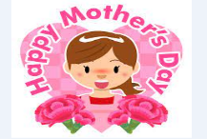**Newsletter** May 2025

**Minowa City Hall 箕輪町役場**

**The Newsletter is published monthly by the Minowa City Council.**

〒399-4695 Nagano-ken.Kamiina-gun. Minowa-machi. Oaza Naka Minowa ,10298.

399-4695 長野県上伊那郡箕輪町大字中箕輪10298

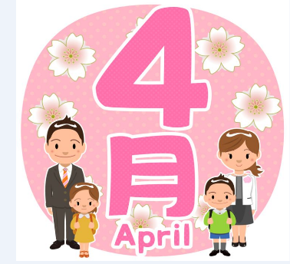TEL:0265-79-3111 内線・extensions: 1372/1711

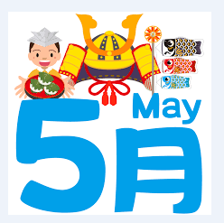

**[Notice to foreigners residing in Minowa]**

**ATTENTION ! We updated the apps and the QR Code has changed!!**

**Minowa City Hall provides means of communication through:**

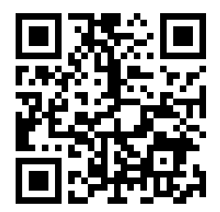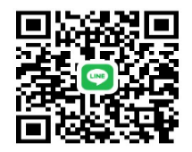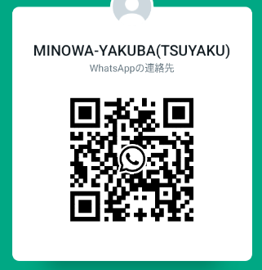

**●Messenger**



**●Line**

**●Ｗhats**

**App**

**(Minowa-Yakuba)**



We send updated news/information from the City HallandMinowa through Facebook to foreigners.

Please confirm via**[ Minowa News ]**on Facebook.

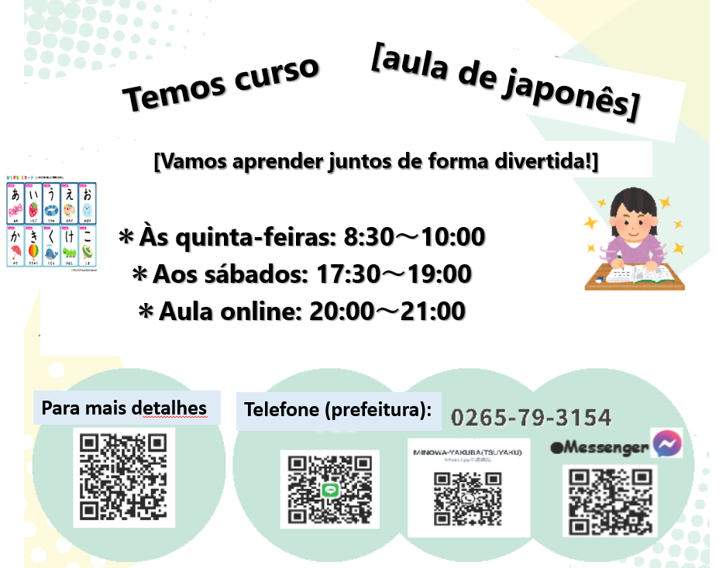

**City hall phone**

**For more details**

**On saturdays**

**Online class**

**Thursdays**

**[ We have a course]**

**[ Let`s learn together in a fun way!]**

**[ Japanese class]**

**[Japanese class[ês] with Japanese volunteers**

(On Saturdays – from 1:00 pm to 3:00 pm)

(＊**Rate of \200yen/por time**)

*dayMay 10th:from 1:00pm～(location: Bunka Center Minowa rooms 5 and6)

*dayMay 17th:from 1:00pm～(location: Bunka Center Minowa rooms 5 and6)

*May 24th: yassumi (day off)

*May 31st:from 1:00pm～(location: Bunka Center Minowa rooms 5 and6)

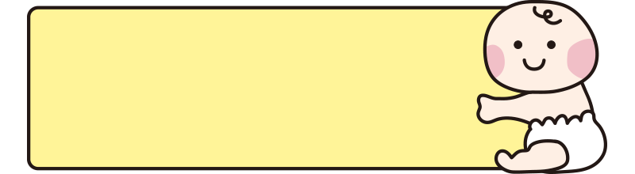

**乳幼児おむつ用品購入券**

**交付事業のお知らせ**

**THEvision: ¨Coupon Granting Program**

**for the purchase of diapers & baby products"**

Minowa City Hall will provide a system/benefit to ease the financial burden of families raising children from July 1, 2024. Vouchers will be issued for the purchase of baby care products such as diapers, wet wipes, etc.

**１ Who can receive:**

**Parents or guardians who reside in Minowa City and are raising children who are 0 years old or who will turn 1 year old this year of Reiwa year 7 (2025).**

**２ Coupon Details:**

・Amount/quantity: 30,000 yen (1,000 yen x 30 coupons) per beneficiary child

・Period of use: Until the end of the year following the date of grant

・Reissue: We will not reissue in case of loss or other inconvenience, therefore,store them carefully.

**３ Baby Care Products:**

・disposable diaper ・cloth diaper ・diaper liner ・diaper cover ・wet wipe

**４ Application Method and Deadline:**

**Registration deadline: from the month of the child's birth or 1st birthday until the end of the following 6 months.**

The child's parents or guardians must complete the application form and make the request at the Children's Future Department counter (Counter 5).

The purchase coupon will be delivered at the counter after confirmation of the registration form. The application form is submitted on the following occasions:

・For babies aged 0 and under: The application form is submitted at the Children's Future

Department counter when registering the birth.

・For 1-year-olds: The application form is sent together with the 1-year health examination notice.

＊For more details or inquiries, please call or come directly to the City Hall, counter 5 or counter 11(tsuyaku).

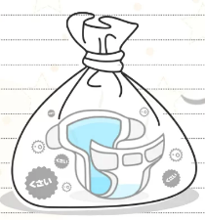

**紙おむつをお使いの方へ、ごみ袋の支給制度がありがます**

**[Garbage bag supply system for disposable diapers]**

Minowa City Hall has restarted the system that provides "burnable garbage bags" for the disposal of disposable diapers from babies and certified people in need of nursing care. Applications are being accepted and distribution will begin April 1st. This system aims to reduce the financial burden on disposable diaper users, provide support for childcare and improve well-being.

**Who can receive: *Infants (children under 3 years old) *those who use disposable diapers *other special cases**

**Benefit content: For each eligible person upon request, up to 60 bags of burnable garbage (medium size). ※In some special cases, you may be able to request an additional 100 diapers per year.**

**Application method: Please apply at Minowa City Hall, Counter 11.**

Please attach the following documents: ①Proof of eligibility (boshitechô, disability booklet, etc.)

➁Proof of purchase of disposable diapers (receipt, etc.)

※Document is not required for infants.

Department of Safety and SecurityLife, Environment/Transportation Sector (Counter 11)

**※In mid-March, the City Hall sent “garbage tickets” to homes.**

**If you have not yet received these tickets, please contact us.**

**※Have you already received the ¨Collection Calendar?selective domestic waste¨ from 2025??**

**If not yet, it could be thepurchased at City Hall, Counter 11.**

**Curiosities:**

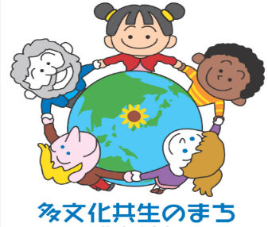**Do you know the situation of foreign residents in Minowa?**

In recent years, have you heard the word "Tabunka Kyōssei (multicultural coexistence)"?

**"Multicultural coexistence" is when people of different nationalities and ethnicities recognize each other's cultural differences and live together on an equal footing in the local community. Foreign residents are also important citizens in Minowa. Through this publication, we will introduce the situation and environment of foreign residents in Minowa to promote mutual understanding and strengthen cooperation as fellow residents living together in the community. In Minowa City, the majority of foreign residents are Brazilians, representing 41% of the total, followed by Filipinos (19%), Vietnamese (11%), Chinese (9%) and Indonesians (8%), with the top 5 countries representing 88% of the total. In Minowa, there are few residents from English-speaking countries, and the common language is "Yassashii nihongo (simple Japanese)". Furthermore, South Asian skills trainees supporting Minowa’s core manufacturing industry are increasing annually, with a continued increase expected from 2027 when a new training and employment system will be introduced.**

In the next edition, we will analyze the situation of foreign residents in each district.



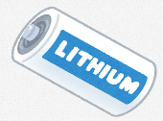

**About Security:**

**[A fire can start in a lithium-ion battery]**

Rechargeable electronic devices that contain lithium-ion batteries or built-in lithium-ion batteries pose explosion and fire hazards and should never be placed in "non-combustible waste", "combustible waste" or "recyclable plastic" garbage bags.

**Some examples of electronics that contain lithium-ion batteries:**

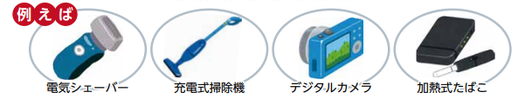

Barbeadorelectricrechargeable vacuum cleanerdigital camera electronic cigarette

Why products that use mercury should not be placed

in designated garbage bag (burnable garbage, plastic, etc.?

**At waste collection facilities such as the Yaotome Clean Center, there have been fire accidents believed to have been caused by lithium-ion batteries mixed with non-combustible materials. Lithium-ion batteries have the property of igniting when subjected to external impacts. For these main reasons, please do not put them in the designated trash bag (burnable, non-burnable trash, recyclable plastic). Be sure to remove batteries (lithium-ion batteries, batteries, etc.) from home appliances. When mercury is released into nature, it causes harm such as environmental pollution and health problems. Furthermore, if mercury is emitted in a concentration higher than the standard value determined by law, it will be necessary to shut down the "waste treatment plant" for a long period, and it will not be possible to treat all the waste generated in homes.**

Please place lithium-ion batteries in the city hall's "battery recycling box".

If electronic devices cannot be separated from lithium-ion batteries, place them in the city's "small electronics recycling box" (up to 10 cm x 30 cm).

Items larger than 10 cm x 30 cm will be collected in the parking lot in front of the city hall on September 28, 2025 (Sunday), from 8 am to 9 am.

Department of Safety and SecurityLife, Environment/Transportation Sector (Counter 11)

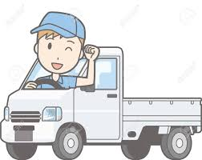ATTENTION !!!

**Light Vehicle Tax (Kei Jidousha)**

In May, Minowa City Hall will send a hagaki (card/invoice) for payment of the "vehicle tax" for light vehicles (kei jidousha) to people who own light vehicles and are registered on April 1, 2025.

Proof of payment of this tax will be required for the shaken (annual vehicle inspection), therefore, we ask that you make the payment and keep the receipt carefully and in a safe place.

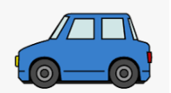

**Automobile Property Tax (Jidousha zei)**

The automobile ownership tax (does not include light motor vehicles or motorcycles, etc. is a provincial tax, levied on all those who own automobiles on April 1st of each year.

Upon receiving the tax collection notice issued by the provincial tax offices, please make payment at banks or convenience stores by the end of May.

**⚠[News about vehicle tax “Payment Methods”]⚠**

The payment deadline for Vehicle Tax Reduction Type for the fiscal year 2025 is June 2 (Monday).

When you receive your tax notification, please make the payment by the specified deadline.

In addition to convenience stores and tax offices, payment can be made at banks, financial institutions and post offices throughout the country.

**New: The tax payment notice contains a QR code that allows you to easily pay via mobile payment apps such as PayPay, Rakuten Pay（楽天Pay）and払い.**

In addition, it is possible to make the payment using the QR code when accessing the municipal tax payment website via smartphone or computer, via credit card, internet banking, among other options.

With this payment method, there is no need to go to a physical store or banking institution and there is no waiting time. How about trying to use them.

＊＊ There are certain conditions and procedures required for payment.

Additionally, depending on the payment method chosen, it may not be possible to issue a receipt or tax payment certificate. Please be aware of this in advance.

Nagano-ken Nanshin Kenzei Jimusho Kanri-ka

[Nagano Prefecture Automobile Tax Office]

Tel.: 0265-79-3146

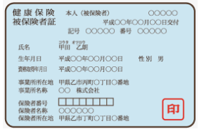

**National Health Insuranceúde (Kokumin Kenkthe (Hoken)**

People up to 74 years of age who are subject to residence registration and do not have health insurance where they work or other public insurance must register with the National Health Insurance. Please complete the registration process at the city hall corresponding to your place of residence within 14 days.

Applies in any of the following situations.

* People who have a residence registration
* When moving to another municipality
* When to leave your health insurance (shakai hoken) where you work
* When the child is born (the child's part)

In addition, people who are not subject to residence registration or who have less than 3 months of residence qualification, when their intended period of stay exceeds 3 months, will be able to enroll in national health insurance. So be careful. For more information, contact the city hall. ※[Payment hagaki for fiscal year 2025 will be sent in May]

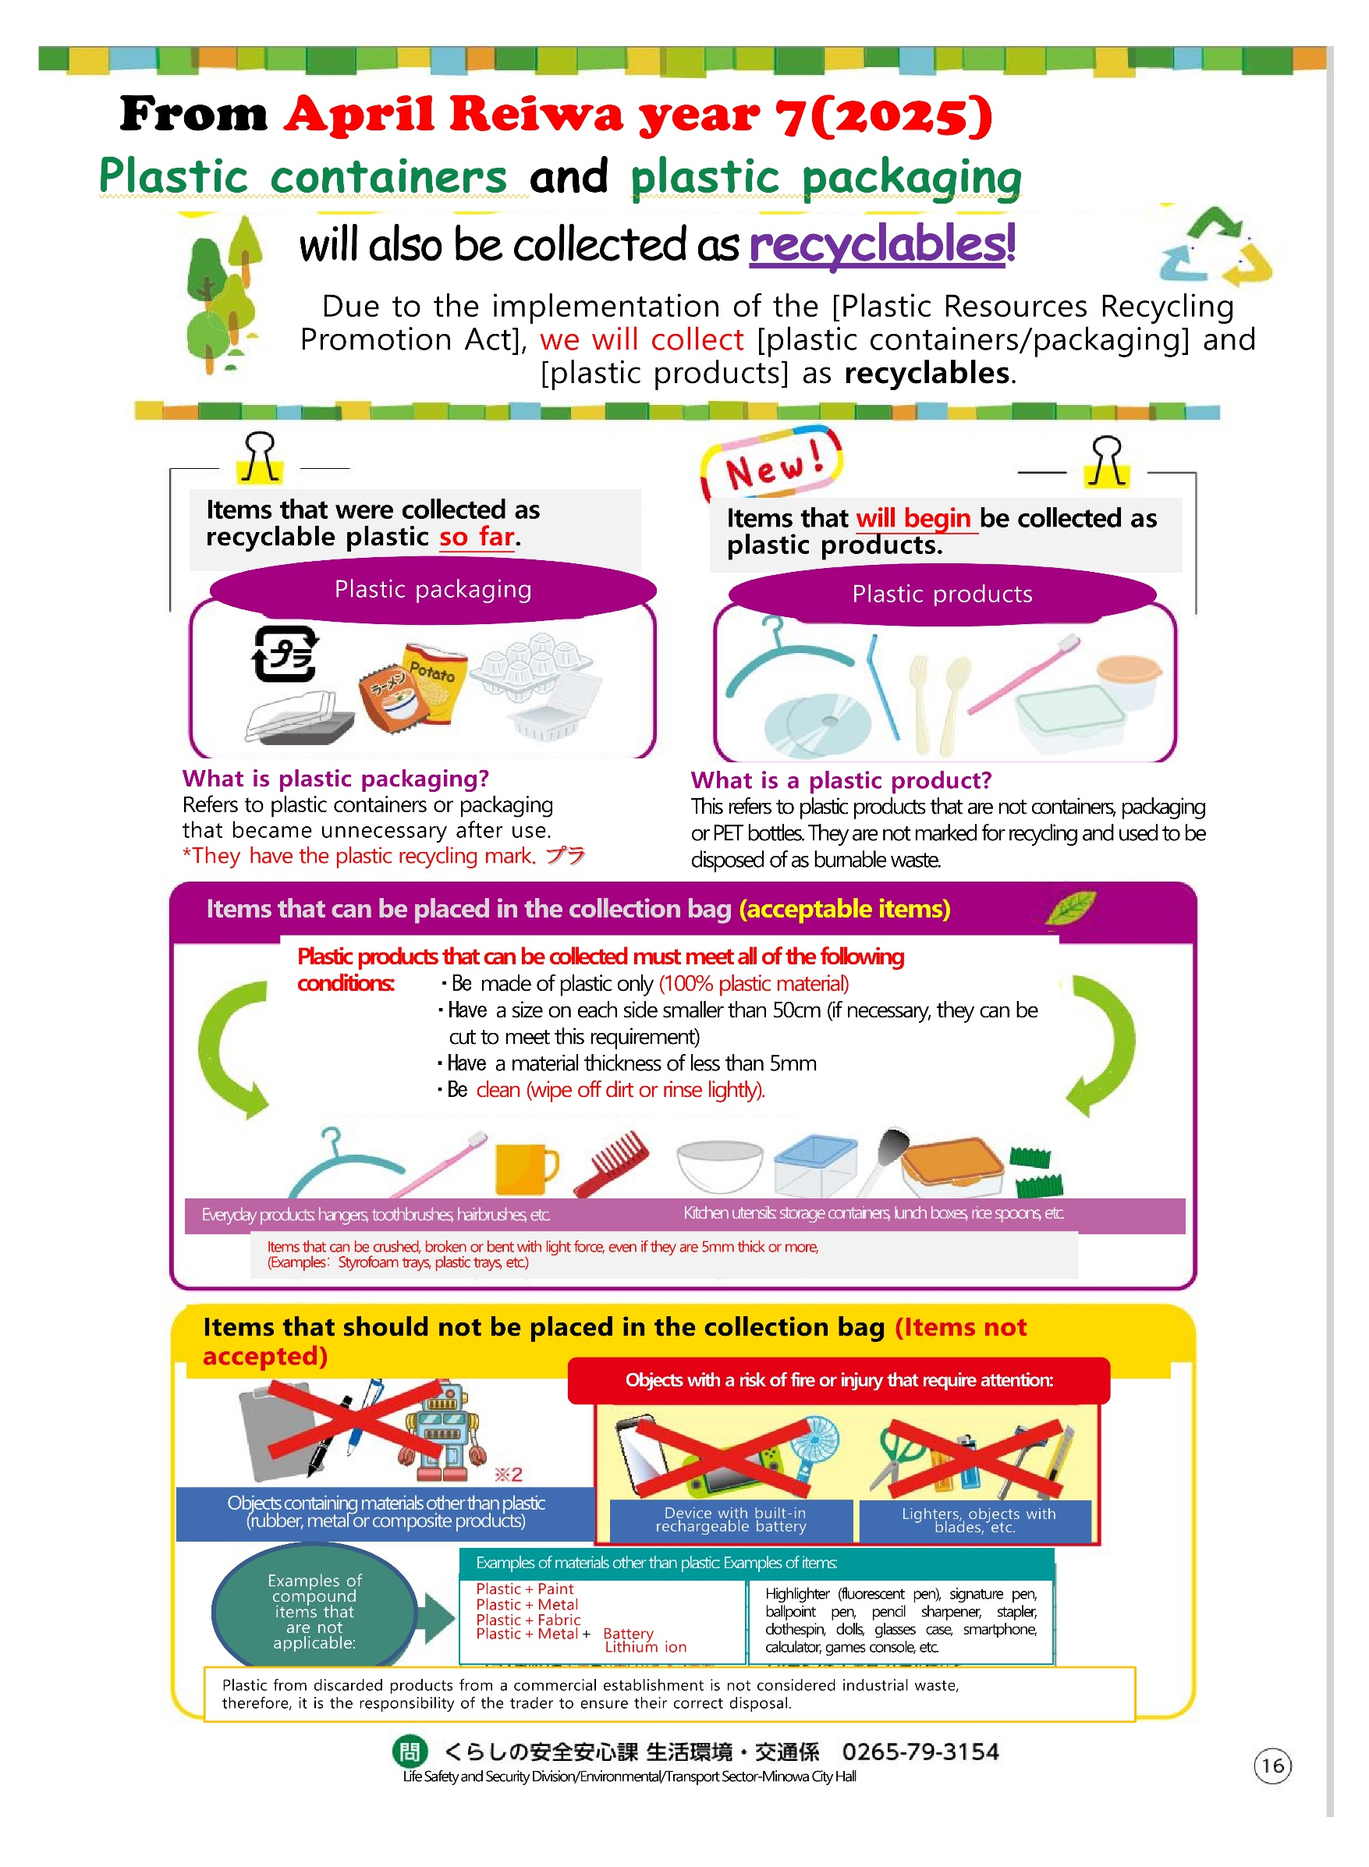

will also be collected as**recyclable!**

Due to application of the [Law on Promotion of Recycling of Plastic Resources],collectrewe[containers andplastic packaging] and [plastic products]

as recyclable.

Examples of materials other than plastic: Examples of items:

Marker (fluorescent pen), highlighter peninature, ballpoint,apieira, stapler, clothes peg, dolls, glasses case, smartphone, calculator, game console, etc.

Plastic＋Ink

Plastic＋Metal

Plastic＋Tissue

Plastic＋Metal＋Battery of

Lithium ion

Device with rechargeable batteryincorporated

Ilighters, objects with blades, etc.

Objects containing materials other than plastic

(rubber, metal or composite products)

**Fire hazard objectsor injuries, which require attention:**

**Items you should notm be placed in the collection bag(Items not accepted)**

Items that can be crushed, broken or bent with light force, even if they are 5mm or more thick,

can be included. (Examples:Styrofoam trays, plastic trays, etc..)

Kitchen utensils:storage containers, lunch boxes,to harvestrice etc.

Products for usediarythe:hangers, toothbrushes, hairbrushes, etc.

**Plastic products that can be collected must meet all of the following conditions:**・Be made only of plastic(100% plastic material)

・Have a size on each side smaller than 50cm (if necessary, they canbe cut tomeet this requirement)

・Have a material thickness of less than 5mm

・Be clean (cleandirt or light rinsing).

**Itemsthat can be placed in thebagthere collection(acceptable items)**

**What is Product plastic**

Refers to plastic productss that are not containers, packaging or PET bottles. They do not have the recycling marking and used to be discarded as burning waste.thevel.

**What is Plastic Packaging**

Refers to plastic containers or packaging

that became unnecessary after use.

*They have the plastic recycling mark.**プラ**

**Fire hazard objectsor injuries, which require attention:**

**Items you should notm be placed in the collection bag(Items not accepted)**

Items that can be crushed, broken or bent with light force, even if they are 5mm or more thick,

can be included. (Examples:Styrofoam trays, plastic trays, etc..)

Kitchen utensils:storage containers, lunch boxes,to harvestrice etc.

Products for usediarythe:hangers, toothbrushes, hairbrushes, etc.

**Plastic products that can be collected must meet all of the following conditions:**・Be made only of plastic(100% plastic material)

・Have a size on each side smaller than 50cm (if necessary, they canbe cut tomeet this requirement)

・Have a material thickness of less than 5mm

・Be clean (cleandirt or light rinsing).

**Itemsthat can be placed in thebagthere collection(acceptable items)**

**What is Plastic Packaging?**

Refers to plastic containers or packaging

that became unnecessary after use.

*They have the plastic recycling mark.**プラ**

**What is Product plastic**

Refers to plastic productss that are not containers, packaging or PET bottles. They do not have the recycling marking and used to be discarded as burning waste.thevel.

**Items that should not be placed in the collection bag(Items not accepted)**

Kitchen utensils: storage containers, lunch boxes, spoonrice etc.

**Objects with a risk of fire or injury that require attention:**

Items that can be crushed, broken or bent with light force, even if they are 5mm or more thick,

can be included. (Examples:Styrofoam trays, plastic trays, etc..)

Daily use productsthe:hangers, toothbrushes, hairbrushes, etc.

**Plastic products that can be collected must meet all of the following conditions:**・Be made only of plastic(100% plastic material)

・Have a size on each side smaller than 50cm (if necessary, they canbe cut tomeet this requirement)

・Have a material thickness of less than 5mm

・Be clean (cleandirt or light rinsing).

**Items that can be placed in the collection bag(acceptable items)**

**What is Plastic Product**

Refers to plastic productss that are not containers, packaging or PET bottles. They do not have the recycling marking and used to be discarded as burning waste.thevel.

**What is Plastic Packaging**

Refers to plastic containers or packaging

that became unnecessary after use.

*They have the plastic recycling mark.**プラ**

**Items thatto startto theto be collectedsuch as plastic products.**

**The items that were collected as**

**recyclable plasticuntil now.**

Objects containing materials other than plastic

(rubber, metal or composite products)