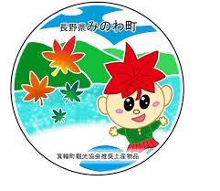**箕輪町英語ニュースレター 令和７年４月**

**April 2025 Newsletter**

**Minowa town Hall 箕輪町役場**

 **The Newsletter is published monthly by**

**the Minowa town hall**

〒399-4695 Nagano-ken.Kamiina-gun. Minowa-machi. Oaza Naka Minowa ,10298.

399-4695 長野県上伊那郡箕輪町大字中箕輪10298

TEL:0265-79-3111 内線・extensions: 1372/1711

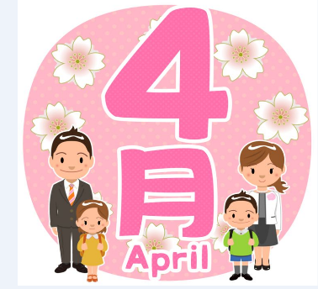

**[Notice to foreigners residing in Minowa]**

**ATTENTION ! We updated the apps and the QR Code has changed!!**

**Minowa City Hall provides means of communication through:**

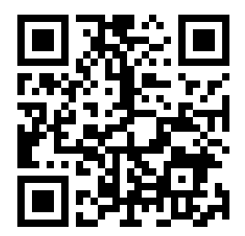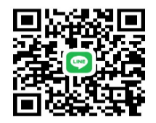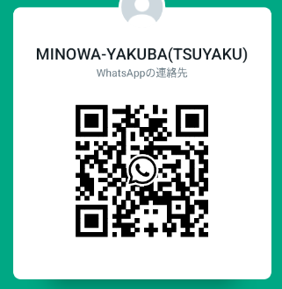

**●Ｗhats**

**App**

**●Messenger**

**●Line**

**(Minowa-Yakuba)**



We send updated news/information from the City HallandMinowa through Facebook to foreigners.

Please confirm via**[ Minowa News ]**on Facebook.

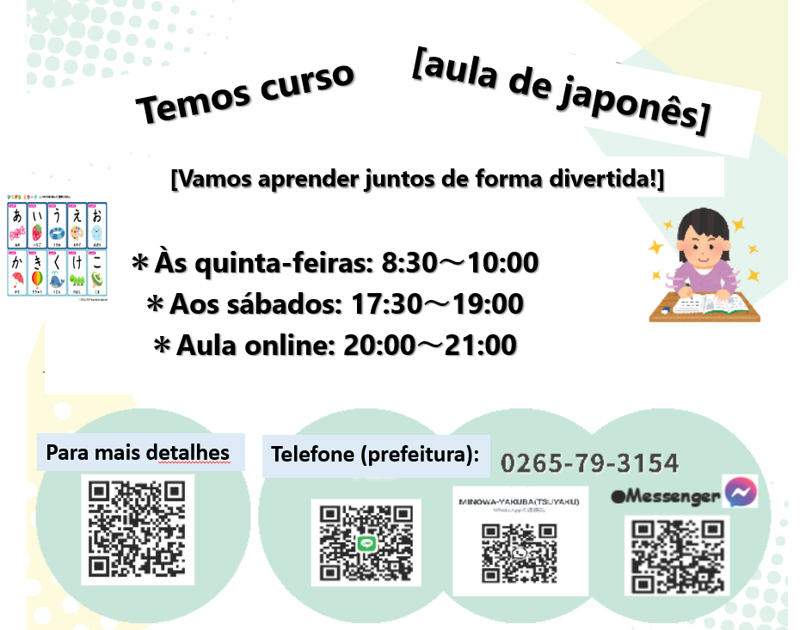

Phone number of the town hall

For more details

online classes

Saturdays

on Thursdays

let's learn together in a fun way

We have a Japanese course

**[Japanese class[ês] with Japanese volunteers**

(On Saturdays – from 1:00 pm to 3:00 pm)

(＊**Rate of \200yen/por time**)

*dayApril 5th: yassumi (day off)

*dayApril 12th:from 1:00pm～(location: Bunka Center Minowa rooms 5 and6)

*day 19 April: from 1:00pm～(location: Bunka Center Minowa rooms 5 and6)

*day 26 April:from 1:00pm～(location: Bunka Center Minowa rooms 5 and6)



**乳幼児おむつ用品購入券**

**交付事業のお知らせ**

**THEvision: ¨Coupon Granting Program**

**for the purchase of diapers & baby products"**

Minowa City Hall will provide a system/benefit to ease the financial burden of families raising children from July 1, 2024. Vouchers will be issued for the purchase of baby care products such as diapers, wet wipes, etc.

**１ Who can receive:**

**Parents or guardians who reside in Minowa City and are raising children who are 0 years old or who will turn 1 year old this year of Reiwa year 7 (2025).**

**２ Coupon Details:**

・Amount/quantity: 30,000 yen (1,000 yen x 30 coupons) per beneficiary child

・Period of use: Until the end of the year following the date of grant

・Reissue: We will not reissue in case of loss or other inconvenience, therefore,

store them carefully.

**３ Baby Care Products:**

・disposable diaper ・cloth diaper ・diaper liner ・diaper cover ・wet wipe

**４ Application Method and Deadline:**

**Registration deadline: from the month of the child's birth or 1st birthday until the end of the following 6 months.**

The child's parents or guardians must complete the application form and make the request at the Children's Future Department counter (Counter 5).

The purchase coupon will be delivered at the counter after confirmation of the registration form. The application form is submitted on the following occasions:

・For babies aged 0 and under: The application form is submitted at the Children's Future Department counter when registering the birth.

・For 1-year-olds: The application form is sent together with the 1-year health examination notice.

＊For more details or inquiries, please call or come directly to the City Hall, counter 5 or counter 11(tsuyaku).

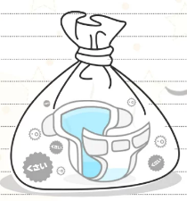

**紙おむつをお使いの方へ、ごみ袋の支給制度がありがます**

**[Garbage bag supply system for disposable diapers]**

Minowa City Hall has restarted the system that provides "burnable garbage bags" for the disposal of disposable diapers from babies and certified people in need of nursing care. Applications are being accepted and distribution will begin April 1st. This system aims to reduce the financial burden on disposable diaper users, provide support for childcare and improve well-being.

**Who can receive: *Infants (children under 3 years old) *those who use disposable diapers *other special cases**

**Benefit content: For each eligible person upon request, up to 60 bags of burnable garbage (medium size). ※In some special cases, you may be able to request an additional 100 diapers per year.**

**Application method: Please apply at Minowa City Hall, Counter 11.**

Please attach the following documents: ①Proof of eligibility (boshitechô, disability booklet, etc.)

➁Proof of purchase of disposable diapers (receipt, etc.)

※Document is not required for infants.

Department of Safety and SecurityLife, Environment/Transportation Sector (Counter 11)

**※In mid-March, the City Hall sent “garbage tickets” to homes.**

**If you have not yet received these tickets, please contact us.**

**※Have you already received the ¨Collection Calendar?selective domestic waste¨ from 2025??**

**If not yet, it could be thepurchased at City Hall, Counter 11.**

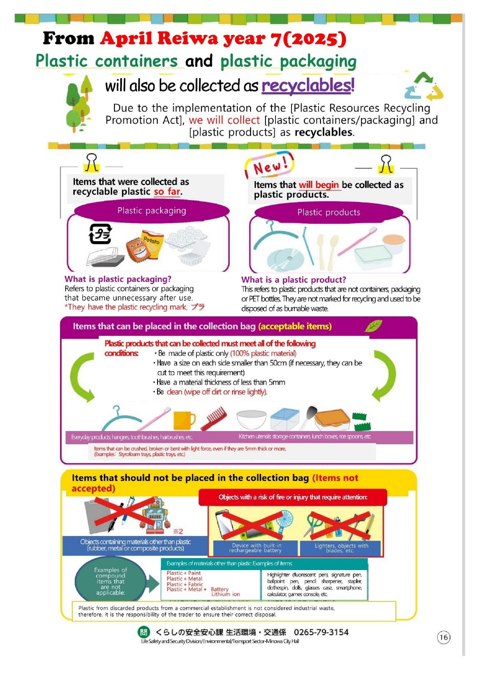

**Items thatwill startto be collected**

**like plastics recyclable.**

**Items that were collected as recyclable plasticuntil now.**

Due to application of the [Law on Promotion of Recycling of Plastic Resources],collectrewe[containers andplastic packaging] and [plastic products]

as recyclable.

will also be collected as**recyclable!**

**Plastic containersandplastic packaging**

FromApril Reiwa year 7(2025)

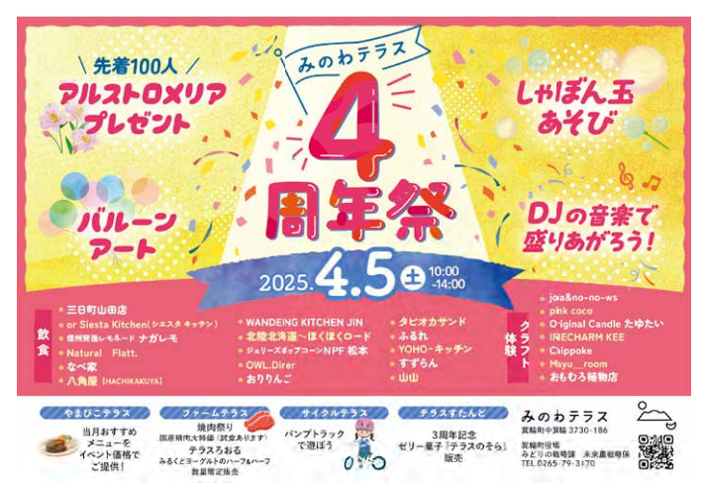

**Three year anniversary, sale of jams**

**"Terasu no sora".**

**[Yakiniku Festival] Special price for domestic meats**

**(there will be a tasting on the day).**

**[Sale of**

**Milk roll with yogurt]**

**Let's go**

**To play**

**with**

**Pump**

**Track**

**We offer a menu for the event at a special price**

**Event [Minowa Terrace]**

**Terrace Stand**

**CircleTerrace**

**Farm Terrace**

**Yamabiko Terrace**

**There will be several stallsof**

**food and drinks**

**(Sat.)**

**Commemorative party**

**at 4ºbirthday**

**For the first ones**

**100 people**

**Games**

**with bubbles**

**of soap**

**Arts with**

**bladders**

**Let's cheer up with music**

**from the DJ!**

**we will give gifts**

**alstrom flowersandlI was goings**

**Minowa Terrace**

**we will give gifts**

**alstromandlI was goings**

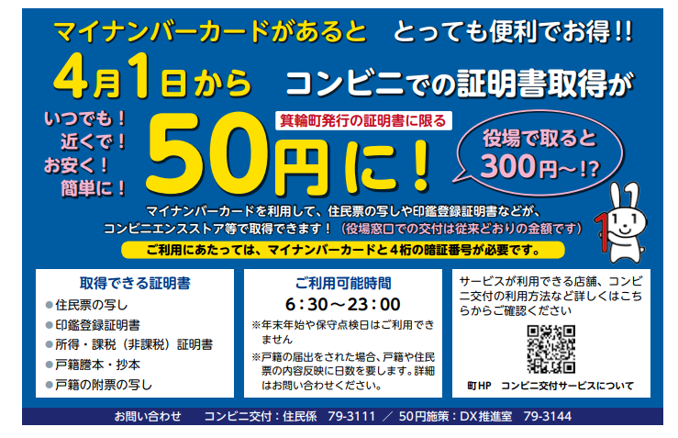

**Contact:Minowa City Hall/Resident Section 0265-79-3111**

**Since April of 2024,**

**Minowa HP/Convenience Stores**

**Check here for details of which locations,convenience stores the service can be used.**

**●Not available during year-end/new year holidays.**

**●If you submit family registry notification, it will take days for details to be reflected in the family registry. (Contact us for more details)**

**Opening hours:**

**Certificates obtained:**

**●Copy of resident registration**

**●Wstamp registration opium**

**●Income/taxation certificateão (tax exemption)**

**●Wfamily registry opium**

**(kosseki tohon)**

**To use the service,to needyour card and 4-digit password.**

**You can use your my number card to obtain copies of resident registration, stamp registration, etc.**

**If you take it out at City Hall,**

**Limited to documents issued by the city of Minowa**

**Anytime!**

**Close to you!**

**Cheap!**

**Simple!**

**obtaining a certificate/document in a ¨Kombini¨, it will cost only...**

**It is very convenient andlucrativeif you have a ¨My Number Card¨!!**