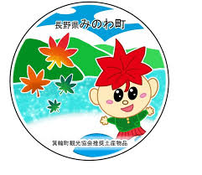
箕輪町英語ニュースレター 令和８年1月
Newsletter January 2026
Minowa Town Hall 箕輪町役場
The newsletter is published monthly by the Minowa Town Hall.
399-4695 Nagano Prefecture. Kamiina District. Minowa Town. Oaza Naka Minowa, 10298.
399-4695 長野県上伊那郡箕輪町大字中箕輪10298
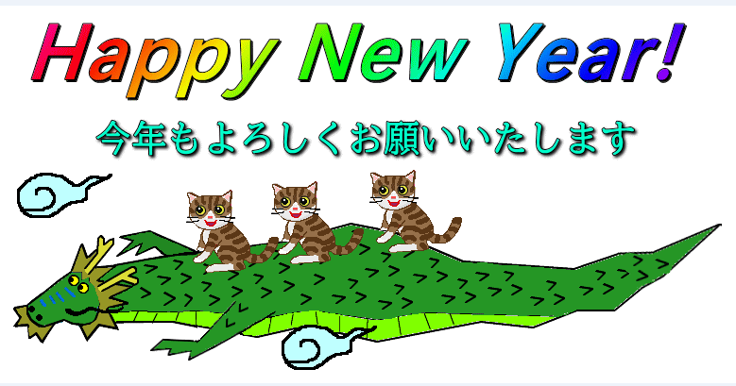
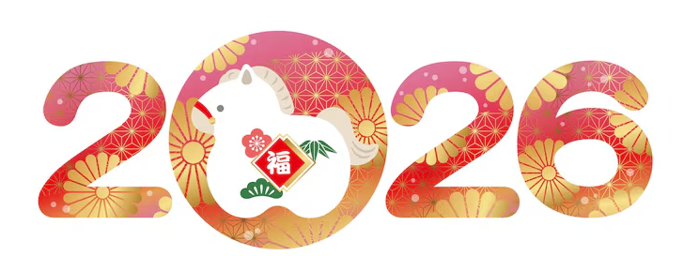




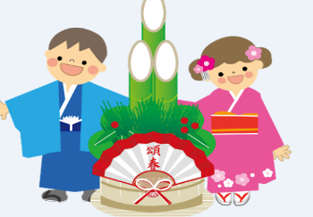
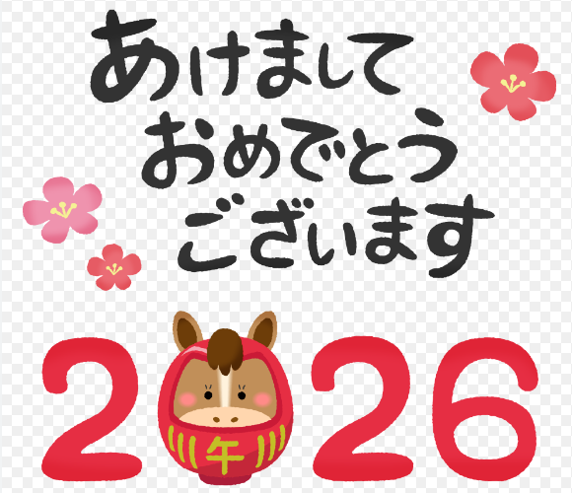
TEL:0265-79-3111 /0265-79-3154
Happy New Year
to all !!

Regarding: Declaration concerning the year Reiwa 7 (2025)

Concerning the "Acceptance of Tax Declarations" at Minowa City Hall, once again this year, only by "advance reservation." If you have made a "day and time reservation" to make a "Tax Declaration/Refund," please check your reservation through the leaflet given at the city hall and attend on the specified date and time. This year, foreign residents will once again need to fill out a separate form justifying their living status, as required by the Tax Office in Ina. For this, please bring your Zairyu card, My Number card, and passports. [Please come early to allow time to fill out the form].
We apologize for any inconvenience and thank you for your understanding and cooperation.
Please check the information below for the schedule and services at Minowa City Hall.

Schedule for receipt/service of the Declaration at the Minowa City Hall:
※For those who have not yet made a reservation, there may still be available time slots. . .
If you want to confirm, we ask that you come in person to the City Hall,
we will help you. (counter 11)
Attention!! The recycling collection center (Clean Center Yaotome) and the (Midori no Shiguen Recycling Station) in Minowa will be closed from January 30th to February 27th.
Date: | ⚠ [ Only by prior appointment ] ⚠  February 16, 2026 (Monday) ～  March 16, 2026 (Monday) (Except Saturdays, Sundays, and holidays)
Hours: | [ Morning ]: from 9:00 AM to 11:30 AM [ Afternoon ]: from 1:00 PM to 3:30 PM  - 9:00 AM ④ 10:30 AM ⑦ 1:00 PM ⑩ 2:30 PM  - 9:30 AM ⑤ 11:00 AM ⑧ 1:30 PM ⑪ 3:00 PM  - 10:00 AM ⑥ 11:30 AM ⑨ 2:00 PM ⑫ 3:30 PM  ※On February 20th (friday), there will be service for declarations from 4:00 PM to 6:30 PM.
Location: | Minowa City Hall – 3rd floor
Declaration that cannot  be accepted  at the city hall: | ・Blue declaration ・Consumption tax ・Special deduction for housing loan, 1st year  ・Donation and inheritance tax ・Capital gains declaration, such as land and houses  ・Revenue from transfer of shares, etc.  ・Other special declarations (virtual currencies, FX, etc.)
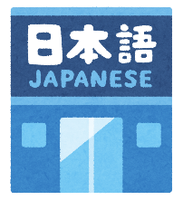
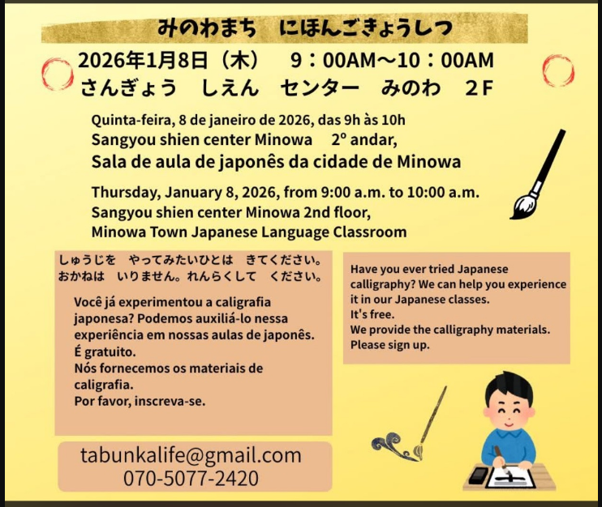
まちで にほんごの きょうしつ あります。
◇Tel:070-5077-2420
◇Mail:m.tabunka@gmail. with
◇LINE:https://line. me/ti/p/rhMKeSYmL2
◇WHATSAPP:https://wa. me/qr/5JEBYX7J2XH5H1
MESSENGER:https://m. me/61574885471583?source=qr_link_share
※さいしょに かならず れんらく してください！

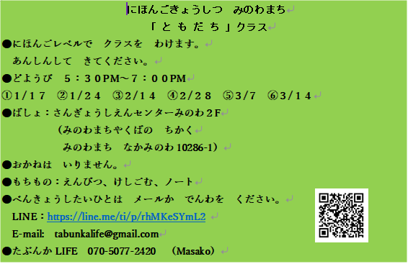
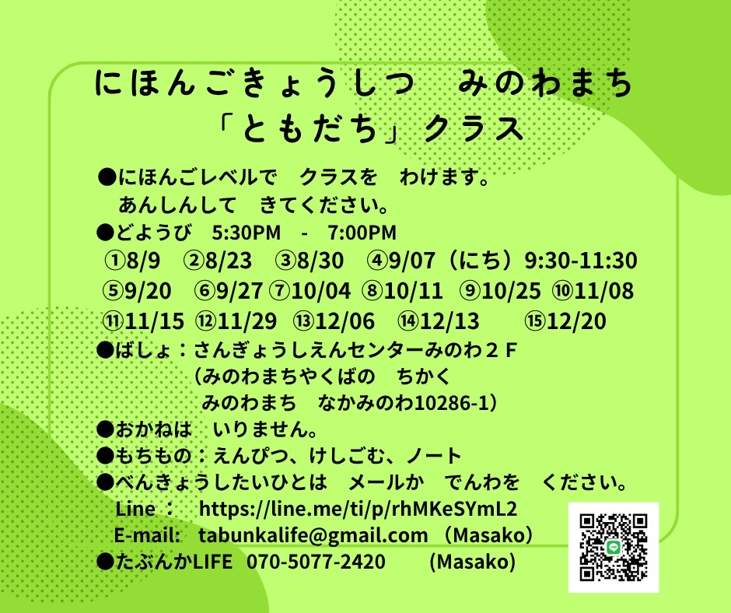
Japanese class on Saturdays
"Friends" class
Students will be divided into groups according to their level of Japanese.
Come with peace of mind.
*Saturdays from 5:30 PM to 7:00 PM.
*Local: Sangyo Shien Center-2ºandar
(almost opposite the City Hall)
*Taxa:FREE
＊What to bring: pencil, eraser, notebook.
＊Dates: January days: 17, 24, 31
February days: 7, 14, 28

Anyone who wants to participate, send an email or call: Tabunka Life: 070-5077-2420 (Massako)

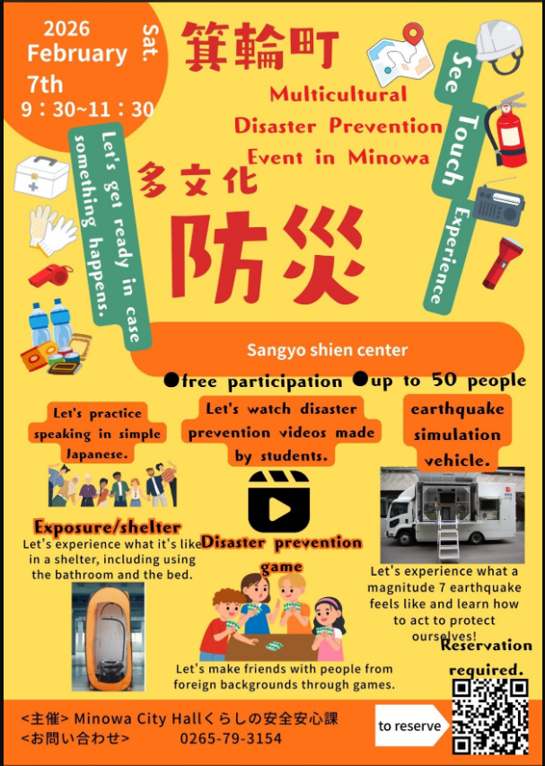

*(Fee of \200 yen/per visit)

[Japanese lessons] with Japanese volunteers
(On Saturdays – from 1:00 PM to 3:00 PM)

*January 10th: Starting 1:00 pm～(location: Minowa Base, room 1)
*January 17th: (Yassumi) Day off
*January 24th: Starting 1:00 pm～(location: Bunka Center Minowa, rooms 5,6)
*January 31th: Starting 1:00 pm～(location: Minowa Base, room 1)

If possible,
we ask that
you wear
a mask

Separation and Disposal of Household Waste and Recyclable Waste
～Let's maintain a pleasant environment by following the garbage collection rules～

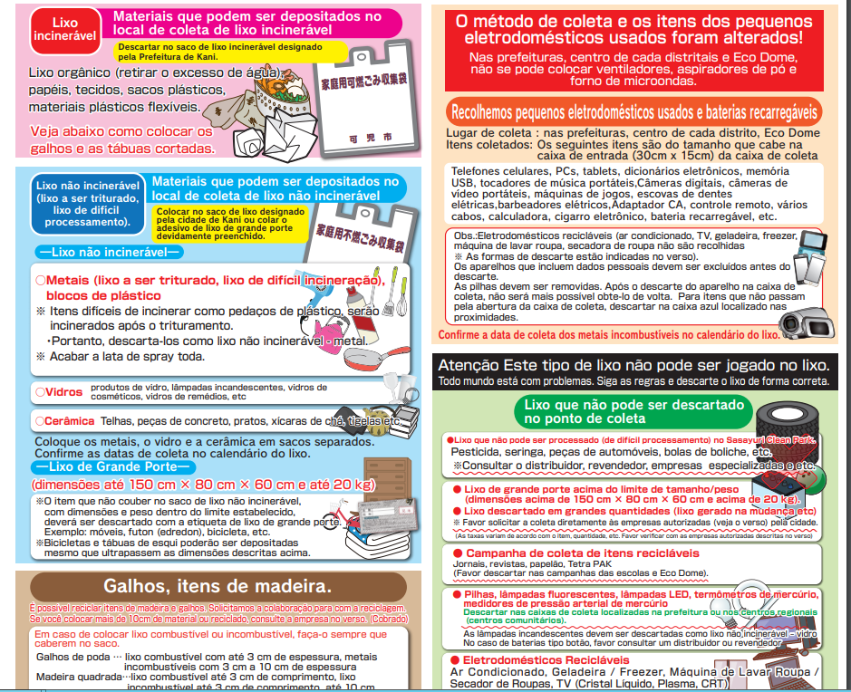
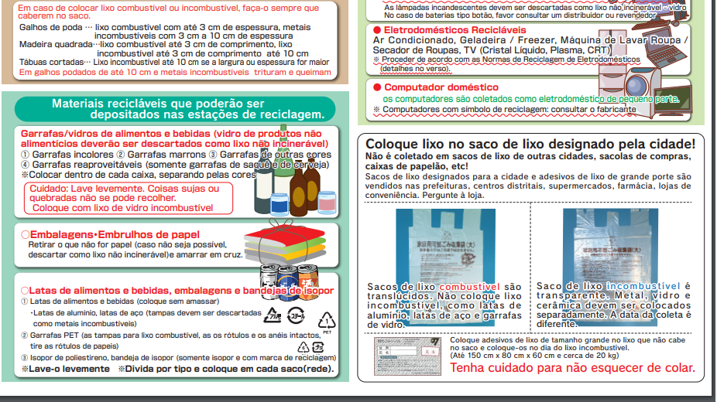
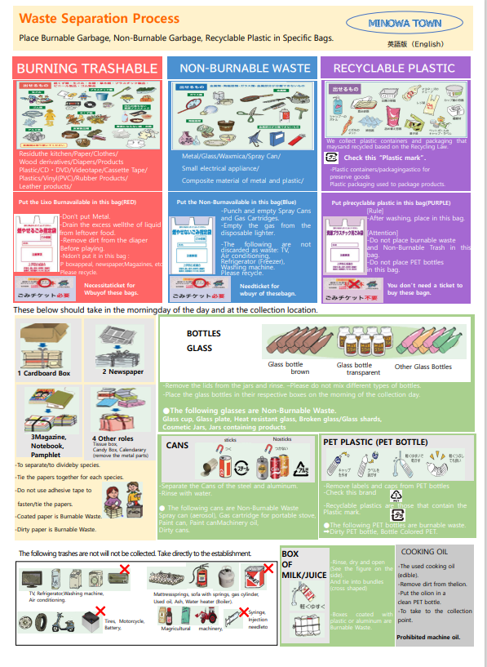
Don't forget to wash before throwing it away!

[Be careful with water freezing in pipes]
＜のにしてください＞
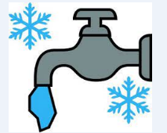
Due to the low temperatures in our region, water freezing in pipes can easily occur. Since we are in a very cold period, let's take the following precautions.
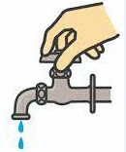
[Places most likely to freeze] External piping, water heater, boiler, etc.
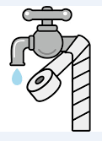
[Prevent freezing] Wrap the water pipes with thermal insulation.
Leave the faucet slightly open to let a small stream of water run.
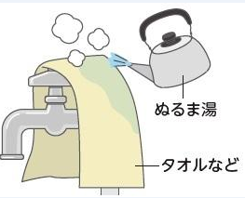
[If water freezes in the pipe] And water does not flow: Wait for it to thaw. Pour lukewarm water.
In case of rupture:
(1) Close the water valve and wrap the pipe with vinyl tape, etc.
(2) Request repair from a specialized store.
